**Merry Christmas Wishes From The Diamondbacks!**



**Watch the Home of the Commandant Merry Christmas Tour**

<https://youtu.be/tQFLw4_4_Ho>

Attachments area: [Preview YouTube video Home of the Commandants[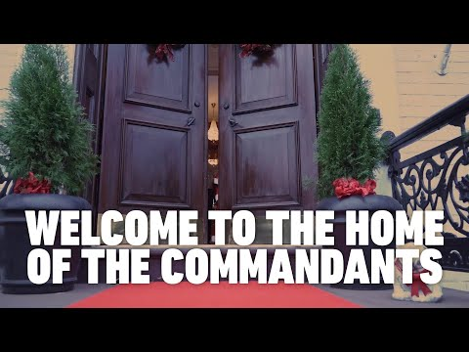](https://www.youtube.com/watch?v=tQFLw4_4_Ho&authuser=0)](https://www.youtube.com/watch?v=tQFLw4_4_Ho&authuser=0" \t "_blank)

[[](https://www.youtube.com/watch?v=tQFLw4_4_Ho&authuser=0)](https://www.youtube.com/watch?v=tQFLw4_4_Ho&authuser=0" \t "_blank)

**[Homof the Commandant](https://www.youtube.com/watch?v=tQFLw4_4_Ho&authuser=0" \t "_blank)**

Message continues on next page

**A Version of a Marine Christmas.**

The United States Marine Corps issued orders, today, to Sergeant Major S. Claus, recalling him to active duty, with a RNLTD of 24 Dec 2020.

Sgt. Major Claus, known to use the alias “Saint Nicholas”, “Kris Kringle”, “Father Christmas”, or simply “Santa”, is a reservist, with 1,743 years of service.

He specializes as a tactical operator of the next generation DEC-25B, Cargo Airborne Delivery (CAnDY) Carrier. The DEC-25B is contractor-modified and fully equipped with Cargo Antlered Navigation Equipment Sensors (CANES).

It has also been retrofitted with eight high-powered, air-cooled Rangifer Tarandus carrot-fed generators. As a single seat cargo delivery platform, it is capable of vertical delivery of high-value items, take-off and landing without pilot controlled lighting (PCL). These unique specifications, coupled with the additional Public Affairs skill sets possessed by Sgt. Major Claus, classify the entire deployable package as a low-density, high-demand (LD/HD) asset.

Also recalled, were 1st Sergeant Dasher, Master Sergeant Dancer, Gunnery Sergeant Prancer, Staff Sergeant Vixen, Sergeant Comet, Corporal Cupid, Lance Corporal Donner, and Private First Class Blitzen.

Private Rudolph is also authorized to report for duty; however, he must first successfully complete his Phase II SERE Training, which he has failed three times due to a medical condition related to his nose.

Although the above Marines are on orders for only 24 hours, it is anticipated that they will submit a travel claim for 24,901 miles at $0.56/mile, using a POV. Suitable Government transportation is not available.

As a special operations unit, each member is granted a high level of uniform flexibility, as well as relaxed grooming standards. Per diem has been modified to include large quantities of hot cocoa and cookies. Government travel card use has been authorized.

