# **Obituary: Donald Patrick O’Hanlon**

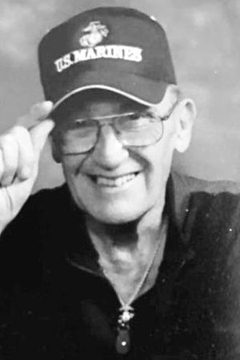

Donald Patrick O’Hanlon

SARASOTA, Fla. – Donald Patrick O’Hanlon was raised on Vinegar Hill and later lived in Fordham the Bronx and Staten Island, New York. He died peacefully at home in Sarasota, Florida, on April 25, 2021.He started his career as a teller for Manufacturer Hanover Trust Co. and worked his way up to being a systems analyst for JP Morgan Chase Bank when he retired after over 30 years. In addition, he gave three decades of service to our country as a Marine Corps Reservist earning the 9th and highest rank of Master Gunnery Sergeant. Donald was active and made friends easily. He was an avid bowler, collected Toys for Tots at Christmastime, and served as an unofficial ambassador for Oakwood Manor, where he enjoyed serving coffee to his friends almost daily. He was predeceased by his parents, Thomas and Alice (O’Hagan) O’Hanlon and siblings, Thomas, Kathleen, and Alice; and leaves his devoted longtime partner, Helen Bonner; four daughters from former marriages: Laura, Karen, Denise, and Kathleen; nephews and nieces, including Alice Casey and Patricia Walsh, who were like sisters to him; four grandchildren; and many friends.A military burial has been scheduled for June 29, 2021 at the Sarasota National Cemetery and a separate celebration of life will be held later this year. FMI: [semperfidelismarine1207@gmail.com](mailto:semperfidelismarine1207@gmail.com) .Semper Fi, Marine!Condolences may be made at [http://www.toalebrothers.com](http://www.toalebrothers.com/)