**A-Bomb Carrier**

**See editor’s revisional notes attached below the news clip.**

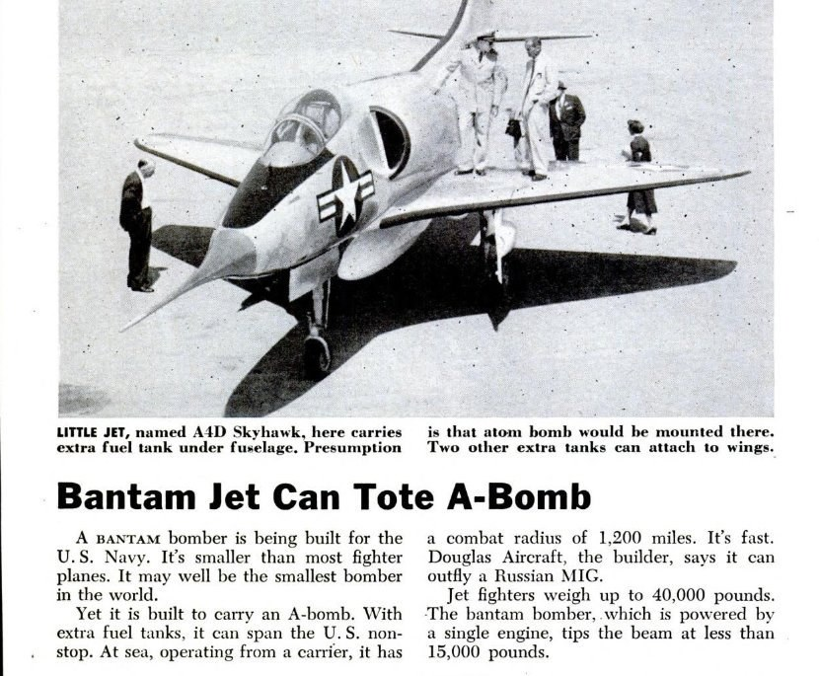

Our beloved Skyhawk has also been called “the strap on bomber” because of the extremely small cockpit space. Also, the photo is not one of an in-service A4 and doesn’t emphasize the height of nose wheel needed to accommodate the A-Bomb. I was six foot tall and had no problem walking under the noise. Thank god no A-Bomb has been dropped since 9 August 1945!

**A little background on A-Bombs**, Col. Tibbets delivered Little Boy on 6 August 1945 from the B-29, Enola Gay. His B-29 had top speed of 357 mph and top altitude of 31,850 feet. In speeches, he has revealed that J. Robert Oppenheimer, known as the father of the A-Bomb, told him to turn and climb at a 27-degree angle at top speed upon dropping the bomb in order to lessen the shock wave.

Information on the B-52 is classified. However, we do know that the Boeing B-52 Stratofortress is capable of flying at high subsonic speeds and altitudes of up to 50,000 feet. The technique for A-Bomb delivery must be quite different than the B-29.

**Now our Skyhawk:** the delivery technique is totally different from the Air Force and it is still probably classified. So, the scuttlebutt around among plane captains and other squadron members is as follows.

The A4 usually flew at low level for bomb delivery. We theorized that an air speed of either 480 or 540 knots, which are divisible, 60, would be used. These speeds would allow timing of a loop. That loop would start at a point or landmark before the target. The bomb would be released on a forward and upward arc. At the top of the loop, the A4 would do a roll to from upside down to bottom side down. Then, the A4 would exit at every bit of speed the Skyhawk could provide to get away from the shockwave. Also, the pilot would then pray!