The video is about forty-six minutes long. It is the most complete that I have seen! The video appears to have been made in the early nineties.

VMA-131 was recommissioned in 1958 and first flew the Skyhawk in 1962. The last flight of the Skyhawk was flown by the squadron in 1994. See other postings on this website.

If this link does not work, report it to: [1965diamondback@gmail.com](https://d.docs.live.net/893b7d9935fc8fab/1965diamondback@gmail.com)

[The story of Douglas A 4 Skyhawk || A4 Skyhawk Documentary](https://www.youtube.com/watch?v=NleoU-9mu3E)

[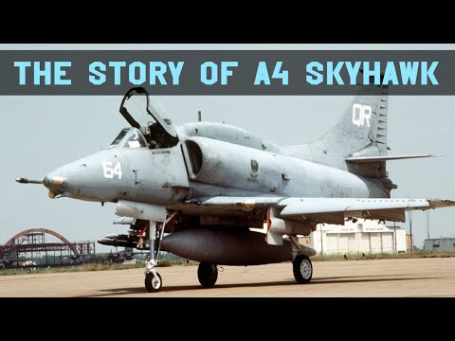](https://www.youtube.com/watch?v=NleoU-9mu3E)