**Dorothy Schmidt Cole, the oldest living U.S.** **Marine, died at age 107.**

[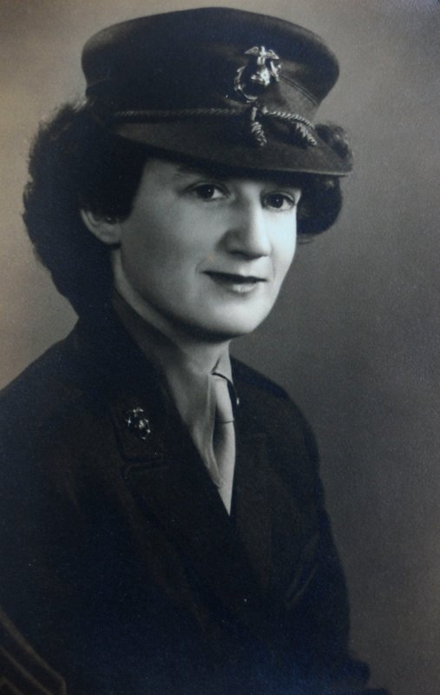](https://apnews.com/article/bombings-kannapolis-north-carolina-c69ba8ee09a01eb26765ac1a49f8591b/gallery/8962452d46f94144b7f2e90eb922ec4a)

KANNAPOLIS, N.C. (AP) — Dorothy Schmidt Cole, recognized last year as the oldest living U.S. Marine, has died at age 107.

Beth Kluttz, Cole’s only child, confirmed Friday that her mother died of a heart attack at Kluttz’s home in Kannapolis, North Carolina, on Jan. 7.

[The Charlotte Observer](https://www.charlotteobserver.com/news/local/article248472220.html) reports Cole enlisted as one of the earliest female Marine reservists following the bombing of Pearl Harbor. She had left her Ohio home to head to Pittsburgh, where she hoped to volunteer for the Navy, but because she was only 4 feet, 11 inches tall, she was deemed too short to meet Navy standards.

Undaunted by her rejection, Cole decided to learn how to fly an airplane and persuade the Marine Corps to let her be a pilot.

In July 1942, President Franklin D. Roosevelt signed the Marine Corps Women’s Reserve into law, giving women the chance to fill positions left open by men headed to combat. The Corps delayed formation of the branch until February 1943, and Cole enlisted five months later at age 29, becoming one of the earliest volunteers for the branch.

Despite putting in 200 hours in the cockpit of a Piper Cub, Cole completed six weeks of boot camp at Camp Lejeune with the Women’s Reserve’s First Battalion and wound up “behind a typewriter instead of an airplane.”

Cole’s husband, Wiley, was in the Navy and served on the aircraft carrier USS Hornet, which sailed in both the Pacific Theater and the Solomon Islands campaign during World War II before it was torpedoed and sunk in October 1942.

Cole moved to San Francisco after the war to be with Wiley. They married and had their only child in 1953. The couple were both hired by the Ames Research Center in Silicon Valley in California before Wiley Cole died of a heart attack in 1955.

Kluttz moved from California to North Carolina in 1976 and Cole followed her to the area around 1979.