**John Warrender Obituary**

Here is John Warrender’s obituary. Please accept Echovita’s sincere condolences.

It is with deep sorrow that we announce the death of John Warrender of Morehead City, North Carolina, born in Newark, New Jersey, who passed away on January 7, 2021, at the age of 90, leaving to mourn family and friends. You can send your sympathy in the guestbook provided and share it with the family. You may also light a candle in honor of John Warrender.

He was loved and cherished by many people including: his parents, Scottish and Robert; his wife Linda Warrender; his children, Robert "Scot" Warrender (Lori), Lesley Warrander and Heather Knight (Christopher); his step-daughter Penny Rule (Stanley Rule); his grandchildren, Asher, Silas Warrender, Lindsey and Sarah Knight; and his step-grandchildren, Amy Johnson Blount, Ryan Johnson and John Rule.

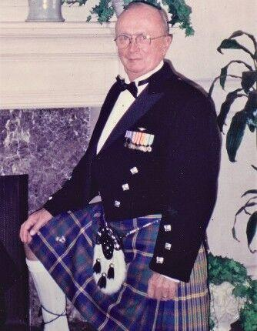

**Testimonies**

**On Jan 12, 2021, at 9:28 AM, Robert Beavis wrote:**

Col. John “Jack” W. Warrender, 90, of Morehead City, passed away Thursday, Jan. 7, 2021, at Crystal Bluffs in Morehead City.

At this time, no services are planned.

Jack was born in Newark, N.J., to Scottish immigrants Robert and Mary Wright Warrender. Jack cherished his Scottish heritage and was a proud U.S. Marine for 31 years and forever. Jack also flew for United Airlines for 26 years.

In 1967, his cousin, Capt. Colin MacManus, was killed in Vietnam; deeply saddened, Jack took a leave of absence from United Airlines to fly missions in the unfriendly skies of Vietnam. His service and sacrifice in Vietnam earned him the Distinguished Flying Cross. New Jersey Rep. Joseph G. Minish wrote a letter of commendation to Jack’s parents, and in a speech before Congress, acknowledged Jack’s heroic act and his parent’s sacrifice.

Jack is survived by his wife, Linda Warrender; son, Robert “Scot” Warrender and his wife Lori; daughters, Lesley Warrander and Heather Knight and her husband Christopher; stepdaughter, Penny Rule and her husband Dr. Stanley Rule; grandchildren, Asher and Silas Warrender and Lindsey and Sarah Knight; and step grandchildren, Amy Johnson Blount, Ryan Johnson and John Rule.

Arrangements are by Noe-Brooks Funeral Home of Morehead City. Condolences and life tributes may be sent to the family at: [www.noefsbrooks.net](http://www.noefsbrooks.net).

There are many stories about him. Loved the story of Jack when he had a conflict with his captain and after landing and at gate when the checklist was completed. He then asked the captain if the flight was complete and when yes was answered reached over and punched his head hard.

Every year he would break into the UAL computer that put out the daily rag and, on our USMC Nov 10th, birthday would input at the top "Happy Birthday Marines". I flew with Jack at UAL and also in the Marines. Many many stories.

GBH. Throw a nickel on the grass!! SF, b

**On January 12, 2021 at 9:32 AM Frederick Dubinsky wrote:**

Good guy, for sure.

**On January 16,2021 at 9:09 AM Joe Hillis wrote:**

ATTENTION Marine Old Timers Club members,

It is with great deal of sadness that we learn of the passing of Colonel **JOHN (JACK) WARRENDER**, USMC, Commanding Officer VMA-131 June 1969-June 1971.  May he Rest in Peace with the Almighty and all his beloved Marines.

A contribution from the Old Timers Club in his memory will be given to the Marine Semper Fi Fund.

Editors note: like to say as a plane captain (1965 -71) at Floyd Bennett, it was an honor to assist him on our flight line. As our pilots would say “Throw a Nickel” to a true Marine aviator!