###### ***This information has just come to our attention***

###### **OBITUARY**

# **Eric Thomas Farrell**

###### **DECEMBER 6, 1940 – MARCH 19, 2016**

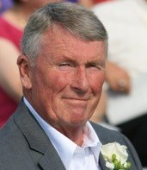

Eric Thomas Farrell Devoted husband and loving father Eric Thomas Farrell, 75, passed away after a long battle with dementia. Eric was born on December 6th, 1940 in New London, Connecticut to Nora and Charles Farrell. He graduated from Boston College in 1963 with a degree in Labor Relations and commission in the Marine Corps. He served in Vietnam as a pilot, returning to the United States to serve on both active and reserve duty until he retired in 1991 at the rank of Colonel. Along with reserve duty, he became a pilot for Trans World Airlines, from 1968 to 2000. Upon retiring from TWA, Eric founded a local transportation company in Point Pleasant, NJ where he employed over 50 people for nearly 12 years. Eric retired in 2008 and moved to Florida spending time boating, fishing, golfing and enjoying the company of good friends. Eric will be fondly remembered by those who loved him as being a determined and charismatic man who cared deeply for his family and friends. Eric is survived by his wife, Carole Sue, daughter, Nora Marian, son, Thomas Stephen, and brothers, Charles and Stephen Farrell. He also has one grandchild, Leighton Bain, with another due to arrive this summer, Thomas Ryan. In lieu of flowers please donate to semperfifund.org

robert beavis

April 10, 2016

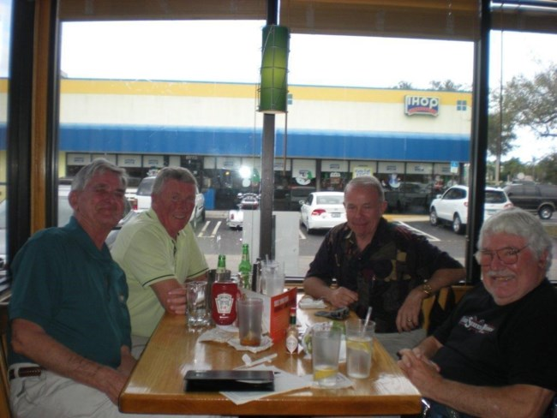

robert beavis

April 10, 2016

Eric (Ric) was one of a kind. A very good friend, pilot and Marine Officer. We abided by "Farrell's Rules" when paying the bill after dining or running up a tab! (No matter what you had, you paid your equal share.) Ric always had a smile. When things did not work out great he would just shrug it off. We met around 1970 and did not always agree but were always friends. Ric would always respond to any request for help. About a year and half ago asked Ric if there was anything he wanted to do as he knew what was coming; his answer: No, I think I have done it all.  
God bless you ETF. SF, bob beavis

