**Anthony M. Pizza**

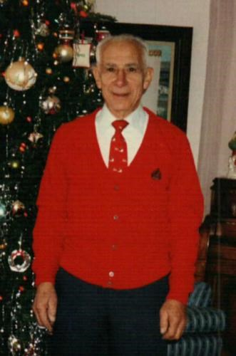

[Send Flowers](https://sympathy.legacy.com/en-us/funeral-flowers/name/anthony-pizza-funeral-flowers/p201371246/?affiliateId=4359&pm=205)

Share

**FUNERAL HOME**

Ballard-Durand Funeral & Cremation Services - White Plains

2 Maple Ave

White Plains, NY

Anthony M. Pizza, born November 5th, 1923 in Brooklyn, New York to Antonio Pizza and Mary Esposito,  
was the second oldest of six children. Growing up in a modest family during the depression, Tony left  
school in his teens to go to work to help support his family. Showing mechanical proficiency, he went to  
work as an apprentice in a machine shop with his uncle. He then acquired a job at a defense contractor,  
Bendix Corporation, as a machinist helping the war effort. At eighteen, he enlisted in the US Marine  
Corps to serve his country. Showing an excellent mechanical aptitude, he quickly advanced to become a  
flight line chief in charge of airplane maintenance. He served in the Philippines and China during World  
War ll. Upon his release from active duty, Tony joined the US Marine Corps Reserves and later the US  
Marine Corps Scholarship Foundation during its infancy, and remained an active force in the Marine  
Corps community his entire life. Master Sergeant Tony Pizza was a proud World War II veteran. For 67  
years wonderful years, he was married to the love of his life, Antoinette (Nettie) Scoca. Nettie and Tony  
have been active volunteers for Marine Corps Scholarship Foundation for over 60 years, and attended  
golf outings and other volunteer events all around the country. As coordinators and board members  
since the very first scholarship event in 1962, Tony and Nettie spent countless hours creating and  
supplying artwork, and photos honoring heroes at home and abroad, including the Marine Corps globe  
and anchor emblem which was the centerpiece of the event. At every ball and Marine Corps event,  
Nettie and Tony were always the first to hit the dance floor, and the last to leave, and were the envy of  
any young marine in the room.  
One day following their engagement, while driving through the country they came across a beautiful  
home in Hartsdale, New York which they immediately fell in love with, and purchased with the assistance  
of his GI bill. Nettie still resides in their home today.  
Tony had an unyielding work ethic, starting as co-owner of a Renault/ Peugeot automobile business, then  
service manager in a Pontiac dealership, finally moving on to open the third Subaru dealership in the  
United States with his brother Marty.  
No matter where Tony went, he was loved by all. His patience, compassion and genuine care for family  
and strangers alike was unmatched by any man ever known. Tony and Nettie were an inseparable team,  
and because of this kindness and compassion for others, became pillars of the community.  
As a husband, Tony's patience knew no bounds. He would be the first to tell you, "Nettie is the boss", and  
because of this they shared a beautiful and fantastic life together.  
As a father, he was an incredibly devoted man who would do anything for his little girl. He worked  
tirelessly to provide her with the best possible life, a good education and everything she ever needed. He  
was kind and understanding, and the perfect role model for the benefits of hard work, understanding  
and patience. He instilled in his daughter the importance of working hard, respecting others and  
reaching for your goals.  
As a grandfather, (affectionately known as Pop Pop), he was the ideal role model. He never showed  
animosity to a single person, and took each and every opportunity to stress the importance of treating  
others with respect and dignity. He was the type of man that every young man should aspire to even  
come close to. If you were to ask any person who had the pleasure of knowing Tony, they would surely  
tell you the same.  
Tony trusted in God and truly practiced what he preached, which was demonstrated in his love for his  
family and those around him. He is survived by his wonderful wife Nettie, his loving daughter Susan and  
son in law Glenn, two beautiful grandsons, Brian and Kevin, and his sister Anne Attardo. Tony was an  
amazing, kind, compassionate, and intelligent man. He lived a long, happy and healthy life to the end.  
Tony will be greatly missed by all. May he rest in Peace.