**Squadron Logo**

I have a solitaire game on line that I been playing for years. I just reached level 67 (new level added every few months). Below is the first level 67 victory image:

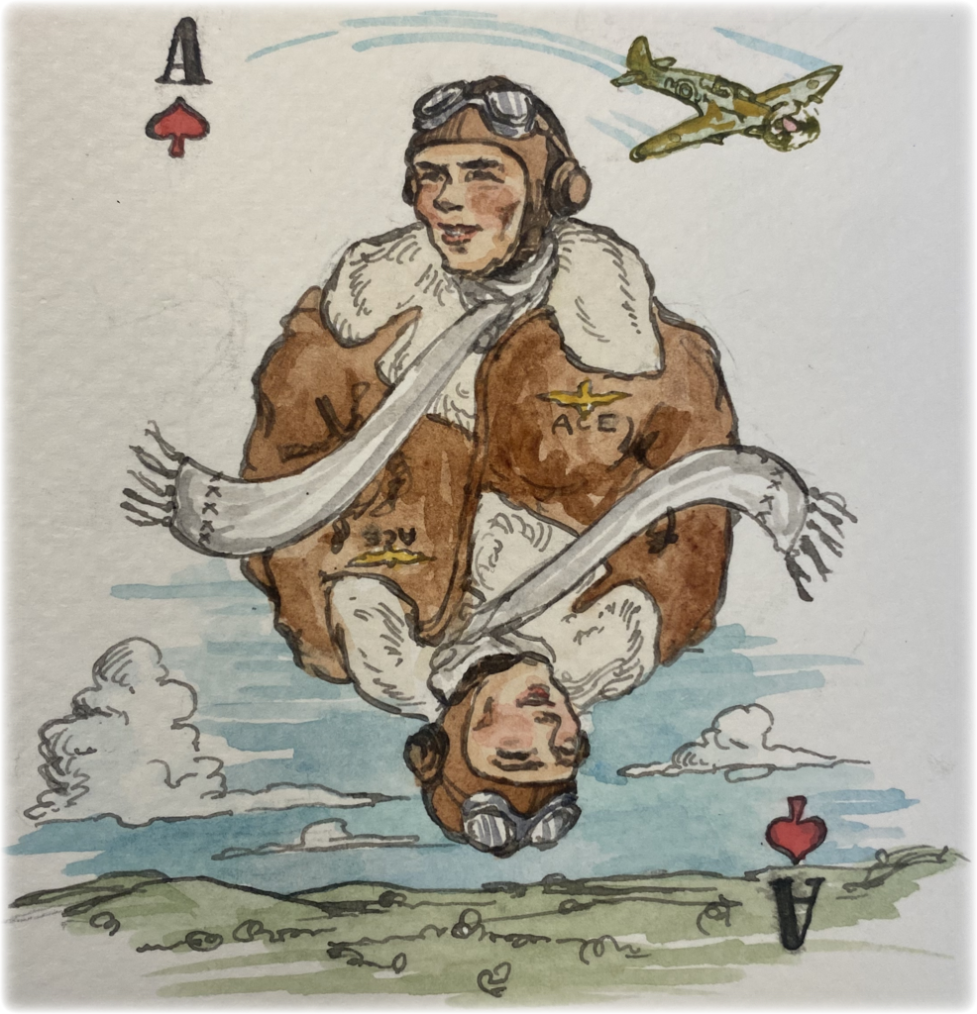

This image reminded me that VMA-131 in WWII were the Ace of Spades and not the Diamondbacks. Following that is the WWII one.

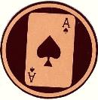 Squadron logo in World War II when they were

VMSB-131

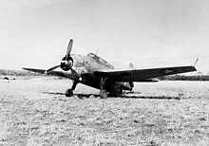 A VMSB-131 TBF-1 on Guadalcanal.

Our Diamondback squadron name and patch was created 15 April 1958 when the squadron was recommissioned. You can view the entire squadron history by on:

<https://en.wikipedia.org/wiki/VMA-131>

This link is also on our website homepage.