When I reported into MARTD at NAS, NY in late October, 1965, I was in an unsociable mood. I reported to the Sgt Major’s office. After checking in, I was told to go pick a rack and put away my gear. Then, I should report to the Master Guns out in the hanger.

As I walked through the barracks, I spotted an eight man cubicle with one occupied rack. I quickly put away my gear, and reported to the Master Guns. It was not until the next morning at wake up that I met Corporal Whitehall. I opened my eyes and looked at the rack across from me. There lay, what could have been a 230 pound bear, sleeping in just his skivvies shorts on a piece of plywood in front of an opened window. His mattress was on the rack above him. You guessed it, I just moved in with MARDT’s animal.

We tolerated each during my service at MARTD. And, we developed a speaking relationship (at times). Out of the blue on the Monday of Thanksgiving week, Cpl Whitehall asks me if I would join him in a visit to his mother's farm somewhere outside of Philadelphia. I had nothing planned so I said yes.

On Wednesday morning, I get dressed in civvies ready for the day's trip. Whitehall comes into our cube and looks at me. He says: change into Winter Service B. My mother is meeting us at the train station in Philly, and we must be in uniform. I responded "no way" and added that, if we go in uniform, one of two things will happen. We will either run into a bunch of peace lovers or get into an inter service fight. Well, I stayed in the barracks. Whitehall went off to Penn Station with a few other Marines who are not in uniform. (Ok, since they are not meeting his mother.) That was the last I heard about his tip until Monday morning when I reported to work at the line shack.

Picture of old Penn Station:

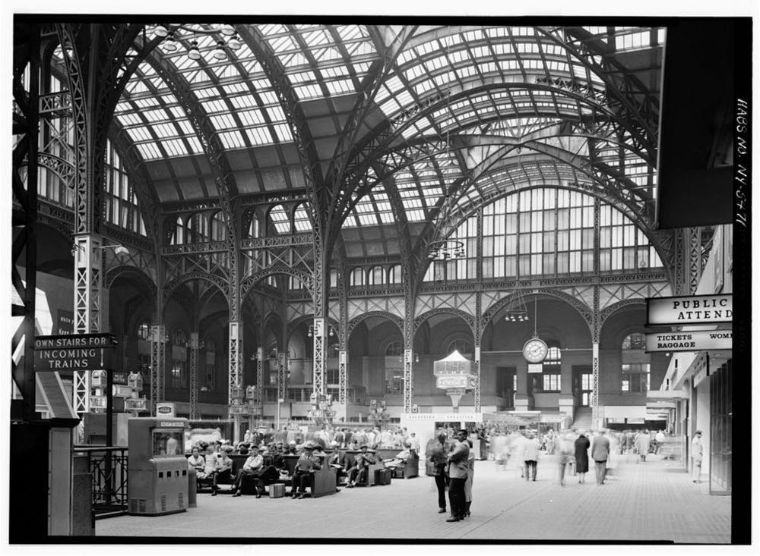

One of my fellow plane captains, who traveled with Whitehall, asked me: Did you hear what happened to Whitehall at Penn Station? I said no.

So, here is the event as told to me. About four of our Marines were with Whitehall sitting on a bench. Whitehall decides to have a smoke and walks about five feet away from them to have one. He is just standing there and four Green Berets in their version of winter service with bloused and highly shined boots walk by him and stop. The group was composed of a Lieutenant, a NCO, and two enlisted men. The Lieutenant walks up to Whitehall and says: "Marine". Whitehall puts out his smoke and comes to attention. They stand there for a minute or more and finally the officer says: You’re supposed to salute me, Corporal! Whitehall responds: Sir, I am uncovered and indoors. The Lieutenant looks up at the glass ceiling and says we are not indoors. Whitehall says: Sir, it keeps out rain, snow, and all the elements. It’s a roof. Suddenly, Whitehall in a catlike quick move bends down and snitches something and stands back up. In his hand is a huge railroad or subway RAT. He looks at the four greenie beanies. Then, he proceeds to bite off the rat's head and spits it out. He aims the headless rat at the Berets and the rat pulsates blood all over them and their uniforms. Whitehall says: You guys live off the land. Here’s a morning snack, and drops the rat at their feet. He turns and walks away through an astonished crowd not to be seen again. (I hope he went to a head to wash his hands and gaggle). I was also told that Whitehall didn’t get a drop of blood on his Winter Service A’s.

After the story was finished, I told my fellow plane captain thanks for the update. I added that Whitehall will never tell me about this encounter.

Brian Putney

Plane Captain

MARDT and VMA-131

At NAS, NY