Beware of a Pissed Off Marine | Against the Odds  
  
Let’s hope we still produce these kids.  
  
<https://youtu.be/n0N7l396cJI>

If this link does not work, report it to: [1965diamondback@gmail.com](https://d.docs.live.net/893b7d9935fc8fab/1965diamondback@gmail.com)

Attachments area

[Preview YouTube video Beware of a Pissed Off Marine | Against the Odds](https://www.youtube.com/watch?v=n0N7l396cJI&authuser=0" \t "_blank)

[[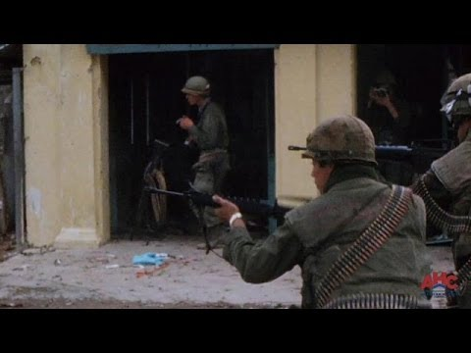](https://www.youtube.com/watch?v=n0N7l396cJI&authuser=0)](https://www.youtube.com/watch?v=n0N7l396cJI&authuser=0" \t "_blank)

[[](https://www.youtube.com/watch?v=n0N7l396cJI&authuser=0)](https://www.youtube.com/watch?v=n0N7l396cJI&authuser=0" \t "_blank)

**[Beware of a Pissed Off Marine | Against the Odds](https://www.youtube.com/watch?v=n0N7l396cJI&authuser=0" \t "_blank)**