---------- Original Message ----------   
From: Earl Robert Smith

Marine A-4 Skyhawk Memorial Complete at Quiet Waters Ranch

By [April](https://warriorsandquietwaters.org/author/susan/) | Aug 13, 2018 | [Quiet Waters Ranch](https://warriorsandquietwaters.org/category/quiet-waters-ranch/), [Uncategorized](https://warriorsandquietwaters.org/category/uncategorized/)

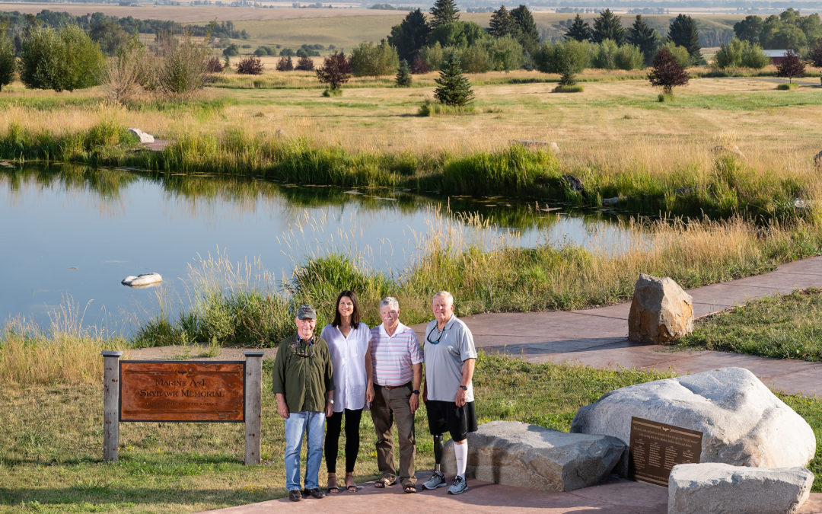

The following is a letter from Col Eric Hastings written to those who made monetary contributions to the A-4 Skyhawk Memorial. The people in the photo above are (L-R): Eric Hastings, Founder; Faye Nelson, Executive Director of WQW; Ed Brandt, Board Treasurer and Bernie Plassmeyer’s cousin; Jim Collins, Board Member and Memorial Committee Member.

I thought you might enjoy seeing the product of your *personal investment* in Warriors and Quiet Waters Foundation’s A-4 Skyhawk Memorial.  *Because of your generosity*this ADA-compatible fly fishing pond, stream, and pathway was completed at Quiet Waters Ranch.

This project was a labor of love for myself and my stalwart committee of eight: Eric Jones (Rico), Bob Hickerson (Raven), Pat Bole (Pipper), Dan Brannon (Dapper), Todd Frommelt (Hun), Bill Egen (Jigger), and Jim Collins (Red Dog) – all A-4 pilots and former Blacksheep but one. It was an opportunity to memorialize those “Skyhawkers’’ who gave the last full measure of their lives and love in support of Marines, Sailors, Soldiers and Airmen on the ground in Viet Nam. I know of no other memorial like this. I hope you like what, together*, we have created* and that you find your *investment* worthwhile. I know the nonambulatory warriors will love the access path and will fly fish the heck out of the pond!

I also know this may trigger many memories among you…of a time when you sought that violent perfection of placing your weapons precisely on a determined, elusive enemy bent on overwhelming Marines in close contact… *of creating legendary Close Air Support*…of escaping and doing it again, and again, and again under deadly circumstances…of squadron-mates and wingmen who pressed too close and paid the ultimate price.

*So, please come and visit your A-4 Skyhawk Memorial*, 15 miles north of scenic Bozeman, Montana. I assure you: you will be welcomed with open arms and open hearts. Here you can literally breathe in the serenity and beauty, joy and hope, love and camaraderie that is embodied in Warriors and Quiet Waters Foundation and Quiet Waters Ranch…and take some with you when you return home. Don’t forget your fly rod. Here you can peacefully catch and release a few Westslope Cutthroat trout. We don’t kill and eat them for they are too beautiful and wild!  Enjoy the photos. Again thank you for your support.

Semper Fidelis,

Sinus

Col Eric Hastings, USMC (Ret)

A-4 Skyhawk Memorial Sign

At the base of the Bridger Mountain Range.

The Memorial Plaque

Honoring those “Skyhawkers’’ who gave the last full measure of their lives and love in support of Marines, Sailors, Soldiers and Airmen on the ground in Viet Nam

The Skyhawk Memorial

The Skyhawk Memorial is comprised of an accessible pathway, rippling creek, and a pond stocked with Westslope Cutthroat Trout.