**Right Marine at the Right Place**

*Heir to an impressive South Asian military legacy, Captain ‘Harry’ Baig, USMC, was instrumental in the survival of besieged Khe Sanh Combat Base.*

**By Michael Archer**

**April 2021**

In February 1968, 6,000 U.S. servicemen found themselves encircled by nearly 30,000 North Vietnamese Army (NVA) soldiers at the isolated mountain outpost of Khe Sanh. Leaders in Hanoi and Washington, seeing no end to the Vietnam War, were desperate for a decisive victory that would force the other side to the negotiating table. Khe Sanh was where both decided to make that stand.

Fourteen years earlier, the Viet Minh Army had successfully engineered a similar scenario against French colonial forces by besieging and eventually capturing the isolated French garrison at Dien Bien Phu, which was eerily similar to Khe Sanh in geography and the attackers’ short supply lines from sanctuary areas in nearby Laos. Sapped by 56 days of artillery and rocket pounding, the French could not resist the final massive ground assault. France soon agreed to withdraw from Southeast Asia. Viet Minh leaders Ho Chi Minh and General Vo Nguyen Giap had stunned the world by defeating the army of a modern industrialized nation. The pair now sought to replicate that feat at Khe Sanh.

**A Cambridge-Educated Marine**

As ominous as the situation appeared for the outnumbered Marines at Khe Sanh, it was precisely what some U.S. military leaders had hoped for—luring their adversaries out into the open and destroying them by the thousands with the United States’ enormous advantage in air power.

The success of this gambit would rely on the courage and resolve of those beleaguered Marines—now bait in the trap—to hold on long enough for bombs, as well as artillery fire, to inflict such staggering attrition. Ultimately, the fate of those defenders would hinge on the talent and synergy of a small band of resourceful officers from several branches of the military and with varying specialties, all working in a small underground room, the Fire Support Coordination Center (FSCC), located in the base’s main command bunker. Within that cramped, poorly ventilated chamber, filled with tobacco smoke and the constant buzz of activity, this group was entrusted with the high-stakes responsibility of devising imaginative and effective artillery and bombing schemes amid the ever-changing flow of the battle swirling around them—at times just a few hundred yards away—with almost no margin for error.

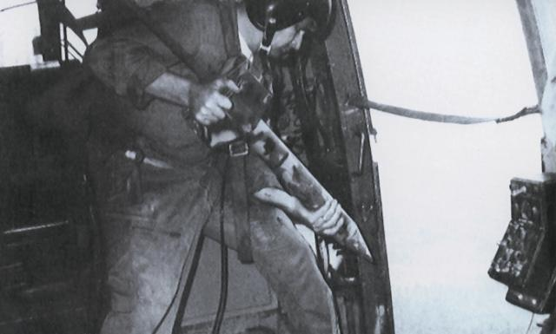

In early 1968, an airman prepares to drop a top-secret sensor near Khe Sanh. Baig largely taught himself how to translate the often-confusing sensor data into targeting information. As the British-educated officer eloquently described the learning process, “We were thrown as children into the river to swim on our own.”  Courtesy of the author

Chief among the group was 36-year-old Marine Captain Mirza Munir Baig, a Cambridge-educated immigrant born in India and heir to an impressive military tradition dating back hundreds of years. His grandfather had been the first Indian member of the British Cabinet and was later knighted by King George V, and his father was a renowned general in the British Colonial Army who became a distinguished international diplomat.

Possessing an aristocratic manner and posh British accent, bespectacled and scholarly Captain Baig seemed out of place amid the constant danger and deplorable, vermin-infested living conditions of besieged Khe Sanh. This, combined with his unusual, nonregulation accoutrements—including a large, wide-bladed ancestral *kukri*, or Gurkha knife, and a Boy Scout backpack he had purchased from Sears as a nod to his former, and only, civilian employer—gave many observers a first impression that the overly refined Baig lacked the toughness required to defeat the enemy surrounding them.

They would not have to wait long to learn why fate had placed this peculiar character in their midst. Called “Harry” by his fellow officers, Baig’s dual expertise in counterintelligence and artillery, accompanied by a steely sense of purpose and the instincts of a jungle predator, uniquely equipped him intellectually and temperamentally for the life-or-death challenges he was about to face.

**Early Inspiration**

During the late 1940s, Baig’s father, Osman, was stationed at the Pakistan embassy in Washington, D.C., and struck up a close friendship with artist Felix de Weldon, who was then in the process of creating the Marine Corps Memorial, featuring a 100-ton, bronze sculpture depicting the iconic flag-raising atop Mount Suribachi on Iwo Jima. When the Baig family visited the de Weldon studio, young Munir was captivated and inspired by a small prototype of the statue and his father’s comment that “the United States Marine Corps is the only real military organization left in the world.” Munir decided right then that the best way to achieve his dreams of glory in battle was to become a Marine officer.

In late 1956, two years after de Weldon’s monument was unveiled in Arlington, Virginia, the artist took 18-year-old Munir Baig directly to the Commandant of the Marine Corps, General Randolph McCall Pate, who explained to the young man that, despite his exceptional education and prestigious family background, federal law required that all military officers be U.S. citizens—though, this rule did not apply to enlistees.

Baig, who was then classified as a resident alien but still confident in his sense of personal destiny, enlisted in the Marines and was promptly shipped off to boot camp at Parris Island, South Carolina. On receiving his U.S. citizenship in 1960, Sergeant Baig was immediately accepted to Officer Candidate School.

**Mastering a New Intel System**

By 1963, Baig was engaged in clandestine counterintelligence work along the dangerous Demilitarized Zone in Vietnam. He became adept at using defectors, spies, and radio intercept intelligence to ascertain information on enemy troop strength, locations, and intentions. Yet on arriving at Khe Sanh on 23 January 1968, with two NVA infantry divisions supported by artillery and armored battalions now to be accounted for, Baig needed something more. This led to what was perhaps his greatest personal achievement: teaching himself to use an entirely new top-secret, highly complex system of acoustic and seismic sensors carefully deployed by aircraft alongside roadways and trails in the Khe Sanh area. This technology was so secret that few in the U.S. military knew about it.

Captain Baig’s prior knowledge of the system was limited and theoretical. In the summer of 1966, he had been invited to a well-guarded meeting in Santa Barbara, California, to assist a group of world-class scientists who gathered every summer to tackle problems the Department of Defense could not solve. There, Baig’s expertise in NVA infiltration methods helped the experts determine the practicality of such a sensor system. Just 18 months later, Captain Baig and fellow officers, now in the midst of battle, were called on to quickly master this untested system. Failure to do so could prove disastrous. In addition to Baig, who was the 26th Marines’ target information officer, key members of the intelligence and targeting team included 3d Marine Division intelligence representative Major Robert Coolidge and 26th Marines intelligence officer Major Jerry Hudson.

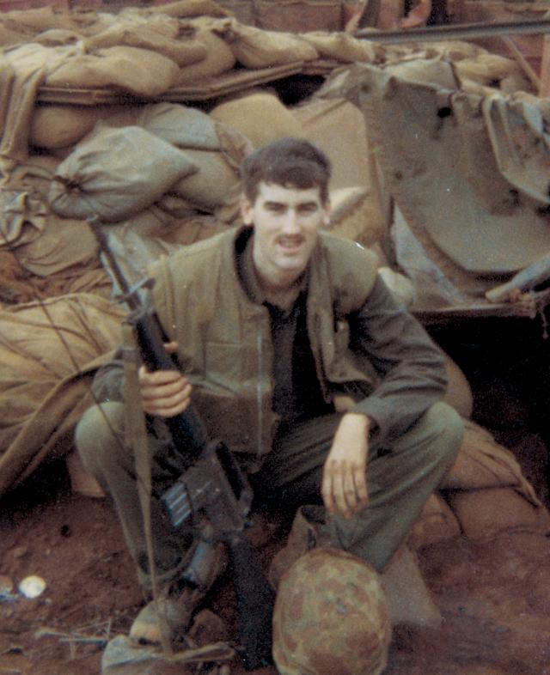

The author, pictured at Khe Sanh, observed Baig up close, serving as his radio operator during the siege. On the day the captain arrived, the private first class saw him target an enemy artillery piece after studying a crater and bit of shrapnel from one of its shells. Courtesy of the author

After an enemy artillery shell exploded nearby during his first day at Khe Sanh, Baig exited the command bunker in search of the resulting crater. On finding it, he bent a knee to the ground and measured its dimensions with a retractable tape measure. He then searched the immediate area until he found a thumb-sized piece of shrapnel, still so hot he had to bounce it in his palm. After a brief examination of the shard, he dropped it, returned below ground to his makeshift desk, and plotted a coordinate on his map. He then requested an artillery mission on a target south of the base, where he reckoned the gun that fired the shell was located. When no further firing was recorded from that location, those around the newly arrived Captain Baig began to suspect he had a special gift.

**Sensing the Enemy’s Moves**

Within a week, Baig had developed reliable and real-time intelligence, largely based on sensor data, indicating that thousands of enemy troops had begun staging for a massive, human-wave attack to capture Khe Sanh. Hundreds of them already were dug in close to the Marines’ southern perimeter. The NVA operational plan was to race across relatively flat terrain in the dead of night and quickly breach the base’s barbed-wire perimeter with explosive charges. Then, crack assault troops would flood into the interior of the combat base.

Rather than targeting these enemy forces closest to the base, Captain Baig gambled there was sufficient time to first cripple their command and supply chain. Extending out for miles along the main approaches to the combat base, the communist forces were constructing hidden bunker complexes; antiaircraft, mortar, and artillery positions; ammunition dumps; logistic areas; and fuel dumps and maintenance parks for their vehicles.

Relying on his experience and scholarship, Baig perceived that his adversaries’ plan would adhere to the siege tactics used so successfully in capturing Dien Bien Phu and modified after the 1967 NVA investment of the Marine base at Con Thien. The enemy would not disappoint him. By studying the predictable NVA methods, he was able to discern details few others could. For example, the enemy constructed their positions around Khe Sanh using the same inflexible formula in layout, dimensions, and even spacing between locations they had used for decades—what Baig termed “doctrinal position area engineering.” Therefore, it was necessary to identify only a small portion of a camouflaged position to be able to destroy the rest of it and to determine where other positions were in proximity to it, often eliminating them sight unseen.

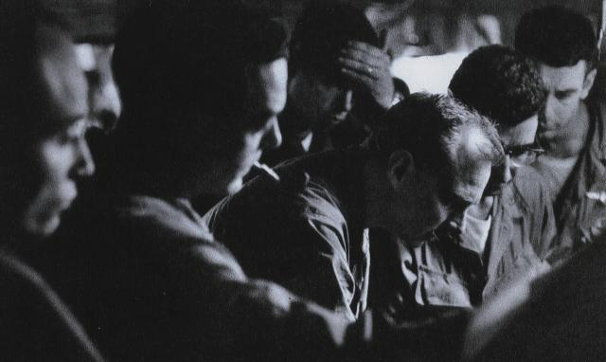

During a tense moment in the main Khe Sanh command bunker, officers gather around Baig’s target map as the captain (second from right) briefs the base’s commander, Colonel David E. Lownds (third from right). Baig’s targeting for B-52 strikes played a key role in defeating a major enemy attack on the night of 29 February–1 March. Courtesy of David Douglas Duncan

After studying an aerial reconnaissance photograph one evening, Baig recognized faint truck tire tracks in the dust leading up to a hill about two miles from the combat base. Applying his unique expertise, he concluded the hill was the site of a significant NVA ammunition dump. He called in bombers that attacked the site, which burned and continued to erupt in secondary explosions. After just a few moments of analysis, Baig had discovered a large ordnance depot that had taken the NVA the better part of a year to secretly stockpile.

He and FSCC colleague Captain Kent Steen, the 26th Marines’ assistant fire support coordinator, left the command bunker to see the results for themselves. As they stood watching the pyrotechnics, a large 4.2-inch mortar shell—probably a “short round” from a Marine battery, but one that had traveled far enough to be fully armed—bounced in front of Baig and rolled to a stop at his feet. Miraculously, it did not go off. Steen was astonished by Baig’s composure and asked if he were frightened, to which he quietly replied, “No, it is not my time.” As another fellow officer in the command bunker later wrote, “Harry was absolutely fearless.”

**Turning Back the NVA**

During the following weeks, U.S. artillery and aircraft used Baig’s targeting information to inflict tremendous damage to the enemy’s hidden gun positions, command-and-control facilities, and supply and support locations. The captain then turned his attention to enemy forces closer to the southern perimeter. At the time, NVA strategists believed they held an advantage in that Pentagon rules of engagement prohibited the use of the deadliest conventional U.S. weapon—B-52 strategic bombers—within 3,000 meters of friendly forces. Astutely, enemy forces were moved as close as possible to the Marines.

Baig and his fellow Khe Sanh FSCC officers, knowing that the dire situation required flexibility, petitioned for a modification of the rules. As their request slowly worked its way up the chain of command, defenders at Khe Sanh anxiously waited and watched. Then, a few days before the NVA was to launch its attack, special permission arrived allowing B-52s to waive the 3,000-meter restriction.

On 27 February, Baig directed the first B-52 strike under the new rules of engagement on Khe Sanh village, where his intelligence sources told him NVA troops and tanks were assembling for the attack among the civilian inhabitants. The bombing knocked out much of the enemy presence there, but also likely killed hundreds of civilians.

At 2200 on the night of 29 February–1 March, North Vietnamese artillery commenced a bombardment of Khe Sanh, signaling the beginning of the long-anticipated attack. Captain Baig’s team had identified two target areas behind what was estimated to be a battalion of enemy troops massed near the southern perimeter. The areas contained 12 artillery positions, two ammunition dumps, and another battalion of troops. When NVA artillery opened fire, Khe Sanh commanders requested that two B-52 strikes that already were in the air be redirected to hit the target areas. Hundreds of bombs exploded close enough to the base that ground shock waves shook the command bunker for several minutes. With each succeeding quake, Baig grew more confident that Khe Sanh Combat Base would be spared.

Meanwhile, U.S. artillery, Marines, and South Vietnamese Army Rangers opened fire on attacking enemy troops, none of whom were able to reach the base’s perimeter wire. Baig’s intelligence network and targeting data had proved instrumental in defeating the large-scale attack.

**‘Matched against a Master’**

Ultimately, the salvation of Khe Sanh on 29 February–1 March was contingent on Baig’s self-initiative and the fact that he came to those remote mountains with a keen awareness of his own personal destiny and a few well-thumbed volumes of antiquated British, French, and Vietnamese military warfare techniques. It was as if he had been rehearsing for his entire life to step on to a stage like Khe Sanh and shape the course of history.

Veteran combat photojournalist David Douglas Duncan later wrote: “[Khe Sanh] was the biggest chess game played in Vietnam, with General Giap matched against a master, in Baig, who anticipated his every move.” Baig’s closest colleague in the command bunker, Captain Steen, later said: “With the perspective of age, I realize the Marine Corps attracts strongly put together people, but Harry was clearly of another genius. The rest of us were probably interchangeable—Harry was one of a kind.”

After the siege ended in April 1968, some news reporters and historians chose to believe that the NVA never intended to capture the Khe Sanh base. Despite tens of thousands of their troops being sacrificed and the expenditure of enormous amounts of precious ammunition and other matériel, its activity around Khe Sanh was seen as nothing more than an elaborate decoy to keep those Marines, and the aerial resources necessary to sustain them, from being redeployed to fight in concurrent, widespread battles across South Vietnam during the Tet Offensive.

Such a conclusion is almost understandable given that, for many years after the war, few fully understood Captain Baig’s decisive role—a rare case of the right person appearing at the right moment in history. It would be decades before declassification of U.S. records and the discovery of reliable Vietnamese military reports detailing the grisly effectiveness of Baig’s efforts in thwarting their master plan became available. When overlaid chronologically, these dual accounts make a persuasive case that Baig regularly exercised an uncanny “sixth sense.” But he actually had a profound understanding of NVA methods and mind-set, to anticipate their movements and to identify and destroy barely perceptible fortifications and artillery emplacements.

**An Untimely End**

Three years after leaving Khe Sanh, now promoted to major, Baig, his wife, and daughter were killed under suspicious circumstances in a Bangkok hotel fire after he had participated in a secret intelligence operation against NVA forces in neighboring Laos. At his funeral service at Arlington National Cemetery, sibling Taimur Baig, who knew nothing of his brother’s work, was astounded so many generals (including a former and the current Commandant of the Marine Corps), admirals, high-level members in the intelligence community, and other dignitaries “would come out for the funeral of a major.”

Major Mirza Munir Baig, one of the most unlikely heroes in Marine Corps history, lived and died in relative obscurity. He had saved the lives of countless Marines at Khe Sanh, while depriving a numerically superior foe of a stunning triumph, one that may well have changed the course of the war. To the end, he served his adoptive country like few others could have, in the uniform of—what he never doubted to be—“the only real military organization left in the world.”