**The Incredible Saga of OSS Col. Peter J. Ortiz in World War II**

**A Marine in the OSS**

**BY**[**DWIGHT JON ZIMMERMAN**](https://www.defensemedianetwork.com/author/dwight-jon-zimmerman/)**- JULY 20, 2014**

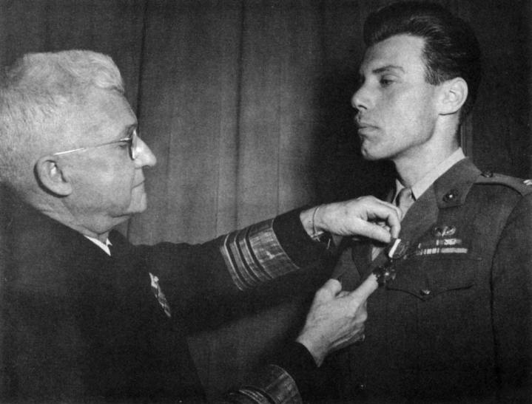

**One U.S. Marine assigned to covert activities in Europe with the Office of Strategic Services (OSS) was Capt. Peter J. Ortiz, who was twice decorated with the Navy Cross. Here he receives his first Navy Cross from Adm. Harold R. Stark in London, U.K. Photo courtesy of Dick Camp**

Approximately 80 officers and 200 enlisted men from the Marine Corps served in the [Office of Strategic Services (OSS)](https://www.defensemedianetwork.com/stories/american-special-operations-gets-its-start-the-oss/) during World War II. In that group was one of the most decorated Marines in World War II and the most decorated member of the OSS, Col. Pierre “Peter” Julien Ortiz, U.S. Marine Corps Reserve, whose military career actually began in the French Foreign Legion. Tall, handsome, urbane, and sophisticated, Ortiz spoke 10 languages and was fluent in several, including French and Arabic. His decorations include two Navy Crosses, the Legion of Merit with Valor device, two Purple Hearts, the Ouissam Alaouite, five Croix de Guerre, the Croix du Combattants, the Médaille des Blesses, the Médaille des Evadés, the Médaille Colonial, Chevalier of the Légion d’honneur, and Order of the British Empire, among others. His exploits during the war combined aspects of Errol Flynn, Chesty Puller, and James Bond.

Ortiz was born in New York City in 1913 to an American mother and a French-Spanish father who was prominent in the French publishing industry. After a childhood spent in Southern California, his father sent Peter and his older sister, Inez, to French boarding schools to complete their education. Despite achieving good grades, Ortiz was bored with college, and in 1932, at age 19 and craving adventure, he enlisted in the French Foreign Legion. He found the adventure he sought in the Moroccan Rif, where he earned his first two Croix de Guerre fighting Rif Berbers.

Discharged in 1937 with the rank of sergeant, he returned to Southern California, where he worked in Hollywood as a technical adviser on war films. With the outbreak of World War II in 1939, Ortiz re-enlisted in the Legion and was commissioned a lieutenant. Wounded and captured by the Germans during the Battle of France in 1940, he successfully escaped after about a year-and-a-half as a POW, and eventually made his way back to the United States. Ortiz offered his services to the U.S. Army Air Corps, who promised him a commission. But impatient over the delays in processing his paperwork, on June 22, 1942, he enlisted in the Marines.

[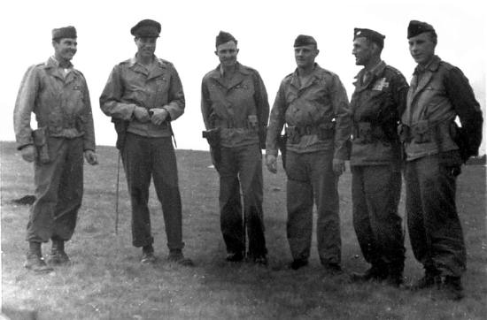](https://i0.wp.com/www.defensemedianetwork.com/wp-content/uploads/2014/07/Operation-Union-II-team.jpg?ssl=1)

**The Operation Union II team the day after the jump into occupied France, Aug. 2, 1944. From left: Sgt. John Bodnar, Maj. Peter J. Ortiz, Sgt. Robert LaSalle, Sgt. Fred Brunner, Capt. Frank Coolidge, and Sgt. Jack Risler. All except Coolidge were Marines. Photo courtesy of Laura Lacey**

His presence in formation for the first time at Parris Island became a learning moment for everyone present when the drill instructor (DI) balefully noticed the decorations on recruit Ortiz’s chest. Two weeks after the DI had vocally satisfied his curiosity regarding the identity and provenance of said decorations, the Parris Island commander was writing to the commandant of the Marine Corps requesting confirmation of Ortiz’s service in the French Foreign Legion, noting Ortiz was a “unique new recruit” with “knowledge of military matters … far beyond that of a normal recruit” and recommended that Ortiz receive a commission. On Aug. 16, Ortiz was commissioned a second lieutenant in the Marine Corps, retroactive from July 24, 1942.

**With the outbreak of World War II in 1939, Ortiz re-enlisted in the Legion and was commissioned a lieutenant. Wounded and captured by the Germans during the Battle of France in 1940, he successfully escaped after about a year-and-a-half as a POW, and eventually made his way back to the United States.**

Initially, he was assigned as an assistant training officer at Camp Lejeune. Two months later, Ortiz was sent to the New River Parachute Training School. Having previously completed parachutist training in the Legion and with 154 jumps under his belt, Ortiz took his re-education with good humor, later saying, “The Legion had its way and the Marine Corps had the right way; I never minded jumping. Airplane travel always made me sick, so I was happy to jump out.”

In the wake of the successful Allied landings in French Northwest Africa in Operation Torch, because of his language skills and Légionnaire’s experience in the region, Ortiz received a promotion to captain and [assignment to the OSS](https://www.defensemedianetwork.com/stories/american-special-operations-gets-its-start-the-oss/). On Jan. 13, 1943, he arrived in Morocco officially as assistant naval attaché and Marine Corps observer, Algiers. But that was just a cover. His real assignment was that of a member of an OSS team working with Britain’s [Special Operations Executive (SOE)](https://www.defensemedianetwork.com/stories/soes-dangerous-white-mouse-nancy-wake/) along the Tunisian border in Operation Brandon.

In [*War Report of the OSS*](https://www.amazon.com/gp/product/0802705294/ref=as_li_qf_sp_asin_il_tl?ie=UTF8&tag=faircount-20&camp=1789&creative=9325&linkCode=as2&creativeASIN=0802705294&linkId=40e87f9c7fa87d5cee0f5eb7b329c7c8), the official history of [OSS operations](https://www.defensemedianetwork.com/stories/office-of-strategic-services-oss-70th-anniversary/) in World War II, Kermit Roosevelt wrote, “Participation in this British operation constituted the first OSS experience in sabotage and combat intelligence teams in front areas and behind enemy lines. That the jobs actually done by the handful of OSS men who joined in the SOE Tunisian campaign were not typical of future activity was due as much to the exigencies of the battle situation as to the misunderstanding of their function by the British and American Army officers whom they served.” In other words, instead of collecting intelligence and conducting sabotage, the teams were sent on reconnaissance missions and ordered to find and kill Germans.

In February, Ortiz was in Gafsa when the [Battle of Kasserine Pass](https://www.defensemedianetwork.com/stories/command-failure-lloyd-fredendall-and-the-battle-of-kasserine-pass/) was launched. During the action Ortiz literally found himself traveling all across the battlefield. He witnessed the panicked flight of American soldiers during the opening hours of the German offensive, briefly fought with an armored reconnaissance unit from the British Derbyshire Yeomanry, then linked up and fought with elements of the American 1st Armored Division. Upon crossing paths with an old Légionnaire friend who was now a captain, Ortiz attached himself to his friend’s unit and fought a desperate action near Pichon.

In March, he was given a series of covert deep penetration reconnaissance missions. One mission, launched on March 18 in and around Matleg Pass in support of Brig. Gen. Paul Robinett’s Combat Command B headquartered at Bir-el-Hatig, almost cost Ortiz his life. After setting up a base camp, at 2300, Ortiz struck off alone in search of enemy tanks. It had been raining for three days, and his progress was hampered by knee-deep mud. Just as he was about to turn back, a burst of automatic fire shattered his right hand and wounded him in the leg. Ortiz fell to the ground and spotted a machine gun and vehicle about 30 yards ahead. Rising to one knee with his good left hand he threw a Mills grenade that fell short, followed by a Petard grenade [probably a MK 74 “sticky bomb”] that scored a direct hit. Avoiding rifle fire, and despite loss of blood and suffering from shock, Ortiz managed to crawl back to the base camp and, with his team’s help, make it to friendly lines. During his convalescence, Ortiz was airlifted back to Washington, D.C., where he wrote a detailed report of his experiences for OSS Commander Col. William J. Donovan. After reading it, Donovan wrote across the top of the first page, “Very interesting, please re-employ this man as soon as possible.”

When Ortiz recovered, he was sent to the Congressional Country Club near Washington, D.C., to begin training for his new assignment as a member of the multinational [Jedburghs](https://www.defensemedianetwork.com/stories/interview-with-maj-gen-john-k-singlaub-u-s-army-ret/). By the end of December 1943, he had completed training and was ready for his new assignment.

**He then returned to the club and approached the German officers. Ortiz ordered drinks for them, then doffed his raincoat to reveal his dress Marine Corps uniform complete with badges and decorations, and aimed his pistols at the stunned officers. “A toast to the president of the United States,” he said. After the Germans had downed their drinks, Ortiz ordered another round and said, “A toast, to the Marine Corps.” Some accounts have him then shooting the officers, killing them.**

On Jan. 6, 1944, Ortiz, British Col. H.H.A. Thackthwaite, and Frenchman Andre “Monnier” Foucault, regarded as one of the best radio operators in the OSS, and their weapons and supplies were parachuted into the Haute-Savoie departement of the French Alps in Operation Union I.

Union I’s mission was to assess the military capabilities of maquis units in the Savoie, Isere, and Drôme departements and assist in the organization and supply of the units. After landing, Thackthwaite and Ortiz changed from their standard issue civilian jump clothes to their military uniforms, thus becoming “the first Allied officers to appear in uniform in [occupied] France since 1940.” In Ortiz’s case, it was his Marine Corps service uniform with all its badges and French combat and campaign ribbons, the better to impress the French Resistance fighters they planned to meet. But his intention didn’t stop with impressing just the maquis. As Thackthwaite later wrote, “Ortiz, who knew not fear, did not hesitate to wear his U.S. Marine captain’s uniform in town and country alike; this cheered the French but alerted the Germans, and the mission was constantly on the move.”

[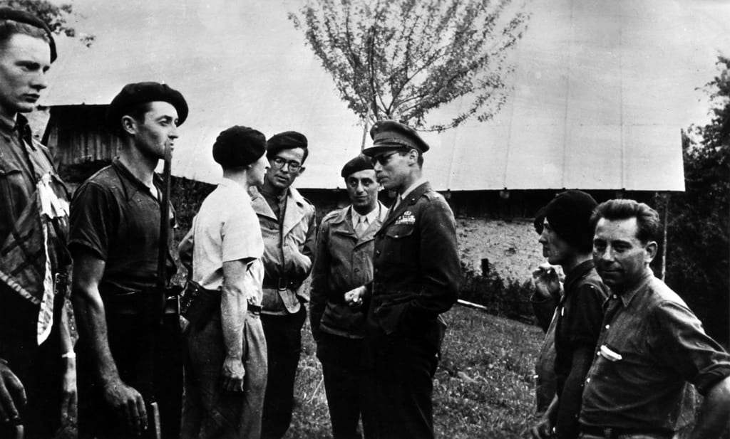](https://i0.wp.com/www.defensemedianetwork.com/wp-content/uploads/2014/07/Ortiz-French-maquis.jpg?ssl=1)

**Maj. Peter J. Ortiz inspects members of the French maquis near Albertville, France, Aug. 7, 1944. Photo courtesy of Laura Lacey**

What the Union I team discovered was that there were many maquis willing to fight in the Resistance, but they had little means to do so. The maquis needed everything from arms and ammunition to radios, money, and blankets – every imaginable supply needed for military operations. The team organized base camps and hospitals and arranged for families of Resistance members to receive stipends, which helped boost morale among the maquis. As weapons and explosives arrived, the team trained the maquis in their use. Wearing his Marine Corps uniform, Ortiz helped lead sabotage missions, believing his uniform and medals would steel the French fighters’ courage. He also was instrumental in helping downed Allied airmen evade the Germans and reach safety in Spain.

His role in rescuing four RAF officers in February 1944 resulted in him committing a spectacular act of theft that infuriated the Gestapo and led to him ultimately receiving the Order of the British Empire. According to his OBE citation, “In the course of his efforts to obtain the release of these officers, he raided a German military garage and took ten Gestapo [vehicles] which he used frequently. He procured a Gestapo pass for his own use in spite of the fact that he was well known by the enemy.”

It was also during this period that Ortiz, who by now had garnered a notorious reputation with the Germans, committed an even greater act of derring-do, a Hollywood-style confrontation between himself and some German officers that, though true, makes for one hell of a sea story. Accounts vary in some of the details. What follows is one version.

A group of officers from the German 157th Division, which had previously suffered at the hands of Ortiz and the maquis, were in the bar of a club (in a town, sadly, unknown) Ortiz occasionally visited and were loudly cursing the “tall American Marine” (Ortiz), the Allies, President Franklin Roosevelt, and the U.S. Marine Corps, among others.

Ortiz, who was sitting nearby and dressed in civilian clothes, determined that he had heard enough. He returned to his safe house and donned his Marine Corps uniform and brace of Colt Model 1911 pistols over which he pulled on his raincoat. He then returned to the club and approached the German officers. Ortiz ordered drinks for them, then doffed his raincoat to reveal his dress Marine Corps uniform complete with badges and decorations, and aimed his pistols at the stunned officers. “A toast to the president of the United States,” he said. After the Germans had downed their drinks, Ortiz ordered another round and said, “A toast, to the Marine Corps.”

Some accounts have him then shooting the officers, killing them. Ortiz said that he escaped without killing the officers because by letting them live, the story of his action would boost even more his legend and further erode German morale.

While it seems improbable for him to be wearing his service uniform with decorations, that detail cannot be dismissed out of hand. Different, reliable accounts agree that on his two missions to occupied France (Union I and Union II) he did carry his Marine Corps uniform. Also, when he returned to France in August 1944 in Operation Union II, maquis leader Raymond Bertand, a professional photographer, took photographs of Ortiz, now a major, in his Marine Corps service uniform in which his badges and ribbons are clearly seen, near German-held Albertville. Those photographs were reproduced in a [California State Military Museum biography of Ortiz by Benis Frank](http://www.militarymuseum.org/Ortiz.html).

Union I was terminated on May 20, and the team was airlifted back to England to await reassignment. During this period Ortiz received his first Navy Cross for his actions in Union I and was promoted to major.

On Aug. 1, 1944, Ortiz returned to the Haute-Savoie as leader of Operation Union II with a team composed of fellow Marines Gunnery Sgt. Robert LaSalle, Sgts. Charles Perry, John Bodnar, Fred Brunner, and Jack Risler, Army Air Force Capt. John Coolidge, and Joseph Arcelin, a Free French officer carrying papers identifying him as a Marine. Union II’s mission reflected the OSS’ changed priorities following D-Day and the impending Operation Dragoon, the Allied landings in the South of France. Union II was an Operational Group, a heavily armed force capable of “direct action” against German troops as they retreated to Germany.

**Ortiz and his men would surrender, provided Kolb would give his word that the townspeople would not be harmed. Thinking he opposed a company-sized unit, Kolb agreed. The Germans were thunderstruck, and Kolb was furious, when only Bodnar and Risler emerged.**

As well as sabotage, Union II-led maquis units were to seize and hold key installations and prevent their destruction by the Germans. In addition to the team, 864 containers were air dropped to supply their contact, the Free French “Bulle Battalion.” Despite ideal conditions and a daylight drop, the mission began badly – with Perry’s chute malfunctioning, causing him to fall to his death – and soon unraveled.

[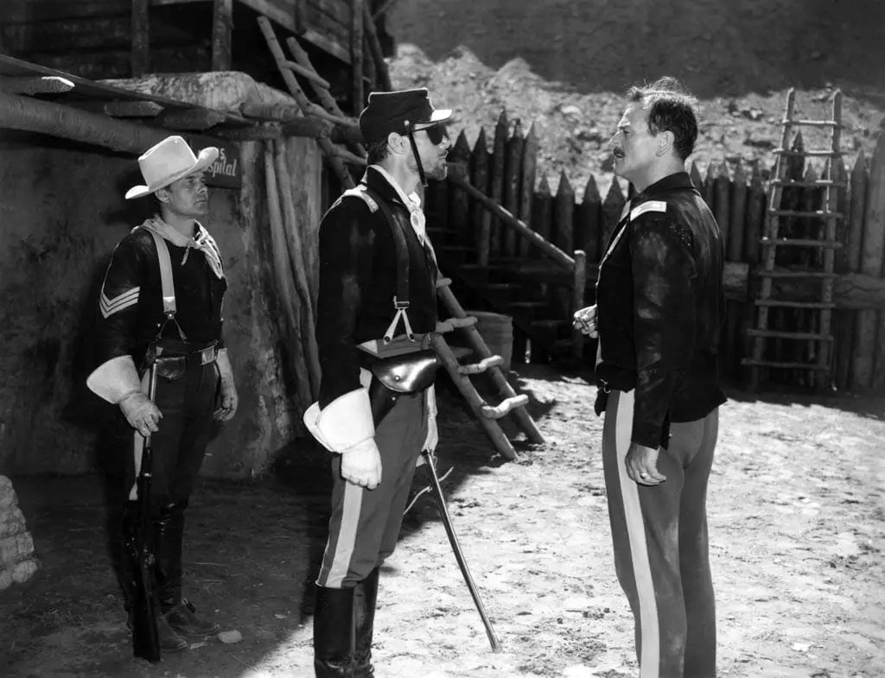](https://i0.wp.com/www.defensemedianetwork.com/wp-content/uploads/2014/07/John-Wayne-Peter-Ortiz.jpg?ssl=1)

**Col. Peter J. Ortiz (left) and John Wayne during filming for the 1950 western movie Rio Grande. In the film, Ortiz played Capt. St. Jacques. Photo courtesy of Charles Pinck**

German troops in the area refused to be cowed. On Aug. 14, Ortiz and his men found themselves far from their operational base, surrounded in unfamiliar mountainous terrain where they narrowly escaped capture. Two days later, their luck ran out.

En route back to their base, they encountered a German troop convoy in the village of Centron. The team split into two groups, with Coolidge and Arcelin in one group and Ortiz, Risler, and Bodnar in the second. House-to-house fighting ensued, with Ortiz and his Marines drawing the bulk of the Germans’ attention. Reminded by villagers of recent German reprisals against civilians who were caught with the maquisards and Jedburghs, after conferring with Risler and Bodnar, Ortiz agreed to surrender.

Ortiz called out in English, French, and German his desire to parley. Then, unarmed, he ignored German gunfire and began boldly walking toward the German lines. An old Frenchwoman ran up in an attempt to shield him with her body. He gently disengaged himself from her. When the bullets stopped, he made his proposal to the German commander, Maj. Kolb. Ortiz and his men would surrender, provided Kolb would give his word that the townspeople would not be harmed. Thinking he opposed a company-sized unit, Kolb agreed. The Germans were thunderstruck, and Kolb was furious, when only Bodnar and Risler emerged.

Coolidge and Arcelin were also captured, with Arcelin rejoining at one point Ortiz, Bodnar, and Risler. Despite speaking no English, the Germans accepted the claim that Arcelin was a Marine. During their trip into captivity, Kolb talked with Ortiz and revealed so much about Ortiz and his mission that Ortiz became certain that there was a spy among the [maquis](https://www.defensemedianetwork.com/stories/the-death-of-jean-moulin-the-french-resistance-gets-its-greatest-martyr/) with whom he fought.

Despite attempts to escape, Ortiz finished out the war a POW. He received a Gold Star to his Navy Cross for his service in Union II. In 1946, Ortiz was discharged from active duty. He remained in the Marine Corps Reserve, finally retiring on March 1, 1955, promoted to colonel on the retired list.

Ortiz returned to Hollywood in 1946 and resumed his career in the movie industry. Two movies loosely based on his life were released, [*13 Rue Madeline*](http://en.wikipedia.org/wiki/13_Rue_Madeleine) (1947) starring James Cagney, and [*Operation Secret*](http://www.imdb.com/title/tt0044999/) (1952) starring Cornel Wilde. Ortiz served as technical adviser and had cameos in both. He formed a friendship with and appeared in several movies by director John Ford. He also appeared in movies by producer Joseph H. Lewis and appeared in two John Wayne movies, [*Rio Grande*](http://en.wikipedia.org/wiki/Rio_Grande_%28film%29) and [*The Wings of Eagles*](http://en.wikipedia.org/wiki/The_Wings_of_Eagles). A still from *Rio Grande* shows Ortiz, in the role of Capt. St. Jacques, wearing his Légion d’honneur.

Ortiz died on May 16, 1988, at age 74. He was buried with full military honors at Arlington National Cemetery. In addition to a Marine Corps honor guard, the funeral was attended by representatives from the French and British military, his Union II comrades Bodnar and Risler, and members of his family, including his son, Lt. Col. Pierre Ortiz, Jr., USMC.

*This article was first published in* The Year in Special Operations: 2014-2015 Edition.