**The U.S. Marines’ mythic fight at Belleau Wood**

David T. Zabecki

1 day ago

AddThis Sharing Buttons

Share to Facebook

Share to TwitterShare to EmailShare to More

18

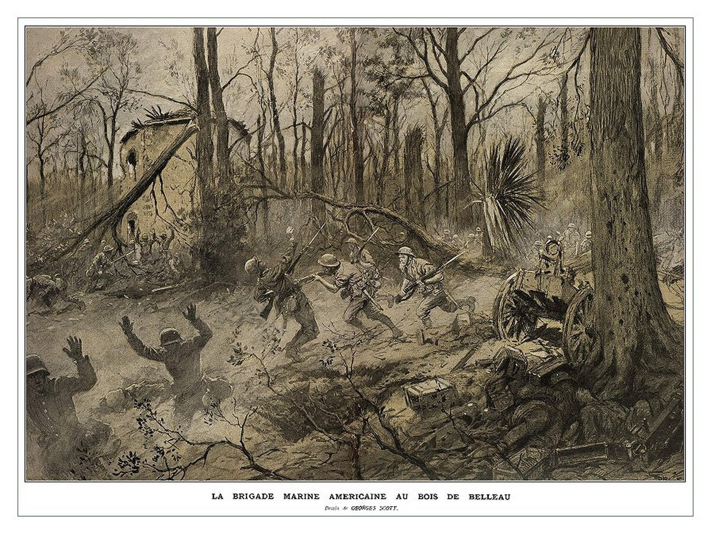By every tactical measure of the time the Marines should have been annihilated; but they weren’t. (Danish Wikipedia)

**Piercing the fog of war to separate legend from fact.**

Many historians consider the June 1918 Battle of Belleau Wood thedefining event in the history of the U.S. Marine Corps. As the Corps’ first large-scale engagement, this World War I battle foreshadowed epic Marine battles to come, from Guadalcanal to Fallujah. Belleau Wood is also a touchstone of Marine mythology, popularly known as the fight in which the Marines — outnumbered and poorly supported by the French forces to which they were attached — almost single-handedly prevented Paris’ capture by a German army intent on destroying the French capital.

But does history support this long-held interpretation of the battle? At 1700 hours on June 6, 1918, the 4th Marine Brigade — comprising the 5th and 6th Marine Regiments and the 6th Machine Gun Battalion — attacked into the densely wooded former hunting preserve near the French village of Belleau to push back elements of the German 237th Division. But the commander of the French XXI Corps who had ordered the attack had vastly underestimated the hold the Germans had on the woods and consequently failed to support the Marines with sufficient heavy artillery. By the end of the first day the Marines had suffered 1,087 dead or wounded, more casualties than the Corps had taken thus far in its 143-year history. The Marines kept fighting, however, and by June 26 they had secured Belleau Wood. The combined casualty count for U.S. Marine and Army units committed to the battle totaled 1,811 dead and 7,966 wounded.

As costly as the battle was, the Marines had proved conclusively they could engage and defeat soldiers from one of the world’s best armies. Many of the Corps’ senior leaders during and after World War II had been junior officers and NCOs at Belleau Wood, and their experience has shaped the ethos of the Marines to the present. As is often the case with epic and heroic battles, Belleau Wood has spawned many legends. For example, the Marines’ semiofficial nickname “Devil Dogs” supposedly came from the term Teufel Hunden, given them by the Germans they faced in France (Marine historian Brig. Gen. Edwin H. Simmons, among others, disputes whether that name originated with the Germans, pointing out that the grammatically correct rendering would be Teufelshunde).

Another legend arising from Belleau Wood is that the lone Marine brigade had stopped Operation Blücher, the 42-division attack the Germans had launched on May 27—and, in thwarting that attack, the Marines had prevented the Germans from capturing Paris and thereby winning the war. Indeed, since 1918 many books and articles have cited “the German drive to Paris” and credited the Marines with stopping it. That makes a great story, but the overwhelming weight of historical evidence indicates that no such thing happened. Furthermore, the strategic and operational realities of 1918 make it clear just how improbable such a scenario was.

At the strategic level it is a stretch to conclude that the fall of Paris would have led automatically to an Allied collapse. By June 1918 Britain’s Royal Navy had imposed a nearly four-year stranglehold blockade on Germany that was not going to go away, whatever happened to Paris. German civilians were starving, and their army’s supply lines were running dry — facts that a French capitulation would not have altered. And so long as German forces were entrenched on the Belgian coast, Britain would not stop fighting, with or without France. As American military strategist Alfred Thayer Mahan had pointed out in his seminal 1890 book, “The Influence of Sea Power Upon History,” the Belgian coast, which dominates the choke point of the English Channel, was the one piece of Continental terrain over which Britain had gone to war time and again. Had France fallen in 1918, incoming American forces simply would have diverted to Britain and used it as a base from which to attack the Continent, as they did in World War II.

The “saving Paris” myth stems largely from the fact that Belleau Wood lay just 39 miles from the “City of Light” and was the closest the Germans got to the French capital. The elaborate pre-attack deception plans the Germans executed certainly were intended to make the Allies believeParis was the objective, but close analysis of the Germans’ operations orders, war diaries and message traffic — plus the terrain and the operational and tactical realities on the ground — clearly demonstrate three things: First, Paris was not the German objective at any time in May, June or July 1918. Second, even if the Germans had intended to take Paris, they lacked both the logistics and mobility to do so. And third, the Marines did not stop the German army from going anywhere, as the Germans themselves had halted Operation Blücher the day before the fight for Belleau Wood began.

To comprehend what the Germans *w*1918, one must consider their eretrying to do in May and June strategic situation following the failures of their two massive offensives earlier that year. Operation Michael, launched on March 21, was a nearly 70-division attack against the British Expeditionary Force in northern France and the Flanders sector of Belgium. The German intent was to push the BEF off the Continent and then deal with France separately before significant numbers of American troops could arrive in Europe and tip the manpower balance decisively in the Allies’ favor.

**Get the Marine Corps Times Daily News Roundup**

Don't miss the top Marine Corps stories, delivered each afternoon

Operation Michael failed, but not by much. So on April 9 the German infantry hit the British once more, with Operation Georgette. Again they came close to succeeding, but with less than half as many divisions Georgette didn’t deliver enough hitting power. The Germans resolved to make a third try against the BEF, but during the fighting that April, General Ferdinand Foch, the newly appointed Allied supreme commander, had moved up 17 French divisions into Flanders, positioning them in reserve behind the British.

The Allies were thus too strong to attack in the north, but Germany’s strategic imperative remained knocking the BEF out of the war. The only way the Germans could hope to accomplish that was by staging a large-scale diversionary attack farther south to draw the French reserves out of Flanders. Operation Blücher was that diversion, intended to make the French believe the Germans were trying for Paris. Surviving German records make it explicitly clear their initial intent was to conduct a limited attack from the Chemin des Dames ridgeline to the Vesle River, some 12 to 13 miles farther south. That was the point at which Germany’s First Quartermaster General Erich Ludendorff was certain the French would panic and pull their reserve divisions out of Flanders to cover Paris. Meanwhile, in preparation for the third great attack against the British, the army group of Bavarian Crown Prince Rupprecht in the north assembled and carefully husbanded a force of 32 attack divisions for the planned Operation Hagen.

In 1918 the German army had two basic types of divisions, and the distinction between them is critical to understanding the subsequent fighting in Belleau Wood. Attack divisions consisted of highly trained storm trooper units equipped for maximum offensive mobility. Trench divisions were trained, equipped and organized to hold and defend sectors of the line. They were neither trained in offensive operations nor equipped for mobility. Unless significantly reinforced, trench divisions during a major offensive could only trail behind the attack divisions, ready to move up and occupy the front lines once the forward momentum stopped. The German 237th Division that faced the U.S. Army and Marines at Belleau Wood was a trench division. In 1918 Allied intelligence rated the 237th as a fourth-class division with a strength of fewer than 10,000 troops.

On May 27 the German Seventh Army started the diversionary attack with six corps on line, moving south across a 41-mile line of departure, each corps’ starting sector some five to 10 miles wide. On the first day of the attack the Seventh Army had 20 divisions in the front line and 17 divisions following in three reserve echelons. The order of battle from west to east was VII Army Corps, LIV Army Corps, VIII Reserve Corps, XXV Reserve Corps, IV Reserve Corps and LXV Army Corps. The 237th Division was in one of the trailing echelons of the IV Reserve Corps.

At first Operation Blücher went well — in fact, too well. By the end of the first day the lead German units had already crossed the Vesle, the end operational objective. The German infantry had advanced more than 13 miles, one of the longest single-day advances of any attack in World War I. Panic ran rampant in the streets of Paris as the French government made plans to evacuate the city. Convinced Paris was the German objective, French army commander in chief General Philippe Pétain ordered 16 divisions — including the U.S. 2nd Division — into position to block the road to Paris that ran from the town of Château Thierry on the Marne River, some 22 miles from the advance German units. Foch, however, could read a map as well as any general and better than most. He saw immediately that the German attack was unsustainable and would grind to a halt long before reaching Paris. Resisting formidable pressure from Pétain and the French government, Foch steadfastly refused to release the French reserve divisions from Flanders.

Ludendorff had a decision to make. In less than a day Blücher had achieved its objectives on the ground, but there was no indication that its primary objective of drawing off the French reserves was working. Unable to bring himself to halt the offensive that had started so spectacularly, on May 28 Ludendorff ordered his forces to keep going — not to Paris, but to the Ourcq River. He then extended the German line of advance to the Marne River, hoping that would pull the French reserves out of Flanders. On May 30 he reminded his corps commanders of the main operational objective—to “threaten Paris” in order to draw large numbers of French reserves from Flanders and thus allow the Germans to launch Operation Hagen against the British.

But as Foch understood so well, terrain was not on Ludendorff’s side. From the Chemin des Dames ridge to the Marne the ridgelines, rivers and most key roads ran east-west, but the lines of communications to all of the frontline divisions along the expanding German perimeter ran northeast-southwest, almost perpendicular to the roads, rivers and ridges. Moreover, the German army had only about 30,000 trucks in 1918 — with insufficient fuel or tires to keep even that number running — and was also desperately short of horses.

Rail transportation was the foundation of German logistics throughout the war, but few rail lines ran between the Chemin des Dames and the Marne. Only one major line ran through the salient, parallel to and south of the Vesle, from Compiègne in the west through Soissons to Reims in the east. North-south lines branched out from all three junctions, but the French held those cities, making the main line useless to the Germans. Thus, as the Blücher attack divisions stormed onward, their north-south supply lines grew longer, stretching to the point of collapse.

As the German advance continued, control of Soissons became increasingly critical, and the daily main effort shifted progressively toward the west shoulder of the salient. Even the center of the German attack started to swing west. From June 2 through the end of the operation the main effort remained in the VII Army Corps sector, on the far right flank of Seventh Army and the right shoulder of the Blücher salient.

The Germans finally took Soissons on May 29, but it did them no immediate good. The rail line from Soissons north to German-held Laon was blocked at the tunnel at Vauxaillon — blown up by the Germans themselves during their 1917 withdrawal to the Siegfried Line. German engineers estimated it would take at least six weeks to reopen the tunnel. Even after taking Soissons, then, the German main effort continued pushing to the west-southwest in a desperate attempt to reach Compiègne, which did have open rail connections running north to German-held territory. When Operation Blücher halted on June 5, the Germans remained some 18 miles short of Compiègne.

By operation’s end the VII Army Corps sector, site of the main effort, had narrowed from 10 to about six miles. The IV Reserve Corps sector, on the other hand, had widened from six to 25 miles, and it had to cover that huge front with just six divisions. The width of that sector, and the fact that the designated main effort had been shifting progressively west, are clear indicators that whatever the German objective was, it did notlie in front of the IV Reserve Corps sector. On June 4 the center of the VII Army Corps sector, the designated main effort for the previous two days, was 25 miles north-northwest of Belleau Wood.

On the night of June 1–2 the U.S. 2nd Division moved into the front line opposite the IV Reserve Corps along a six-mile sector centered on Lucy-le-Bocage. The 4th Marine Brigade held the left of the American line. Holding the right was the Army’s 3rd Brigade, comprising the 9th and 23rd Infantry regiments. The German Seventh Army had 31 divisions in the front line and 20 more in three reserve echelons. But Blücher was already running out of steam. By June 3 the army group of German Crown Prince Wilhelm sent Ludendorff a recommendation to halt the offensive.

Since the start of the attack the German 197th and 237th trench divisions had followed the German 10th, the attack division on the right of the IV Reserve Corps line. On May 31 the 197th moved into the front line for the first time, followed the next day by the 237th. Both divisions continued to probe forward, prepared to dig in as soon as they encountered resistance. Movement of these trench divisions into the front line side by side could only mean the German attack in that sector was ending. The 237th occupied positions in and to the west of Belleau Wood on June 2–3; the division’s 461st Regiment held most of the forest itself. On June 4 the 5th Marines attacked Les Mares Farm, to the west of Belleau Wood, pushing back the 197th. The following day the Seventh Army officially terminated Operation Blücher. The IV Reserve Corps had advanced 34 miles since the start of the offensive. The Marines attacked into Belleau Wood on June 6.

The end of Operation Blücher had left the Germans with a huge and vulnerable salient to defend, with only the most tenuous of supply lines to forward units and not even one functioning rail line in the sector. Though the Germans would launch two more great feints toward Paris in 1918—again seeking to pull the French reserves away from the British army in the north—the main objective of each was to seize control of that critical rail line in order to resupply the logistically starving units in the Blücher salient. The Germans were trapped in an operational box of their own making. At that point a real attack on Paris was a geographical and logistical impossibility, something Allied commander-in-chief Foch recognized only too well.

With Operation Gneisenau (June 9–13) the Germans attempted to capture Compiègne in the west. That operation failed. With Operation Marneschutz-Reims (July 15–18) they sought to pinch out Reims in the east with a massive double envelopment. It too failed, and on July 18 the Allies launched their great counterattack into the Blücher salient. The Germans had lost the strategic initiative; they remained on the defensive through war’s end.

In the end the exaggerated claims fort of Belleau Wood simply do not stand the strategic significance of the battle up to close analysis. The fight was a tightly contained tactical action in a secondary sector of a very wide front, and the results had only a limited influence on the sweeping operations of May–June 1918. When the 4th Marine Brigade attacked into Belleau Wood on June 6, the battle raged across about a mile-and-a-half of the 62-mile-wide front. The Marines launched some 10,000 troops against a German force of about the same size or slightly larger, a fraction of the more than half-million men Ludendorff had committed to Operation Blücher.

Belleau Wood was not an insignificant or pointless battle, however. While the German 237th Division was not an elite attack force, it wasperforming the role for which it had been organized, trained and equipped. Though the Germans’ had built a reputation as the masters of attack, they were also some of the most methodical and tenacious defenders in the history of warfare. Conventional tactical wisdom dictates a minimum of a three-to-one superiority to attack and carry an entrenched and defended position. The Marines did not have anything close to that ratio, and their woefully inadequate fire support only increased the odds against them. The Marines also lacked combat experience going into the battle, while the 237th had been in almost continuous combat since March 1917.

By every tactical measure of the time the Marines should have been annihilated; but they weren’t. Overcoming tremendous odds they persevered and won, in turn drawing the attention of the German General Staff. The Germans had assumed the raw American forces would need many months of experience before they approached anything close to combat effectiveness. But in just the second major U.S. engagement of World War I the 4th Marine Brigade proved the Americans would climb the combat learning curve far faster than the Germans had assumed. The Battle of Belleau Wood also convinced even the most optimistic general staff officers that the strategic clock was fast running out for Germany.

*For further reading David Zabecki recommends his own*The German 1918 Offensives: A Case Study in the Operational Level of War.