A **History** of the McDonnell Douglas A-**4K Skyhawk** in the Service of the. Royal New Zealand Air Force 1970 – 2001. Picture. The McDonnell Douglas A-**4K** ...

Link to full details:

<https://redkiwi.weebly.com/>

Or

Cut and paste to your browser for related information on this service:

[Kahu - the A-4K Skyhawk Story - Home](https://redkiwi.weebly.com/)

[redkiwi.weebly.com](https://redkiwi.weebly.com/)

|  |  |  |  |
| --- | --- | --- | --- |
| [Kahu - the A-4K Skyhawk Story](https://redkiwi.weebly.com/) | |  |  | | --- | --- | |  |  | |

* [HOME](https://redkiwi.weebly.com/)
* [SITE MAP](https://redkiwi.weebly.com/site-map.html)
* [THE KIWI RED STORY](https://redkiwi.weebly.com/the-kiwi-red-story.html)
* [DECEMBER 2001](https://redkiwi.weebly.com/december-2001.html)
* [PROJECT KAHU](https://redkiwi.weebly.com/project-kahu.html)
* [LOSSES AND INCIDENTS](https://redkiwi.weebly.com/losses-and-incidents.html)
* [MUSEUM DISPLAYS](https://redkiwi.weebly.com/museum-displays.html)
* [RNZAF MUSEUM'S NZ 6207](https://redkiwi.weebly.com/rnzaf-museums-nz-6207.html)
* [NZ 6254](https://redkiwi.weebly.com/nz-6254.html)
* [TA-4K NZ 6254 WALKAROUND](https://redkiwi.weebly.com/ta-4k-nz-6254-walkaround.html)
* [LAST FLIGHT EVER?](https://redkiwi.weebly.com/last-flight-ever.html)
* [CAMOUFLAGE SCHEMES](https://redkiwi.weebly.com/camouflage-schemes.html)
* [A NEW BEGINNING](https://redkiwi.weebly.com/a-new-beginning.html)
* [NOWRA DEPLOYMENT](https://redkiwi.weebly.com/nowra-deployment.html)
* [1992 WINGS & WHEELS WIGRAM](https://redkiwi.weebly.com/1992-wings--wheels-wigram.html)
* [WARBIRDS OVER WANAKA DISPLAYS](https://redkiwi.weebly.com/warbirds-over-wanaka-displays.html)

**A History of the**  
  
**McDonnell Douglas**  
  
**A-4K Skyhawk**  
  
**in the Service of the**  
  
**Royal New Zealand Air Force  
  
1970 – 2001**

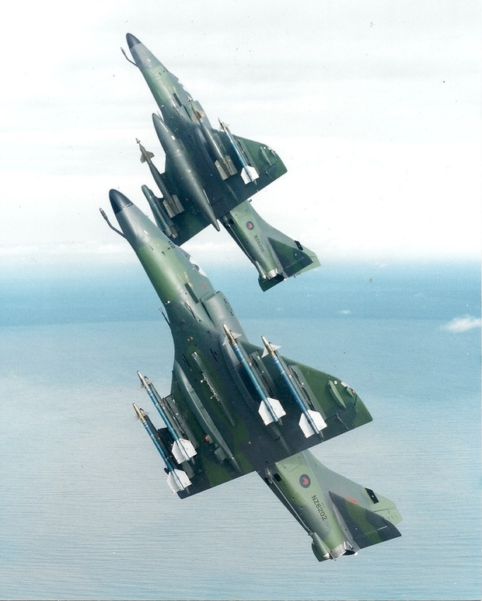

The McDonnell Douglas A-4K served with the Royal New Zealand Air Force between 1970 and 2001, operated by:

* No 75 Squadron
* No 14 Squadron and
* No 2 Squadron

This site aims to document the history of these fine aircraft and the crews who flew and maintained then.  
  
The Skyhawk is likely to have been the final fighter aircraft to be operated by the RNZAF.

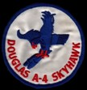

Dedicated to :  
  
FLTLT John Dick,  
  
FLTLT Graham Carter,  
  
SQNLDR Murray Nielson  
  
R.I.P



Photographs on this website are official RNZAF releases or the Webmasters unless otherwise credited. Special thanks to the Air Force Museum of New Zealand for access to their aircraft