* [HISTORY TODAY](https://www.history101.com/category/history-today/)
* [US](https://www.history101.com/category/american-history/)
* [WORLD](https://www.history101.com/category/world/)
* [ANCIENT](https://www.history101.com/category/ancient/)
* [TECHNOLOGY](https://www.history101.com/category/technology/)
* [MYSTERIES](https://www.history101.com/category/world/)
* [CONSPIRACY!](https://www.history101.com/category/general/)
* [ABOUT US](https://www.history101.com/about-us/)

Top of Form

Bottom of Form

**This WWII Ghost Bomber Mysteriously Landed Itself**

[Twitter](https://twitter.com/share?url=https://www.history101.com/foo-fighters/&text=This%20WWII%20Ghost%20Bomber%20Mysteriously%20Landed%20Itself%20" \t ""_blank")

[Pinterest](javascript:void((function()%7Bvar%20e=document.createElement('script');e.setAttribute('type','text/javascript');e.setAttribute('charset','UTF-8');e.setAttribute('src','//assets.pinterest.com/js/pinmarklet.js?r='+Math.random()*99999999);document.body.appendChild(e)%7D)());)

[Flipboard](https://flipboard.com/@History1012018" \t "_blank)

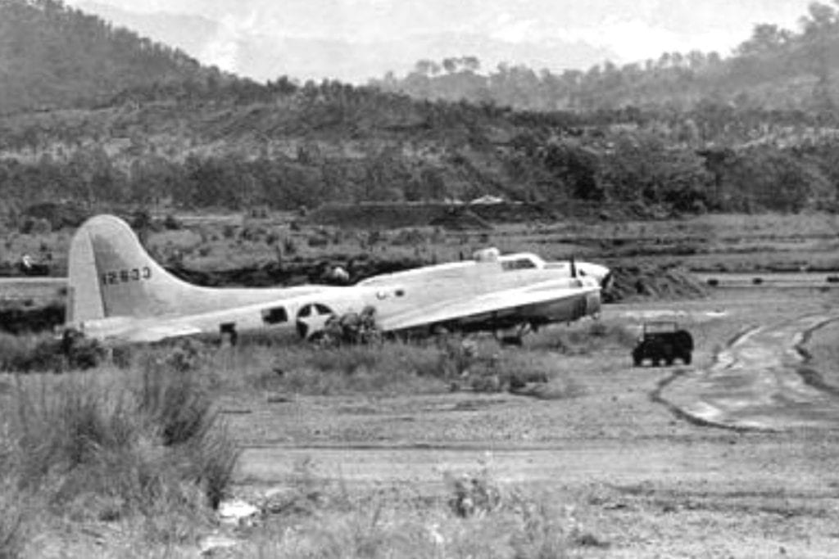

**[Begin Slideshow](https://www.history101.com/foo-fighters/1/)**

World War II saw some of the greatest air battles in history. Explanations for sightings of Foo Fighters to UFOs are still debated, but there’s no arguing the B-17 “Ghost Bomber” incident was one of a kind.

When investigators were finally able to board that mysterious bomber that landed itself, they were left with more questions than answers. Nothing could’ve prepared them for what they found. Have you ever seen anything like this?

**1. Coming in hot!**

On November 23, 1944, something happened at an allied base in Cortonburg, Belgium that still hasn’t been fully explained. On that day an American B-17G bomber was closing in on three Allied anti-aircraft gun positions, and looked like it was going to crash right into them.

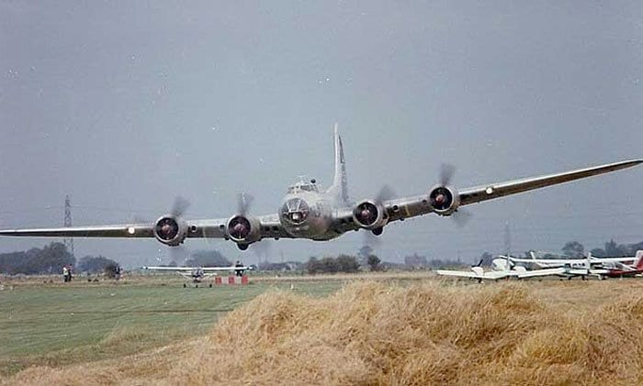warhistoryonline

The soldiers on the ground could see that the bomber’s landing gear was down, and because of the way it was flying, they assumed the plane had been damaged or some of the crew were wounded. It was coming in fast, and the 35,000-pound bomber was falling from the sky right on top of them. They hit the deck and braced for impact as they cursed the pilot of the plane.

**2. An awkward landing…**

The bomber just barely cleared the gun positions and smacked the ground like a falling rock. The extreme force of the impact caused the giant bomber to start bouncing, which led to the plane getting off kilter and one of the wings smashed into the earth. Pieces of the propeller were violently thrown through the air like meteors as they spun into the ground.

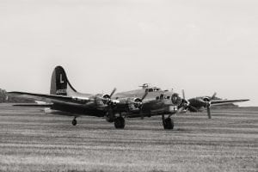Mr. Kuznicki Photography

One hundred feet from the gun position the lumbering bomber finally came to a stop. The engines that worked, kept running and witnesses held their breath. They waited, and waited, and waited some more, but no crew emerged from the Flying Fortress. Soldiers on the ground began wondering, ‘where on earth is the crew?’

**3. Expecting someone to emerge**

The men on the ground certainly didn’t know what to think, and definitely didn’t know how to help. No emergency call from the plane announced its unexpected arrival, and the men in the gun positions were worried from the start. Five minutes went by and no crew emerged. Then ten, and fifteen minutes without a sign of life.

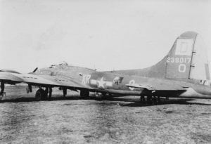American Air Museum in Britain

After all, this was WWII, and sneaky, back-handed tactics had been employed by both sides. The plane stood eerily in the field. The anticipation began to grow as the three remaining engines continued spinning their propellers. After 20 minutes, finally, a British Major named John V. Crisp decided to investigate, but even Crisp was nervous and extremely cautious in his search.

**4. The search begins**

The anticipation continued to grow as the three functional engines continued spinning their propellers. Still no movement, and still no sign of the crew. Time was of the essence, so Major Crisp began searching the exterior of the plane. It wasn’t because he was looking for something, but because he wasn’t an airman, and it took him a minute to figure out how to get inside.

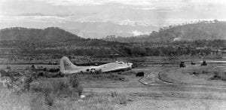Pinterest

Major Crisp was an officer in the British Army, and he was camped nearby along with the rest of his unit. He wasn’t an airman, as he was in the army, so it took him a few minutes to locate the entry hatch below the fuselage. He was alone when he entered and was about to discover something incredible about this airplane.

**5. There wasn’t a soul on board**

Major Crisp was apprehensive in his search, as he expected to find dead or dying men from the aircrew. Why else would no one exit the airplane? Major Crisp pressed on through the thin fuselage that usually held most of the ten crew members of a B-17G.

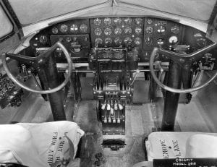worldofwarplanes.com

The Major found some half-eaten chocolate bars, and later commented that, “evidence of fairly recent occupation was everywhere,” but even within the cramped fuselage of the B-17G he couldn’t find anyone. What he did find were twelve parachute packs that hadn’t been used, which was odd, because his search revealed that there was not a single soul aboard the aircraft.

**6. “The Phantom Fortress”**

Major Crisp remained the only person on board while he continued his search for clues as to what happened to the crew. He made his way to the cockpit and didn’t notice anything suspicious about the yoke. In other words, the plane had somehow not only managed to fly itself, but land itself too.

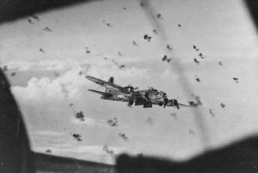Twitter

After some trial and error Major Crisp managed to turn off the engines on the airplane. He also made his way to the aircraft log and noticed some words scribbled there. But just where was the crew? The ensuing investigation would leave allied forces baffled, and word of “The Phantom Fortress” as *Stars and Strips* magazine called it, began to circulate.

**7. The investigation begins**

Alarm over the incident was shot through the chain of command and an investigation started immediately, as commanders feared the worst for the crew. To make matters even more complicated the B-17G that landed itself didn’t even have a name. Major Crisp then reported the incident to his superiors, and a team was sent out to investigate.

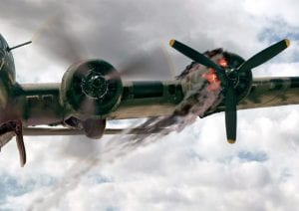<http://www.tombrickhouse.com/>

Investigators arrived at the bomber and found the planes serial number, and this enabled commanders in the 8th Air Force to identify the plane as part of the 91st Bomber Group, which was a contingent of B-17Gs that operated out of East Anglia, England. The plane had indeed taken off from there with its crew, but now they were gone.

**8. The crew was located**

Once the squadron and plane were identified, questions began to swirl around the crew and what became of the. The plane was littered with evidence that they were on board, at some point. The cover to the Sperry bombsite was removed, which was typical when a bombardier was on a bombing run.

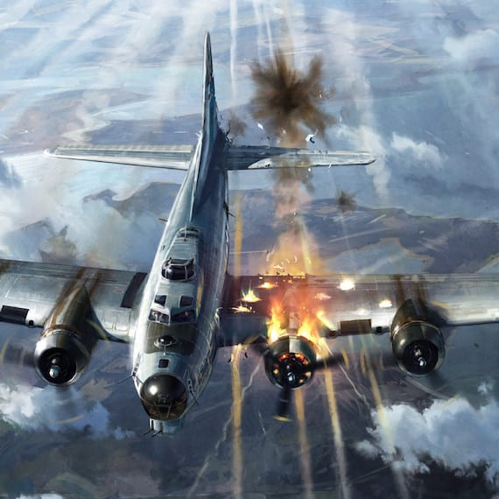mysteriousuniverse.org

The parachutes were the bigger mystery, and even though they were on board, sometime later all of the men were located; All ten of them were alive and well at an airbase in Belgium. Investigators were absolutely baffled by what they found, and dug into the mystery further.

**9. The mission had them fly over Germany**

The B-17G’s mission was to bomb the Leuna oil refinery in Merseburg, Germany, which was a dangerous target given its location in eastern Germany. By that point in the war the allies had been pounding German targets around the clock.

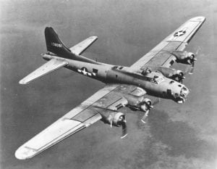Owlcation

The British bombed German targets by night, while American bomber crews from England and Italy bombed during the day. Because bombing accuracy was such a problem American war planners insisted on daylight missions for more precise strikes. This made American bombers far more vulnerable, and upon Crisp’s search of the aircraft he found a log in the navigator’s station that read, “Bad Flak.”

**10. The bomb bay was hit**

Lt. Harold R. DeBolt was the pilot of the B-17G, and even though the plane was new he was an experienced pilot. The bomber made the journey to Germany just fine until the group commenced its bombing run. For some reason the plane was unable to keep altitude with the rest of the group.

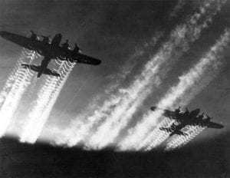Northstar Gallery

That’s when German anti-aircraft fire opened up on the low flying bomber and scored two hits. The bomb bay sustained a direct hit and by some miracle it didn’t set off the bombs. “We had been hit in the bomb bay,” said Lt. DeBolt. “I’ll be darned if I know why the bombs didn’t explode.”

**11. They had to turn around, alone**

An engine was also reportedly damaged by a direct flak hit, despite the fact that when the plane was on approach for landing all four engines were still functioning. The crew knew they were in trouble while flying low, alone, and over enemy territory.

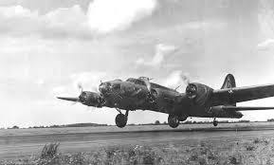thisdayinaviation

The weather had been terrible all day, and the plane experienced a rough flight through towering white clouds. The weather in Europe, like the political climate, was terrible in 1944, and with that, an engine knocked out, and a malfunctioning bomb bay, Lt. DeBolt decided to abandon the bombing run and head back to his base in East Anglia, England.

**12. A second engine quits**

Lt. DeBolt added as much power as he could to the engines, but his plane continued to slowly lose altitude. He then ordered the crew to jettison all loose equipment. They did as ordered but the plane continued to fall.

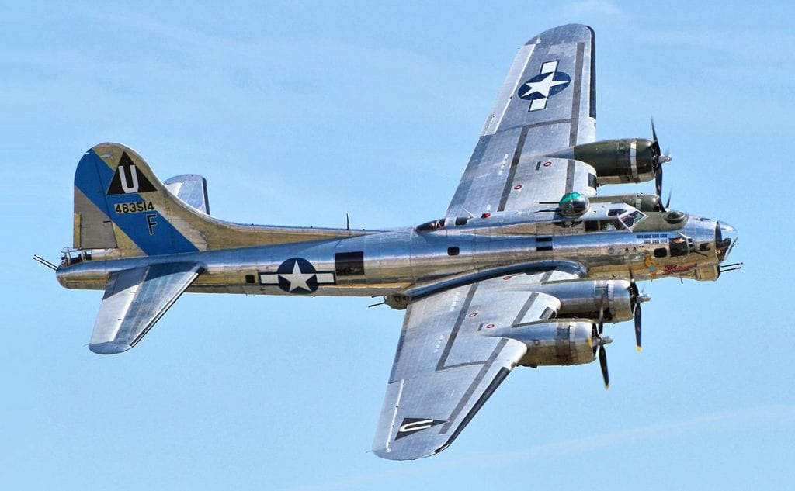Wikipedia

The crew held out hope that the plane would make it back to their airbase, but with each moment that passed their situation looked worse and worse. Then suddenly a second engine stopped turning, leaving Lt. DeBolt no choice; he was going to have to give the order to ditch. He pointed the plane on a course toward Brussels, and ordered the crew to get their parachutes ready.

**13. The parachutes were still on board**

The plane struggled to keep its altitude once it was hit, and pilot Harold R. DeBolt turned the plane around and headed back to England. When a second engine became compromised and stopped working DeBolt knew the plane would never make it across the English Channel.

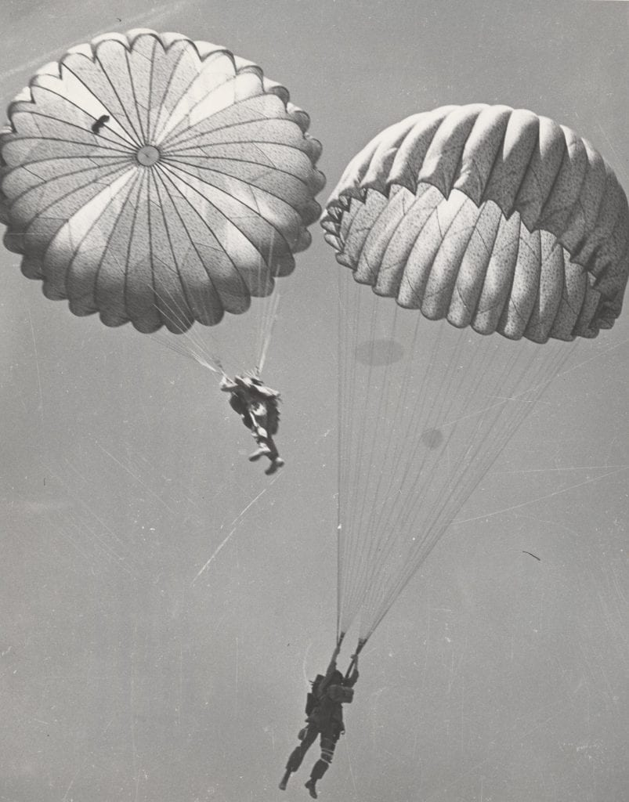army.mil

He then set a course for Brussels, Belgium, which was where the headquarters of the 8th Air Force was located. The crew bailed of the plane and DeBolt was the last to leave. He set the plane on autopilot and jumped. They anticipated that the plane would succumb to its wounds and crash into the ground.

**14. The plane reportedly flew miles on its own**

Reports of a plane flying by itself were not unheard of in WWII, but a B-17G on two engines had very little chance of remaining in the air. The crew watched the plane fly away, but thick cloud cover caused them to lose sight of the bomber. Unbeknownst to the crew the plane was still in the air when they hit the ground.

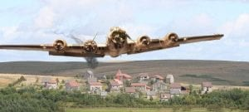dioramas-and-models.com

It is pretty incredible that the plane flew for miles on its own on only half engine capacity, but that seems to be what happened. The captain reported that he and his crew ditched the aircraft near Brussels, Belgium. For investigators this was anything but a neat and tidy explanation. There were still many discrepancies that still needed to be solved.

**15. The biggest question of all**

There was a crew without parachutes, a plane that made it miles on wounded engines, and discrepancies in the investigation report — all unclear, and pale in comparison to the most incomprehensible part of all this the story of the ghost bomber.

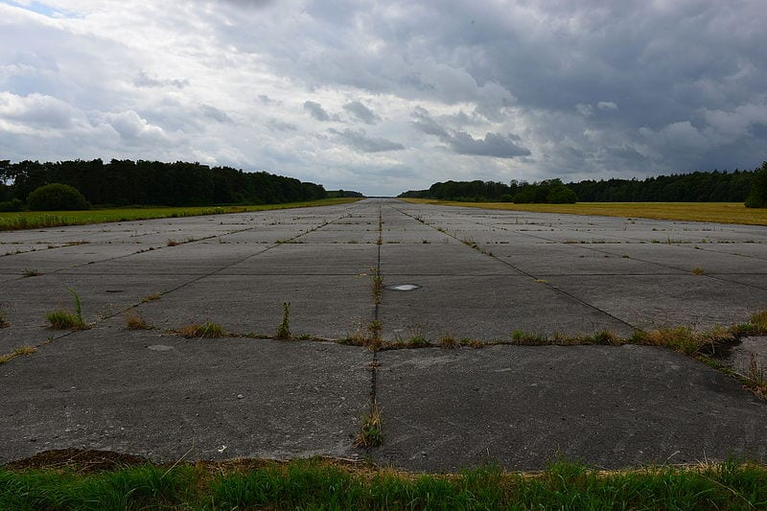Wikimedia commons

The odds that an unnamed plane would make it that far and then land by itself are  no less are infinitesimal. Of all the places, angles it could have come in at, approaches and potential touch down spots (which could have been in the middle of the English channel, after all), it’s mind blowing that the plane landed as though it knew how to land itself, which any pilot will tell you is preposterous.

**16. There were conflicting reports on what happened**

Part of the mystery surrounds the question of why there were conflicting reports between what the soldiers on the ground saw after the plane landed and the crew’s version of events before they aborted their mission. The crew reported that in the course of their mission, one engine was destroyed, and one quit.

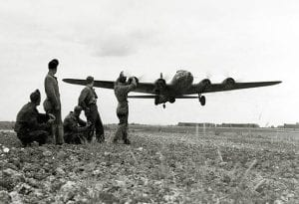Getty Images

However, the soldiers on the ground reported that all four engines were intact (until one was destroyed upon landing) when the plane made its approach. Though both accounts were recorded in the official investigation, the contradiction was never resolved. Was there a hole in the crew’s story?

**17. Soldiers who found the plane may not have been properly trained**

Another discrepancy that was never really resolved was the fact that the crew had reported that they were struck by enemy fire, which is why they felt it was necessary to abort the plane. However, Major Crisp and the other soldiers reported no physical damage on the plane that would substantiate the claim of enemy fire.

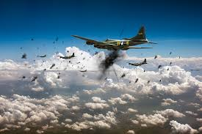flyartworks.com

However, given the rough, unpiloted landing of the aircraft, one possible explanation for the discrepancy is that Crisp and the other soldiers were not trained to identify the difference between damage from enemy fire compared to damage sustained by the plane due to its rough landing.

**18. The parachutes were still on board**

If the crew’s story is true, its bizarre that Major Crisp found all the parachutes on board. While it is plausible that they would decide to abandon the plane if they believed it incurred too much damage under enemy fire, its hard to understand how they evacuated the plane without parachutes.

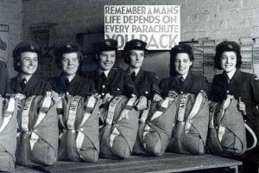Pinterest

Unfortunately, the official report does not resolve this discrepancy, so we may never know why the parachutes were left behind. How else could the plane’s crew have survived jumping from a plane if not using the parachutes? The only answer that is remotely possible is that perhaps Major Crisp identified parachute packs that didn’t have parachutes in them (because they were used). But the report doesn’t make that official, therefore we may never know.

**19. The B-17 Flying Fortress is one tough airplane**

Maybe Major Crisp got it wrong, and maybe the soldiers on the ground did too, but the fact remains that the B-17G managed to land itself. The B-17G was a very tough airplane and could sustain a considerable amount of punishment. Lt. Debolt may have felt he was doing what best for his crew, but his plane was determined to get them all home.

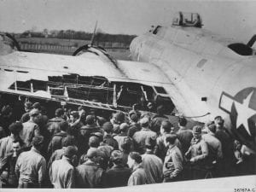Pinterest

The B-17 in the above photo was also determined to get its crew home. Just look at the damage it absorbed on its left engine, and with only 1 1/2 wings it managed land. But at least that plane had a pilot and a crew who brought it in. Planes have autopilot functions, but not the ability to auto land!

**20. Was it a miracle?**

Of all the ways this incredible story could have ended, it seems that the way it did was the best case scenario. After all, the crew made it out safely, and the damaged plane didn’t cause any further destruction as it made its way back down toward Earth.

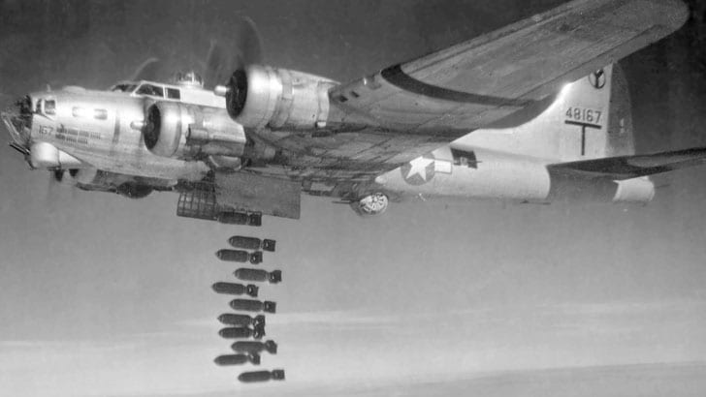firstaerosquadron

Needless to say, there were many stories during the war that didn’t end so well. Perhaps it was a sign to the Allies during the height of the war that fate was on their side, at a time where it might have seemed like all hope was lost.

But the mysteries of World War II don’t end there, as several air crews have encountered incidence without explanation.