OBITUARY Lt. Col. Peter L Kunz

July 10, 1929 – February 5, 2025

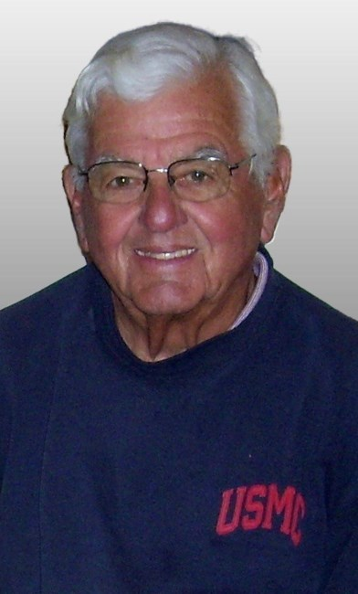

IN THE CARE OF

[Thos. L. Shinn Funeral Home](https://www.dignitymemorial.com/funeral-homes/new-jersey/manahawkin/thos.-l.-shinn-funeral-home/4026" \t "_blank)

Peter L. Kunz

It is with great sadness that we announce the passing of Peter L. Kunz, age 95, of Churchville, PA, and Harvey Cedars, NJ. Peter was born in Albany, NY, to Louis Leonard and Helene (Miller) Kunz. He is survived by his beloved wife of 67 years, Nancy (Kelly), and their children: Edward (Elizabeth), Phillip (Sherine), Stephen (Kelley), David (Dawn), and Kelly Folger (Ken). He was also the proud grandfather of Shannon Lamb (Luke), Devon Kunz, Benjamin Kunz, Erin Folger, Garrett Kunz, Catherine Kunz, Cullen Folger, David Kunz, Alexander Kunz, and Patrick Kunz, as well as great-grandfather to Lawson Lamb. Peter was preceded in death by his parents and his sister, Virginia Lepper.

Peter spent his younger years in up-state New York and suburban Philadelphia. He graduated from La Salle University, enlisted in the military and entered flight school at NAS Pensacola. He served in Korea as a Marine Corps fighter pilot, earned the rank of Lt. Col., and flew as a reservist out of NAS Willow Grove, before retiring from the Marine Corps with 23 years of service.

As he transitioned from active duty to civilian, Peter began a business career as a Manufacturer’s Rep, and eventually established his own company - Kunz Technical Marketing.

Peter led an uncomplicated life, but knew what was important. Riding his bike - be it on Cudjoe Key, Florida or the streets of Harvey Cedars, always brought him a sense of freedom and pleasure. He was an avid reader and a student of history, a creative gardener, a connoisseur of sunsets, an accomplished cook. He spent much of his leisure time fishing and sailing in the waters off the coast of Long Beach Island. Peter was a member of Barnegat Light Yacht Club, served as Commodore in 1976 and as a trustee for the next ten years.

Peter found great happiness in friendships, and had many. He was a master storyteller and captivated friends and family with vivid tales from his childhood, military service and his version of everyday life.

Although his accomplishments were many, being a father brought him his greatest joy, and he was a devoted father, grandfather and great-grandfather. He was an encourager, positive by nature, and led by example, whether it was helping a friend navigate the international waterway from Canada to Florida, or convincing his sons the eel they just caught was “good eating”. His garage was a neighborhood treasure and he could always find what was needed, from a bicycle innertube for a grandchild to a rivet gun for a neighbor.

Peter was a talented man, a resourceful man, a respected man, but most of all, he was a good man and will be greatly missed by friends and family who understand that grief is the price you pay for love - and Peter was deeply loved.

A Memorial Mass will be celebrated at 10:30 am, May 17, 2025 - at St. Francis Catholic Church,

4700 Long Beach Blvd., Brant Beach, NJ 08008

In lieu of flowers, donations in Peter’s memory may be made to

St. Francis Parish

Barnegat Light First Aid Squad, P.O. Box 112, Barnegat Light, NJ 08006

Flight 93 Memorial, P.O. Box 911, Shanksville, PA 15560

To leave online condolences and fond memories of Peter for the Kunz family, please visit [www.shinnfuneralhome.com](http://www.shinnfuneralhome.com/)

Thos L. Shinn Funeral Home, 10 Hilliard Dr., Manahawkin was entrusted with the arrangements.