FORT BRAGG, N.C. — Lt. Col. Michael Burns didn’t know exactly what was inside the small brown box that arrived on his Fayetteville, North Carolina, doorstep but the return address in the left corner let him know he couldn’t open it right away.
The package had made the long journey from Sainte-Mere-Eglise, the first French village to be liberated from Nazi occupation by the U.S. Army's storied 82nd Airborne Division on June 6, 1944. Every year since, division paratroopers travel to Normandy to commemorate the anniversary of D-Day, a trip that was canceled this year amid the coronavirus pandemic.
Weeks later, Burns, a public affairs officer, sat the unopened box down inside the 82nd Airborne Division Museum on Fort Bragg, surrounded by glass cases filled with perfectly preserved green service uniforms, shining jump boots and other World War II relics.
He’d assembled a group of paratroopers and a historian to take part in the unboxing as his team set up cameras and lights to capture the reveal.
Beneath the brown paper lay a keepsake box decorated with American decals — 500 handwritten postcards from the residents of Sainte-Mere-Eglise inside.
After the celebrations were canceled in June, town Mayor Alain Holley organized an effort alongside U.S. Army Europe to express their gratitude for the longstanding relationship they share with the division. Earlier in the year, the division had sent red and blue All American Division patches to the town’s children.
After the celebrations were canceled in June, town Mayor Alain Holley organized an effort alongside U.S. Army Europe to express their gratitude for the longstanding relationship they share with the division. Earlier in the year, the division had sent red and blue All American Division patches to the town’s children During his visits to Normandy, [Captain Darren] Cinatl is always struck by the local’s grasp of U.S. history, specifically how well they know the ins and outs of the 82nd. Children in France know much more about American military history, he admits, than kids in the United States do.

Sainte-Mère-Église Church
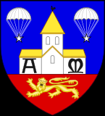

Town seal, Sainte-Mère-Église, Franc

Visible on the face of the tower is a parachute and a dummy representing an event in the history of the town’s liberation. On the morning of 6 June 1944, Private John Steele of the 82nd Airborne’s 505th Parachute Infantry Regiment (PIR) dropped into the town but was blown onto the church steeple where his parachute saved him from immediate capture by the Germans below. He hung there for two hours before being captured; later, Steele was able to escape and rejoin the American forces. He was able to join them in liberating the town. Commemorating the event, the town later hung a dummy and parachute from the position Steele found himself in that morning. It is a permanent fixture of the town and the church. Steele was later made an honorary citizen of Sainte-Mère-Église. The Auberge John Steele stands adjacent to the town square. Inside the church is a stained-glass window depicting the Virgin Mary with paratroopers descending in the foreground:
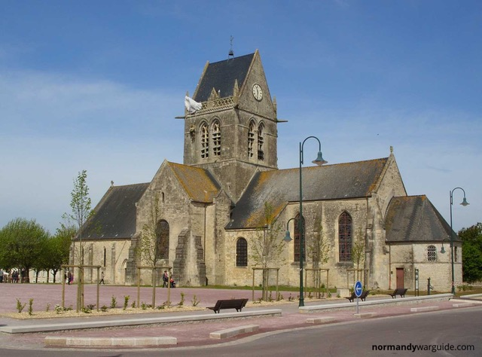
John Marvin Steele (29 November 1912-16 May 1969)
