Gunfighters on the prowl

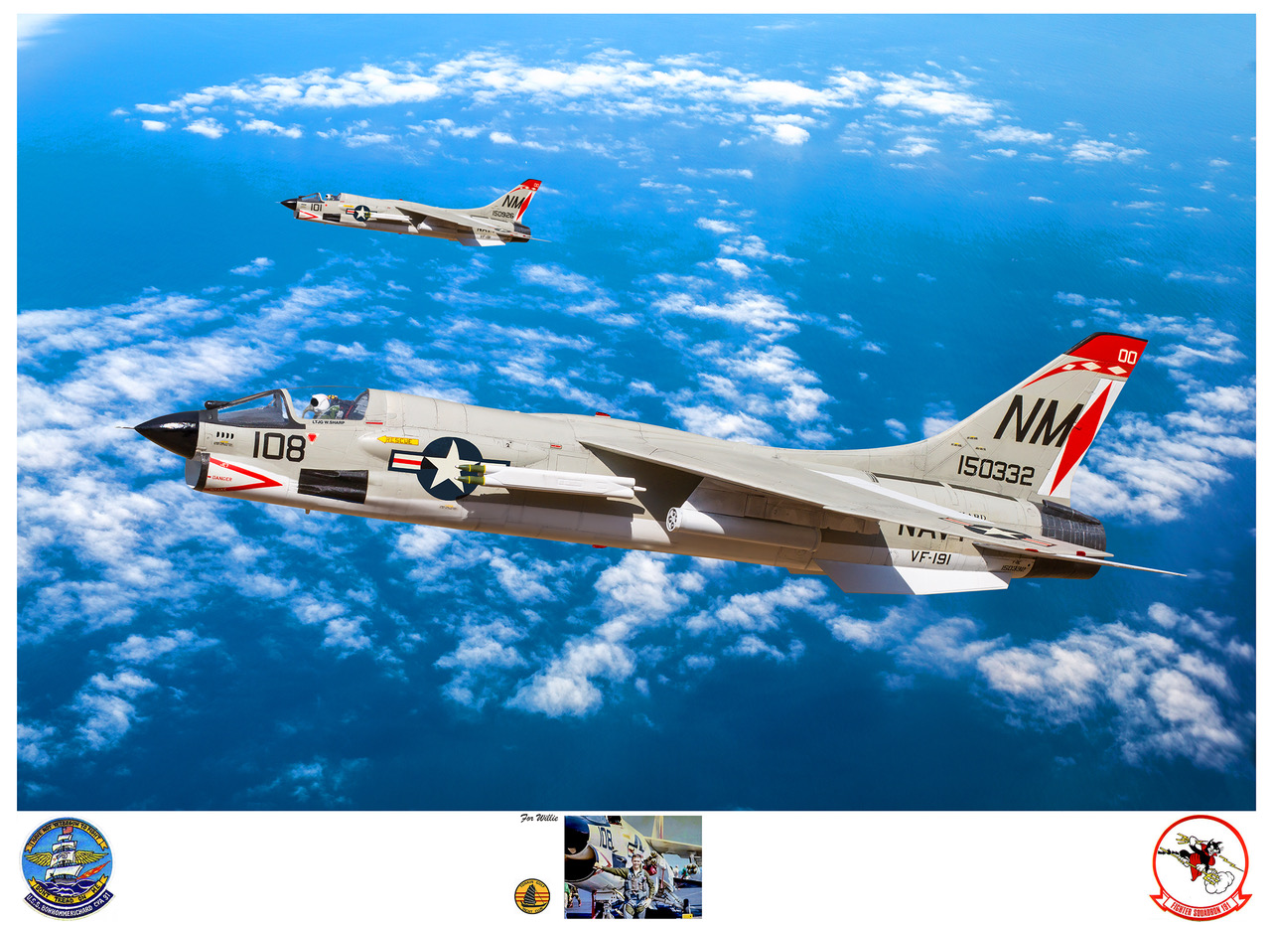

LTJG Willie Sharp’s story below:

My story: I was a flak suppressor along with one other F-8. We were assigned to protect six A-4s who were going to bomb a group of boxcars on a broken rail line. On the edge of the mountains in North Viet Nam, south-west of Hanoi. The flight was led by CDR. John Tierney, who was CAG at the time. I was led by LCDR. Jack Buckley. Three of the six A-4s attacked the boxcars going from South to North. They were followed by 3 A-4s from North to South.

Just as they were approaching the target, the place lit up with anti-aircraft fire. CDR. Tierney (Rocket 88) said, "You F-8s go after those Flak sites.” LCDR Buckley said, "I'll take the sites on the east side. You hit the ones on the west.”  I rolled in on a flak site on the west and just as I got the nose down in my attack, I felt a jolt in the aircraft, followed a dull shudder in the airframe. I fired all 12 of my Zuni rockets and fired the 20mm cannon during my dive and pullout. I said that I had been hit. LCDR Buckley asked how bar and I said I didn't know but thought it was serious.

He caught up to me and said, "Shit, you're on fire. You better get out!” I established a climb and pushed the throttle full forward. I climbed to 11,000 feet and leveled off. The ground below was obscured by a solid stratus layer as far as I could see. I accelerated to 450 knots and headed toward the coast. I was encouraged to eject twice during my race for the coastline.

I refused both times because I sensed that I was still over land. I made a Mayday call and prepared for ejection. After a frantic call from CAG, I finally ejected.

During my race for the coastline, the fire had increased, resulting in the loss of 2 of my 3 hydraulic systems. One was a flight control system and the other was the utility system which is for raising and lowering the landing gear, Nose wheel steering, speed brake, etc. As a result of the Utility system failure, the main landing gear dropped out of the wheel well. When that happened, the right gear separated from the aircraft and the left one was hanging down. As a result of that, the aircraft was "skidding" toward the right.  The wind encountered when the seat started up the rails came from the right instead of head-on. It caught my left arm and blew it around the seat to the point that I thought it had been torn from my shoulder.

After the chute opened and the seat fell away, I discovered that my arm was still attached to my shoulder. I hurt like hell and I could barely close my fingers and thumb together. I was able to attach the lanyard from the seat to my harness and drop the cushion away, revealing the rest of my survival gear. I had inflated my Mk 3 flotation gear around my waist, so I pulled the raft to me and inflated it also. Still above the stratus layer, I held it under my right arm and waited to pass through the clouds. When I came out of the clouds, I expected to see blue water. I was actually straddling the beach. Land on my left and water on my right.

I dropped my raft and reached up and pulled on the risers on my right side and slipped the chute until I was able to land in the water.  I was only about 50 yards off the beach and very near one of the many sampans floating in the water. I held onto the raft with mu right arm and hoped they hadn't seen my land in the water, but moments after I landed in the water, the nearest boat turned toward me and then turned sideways and there were 2 men on the boat. One held an AK-47 machine gun. He fired 2 bursts on my right side and yelled and pointed to a net thrown over the side of the boat.

I let go of my raft and climbed up the net to the boat. He struck me from the left side with the rifle butt and broke my nose. He swung again from my right side but my oxygen mask blunted the impact. I rolled onto the deck of the boat and raised my left arm using my good right arm over my head. The other man on the boat came and removed my .38 revolver that the Navy issued me. He retreated to the middle of the boat and crouched down.

As I was facing the man with the AK-47, I saw one of our A-1 Sky Raiders in a hard left turn and then coming directly toward us. It was so low that the prop was almost hitting the waves. The man with the AK-47 was unaware that it was coming. When it flew over the boat, you could feel the prop wash and smell the exhaust.  The sound was deafening. The man with the AK-47 dropped to the deck and almost curled up into a ball. My wife, at the suggestion of the Executive Officer, had bought me a Ruger .22 automatic pistol, which I carried in a pocket of my flight suit above my left chest...

I knew this would be my best and last time to escape, so I decided to try to take the pistol out of the pocket and try to escape. I was concerned that it might be difficult to remove from the pocket, that it would be more difficult to cock because of my left arm and fingers being injured during the ejection. Also, the gun had been under the water and the ammo my not fire.

I decided this was my last, best chance to escape, so I reached up with my right hand and unzipped the pocket, reached in and got the gun, and then leaned Over and put my left index finger on top of my left knee cap and pushed the pistol against my finger and pushed down hard and I got it cocked. My movement caught his attention and he looked up and saw that I was holding a pistol in my hand. He looked back at the other man with confusion showing on his face. When he turned back around, he started to point the AK-47 at me and I shot him in the face 3 times. His face and head shattered I watched something slid across the deck and hit my right toe. It was 3 teeth on a bone. Part of his jawbone.

The man who had taken my .38 revolver raised the pistol and pulled the trigger. Because it had become Air Group policy to carry the revolver with only four rounds in the six-shot pistol. One empty chamber under the hammer and the next in succession empty also. When he pulled the trigger, it fell on the empty chamber and didn't fire. He dropped the pistol and jumped in the water. I put my .22 back in the pocket of my flight suit and jumped back in the water where my raft was, still attached to me with the yellow lanyard.

I pushed my raft over near a smoke light which had been dropped in the water and waited to be picked up. Moments later, a helicopter arrived and picked me up and took me back to the USS Gridley, a light cruiser which was the SAR coordinator in the Tonkin Gulf.

Whew, there it is.  I'm still looking for a good picture of my helmet. I'll shoot it to you when I can find one.

This story was featured at 2019 Tailhook convention in Reno