
Roll of Honor > Brick Locator > Brick Locator Detail
Semper Fidelis Memorial Park Brick Detail
Brick No. 21616  This brick is located within the The North Marine Trail, Between the divider labeled 'An-Nasiriyah, Iraq 2003 Global War on Terrorism' sign and The Memorial Bridge.  Donor:  Mr. Richard A. De Simone  Melbourne, FL  Engraving:  MARINE CORPS RESERVE  OLD TIMERS CLUB  NAS BROOKLYN, N.Y.  Return to Search Results |  | Semper Fidelis Memorial Park  Where is this?  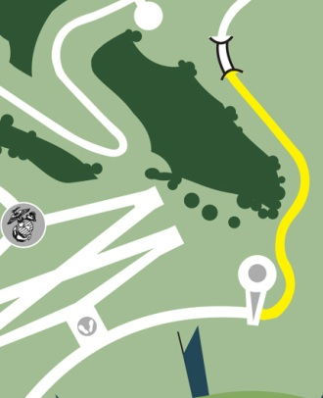  Click for detailed location

C
Click on link to view on original Stort

http://www.marineheritage.com/BrickSearchDetail2.asp?PageFrom=Y&LinkType=&CnBioID=100693&BrickID=21616&ROHName=&ROHFName=&ROHCity=&ROHState=&SearchROHCert=&ROHText=Old%20Timers%20Club

