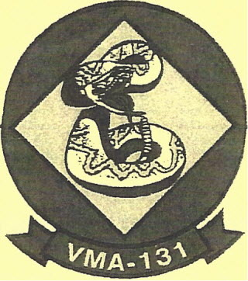

**3 January 2020**

**OLD TIMERS CLUB   
MARINE CORPS RESERVE**

**2020 Annual Report**

The Annual Marine Old Timers Club Brunch was held at the Community Club at Fort Hamilton,   
Brooklyn, New York

Following is the report of the Brunch.

*POINTS OF CONTACT:*

Joe Hillis: 15 Claire Circle, Howell NJ 07731 or HP 732.363.0937 or [jhillis@optonline.net](mailto:jhillis@optonline.net)

Rich DeSimone: 3443 Carambola Circle, Melbourne FL 32940 or 321.507.4546 or   
[fdnychief@gmail.com](mailto:fdnychief@gmail.com)

Best wishes for 2020   
Semper Fi,



From: Joe Hillis

Secretary - Treasurer   
Marine Old Timers Club

To: Rich DeSimone   
President

Marine Old Timers Club

**Subj: MINUTES (After Action Report) from the Marine Old Timers Club Brunch, held on   
Sunday, 27 October 2019 at the Community Club, Fort Hamilton, Brooklyn NY**

Encl: Photo (courtesy of Paul Anderson)

Copy: All Members

1. 

President Rich DeSimone opened the meeting by welcoming all...

*Muster of members attending:* Paul Anderson, John Cappelmann, Rich DeSimone, John Gawley,   
Joe Hillis, Lou Loeven, Bill McShea, Tom Murphy, Ray Pucci, Andrew Rohman, Mike Schatz,   
Tom Simmons, John Stafford, Ernie Stoukas, Ken Udcoff, and Tom Walsh. (Total 16)

A special Welcome Aboard is extended to our newest member, **Tom Murphy.** He hails   
from the earlier years when the Squadron was based at NAS Brooklyn NY. It is great to have   
him with us.

*The following were unable to attend, but did send their dues for the upcoming year:* Steve Baxter,   
Bob Baumert, BOD Beavis, Bob Bums, Tony Cavalier, Tom Christie, RayKrout, John Mishik,   
Neal Mishak, Jesse Murray, Don OHanlon, Lou Patella, Ted Pettine, Tony Pizza, Dick Polk,   
Brian Putney, Fred Shaffer, and Al Vicarelli. (Total 18)

Again, a special thanks is extended to all those Members who gave some extra funds. Your   
additional support is greatly appreciated.

During the meeting, a special moment of silence was held for the passing of **Harry Ammon.** Harry   
goes way back in regard to his association with the MOTe. As usual a contribution in his memory   
was made to the Marine Semper Fi Fund and condolences from the Club were extended to his   
family.

At this meeting, **Brian Putney,** in absentia, was recognized for all his hard work in establishing the   
Squadron's website:

**www.VMA131.NET**

It was not an easy task but Brian held his ground and successfully completed the mission. We are very grateful to him. Now the MOTC can proudly boast and direct others to our unique website. WELL DONE! Brian – many thanks. Remember to check it out for latest updates submitted by present members and others.

As usual it was Ray Pucci who saw to it that we had a reservation for our reunion for our reunion in the Community Club. He always comes through and we are very grateful for his assistance

1. **Hamilton, Brooklyn NY.**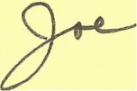

The Treasurer for the Club reported that as of the close of business on 28 October 2019,   
the Club's operating balance was $809.

Furthermore, there was no change in the Club's present officer positions: Rich DeSimone, President   
and Joe Hillis, Secretary-Treasurer.

Once again, the main item of discussion at the meeting was the desire to consider a change in   
location as well as a possible change in the time of year for the annual Brunch. Fortunately,   
Paul Anderson volunteered (yes, volunteered?) to take on the responsibility of scouting out   
the possibility of the Club holding its 2020 Brunch/Reunion at one of the sites within the   
Joint Base McGuire-Dix-Lakehurst complex. Once he has researched all of the particulars,   
he will report to Rich and Joe his findings: Then All Hands will be notified and the Club will   
be able to determine the decision for a change in location plus time of year for our 2020 meeting.

**In the meantime, however, and unless notified otherwise, the MOTC's next brunch/reunion is   
scheduled for 25 October 2020 (last Sunday in month) at the Community Club, Fort Hamilton, Brooklyn NY.**

*Marine Old Timers Club photo:*

1st Row (2 sitting) left to right:

Pucci Stoukas

2nd Row (6 standing) left to right:

Anderson Udcoff Loeven DeSimone Walsh Rohman



McShea Gawley Cappelmann Schatz Hillis Murphy

The following had to leave early: Simmons Stafford

**Age Ranking of Marine Old Timers Club Members (as of** October **2019):**

**Age Name**

**95** Pizza   
Vicarelli

**93** Stoukas

**90** McShea

**89** Mishik (Neal)   
Pucci

**88** Cavalier   
Simmons

**86** Burns

**85** Murray   
Walsh

**84** Baumert   
Shaffer

**83** Q'Hanlon

**82** Gawley   
Mishik (John)

**81** Christie   
Krout

80_D~Simone   
Hillis   
Loeven

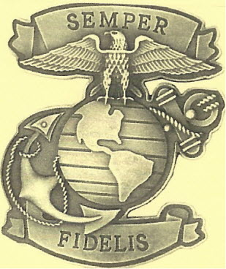



**Age Name**

**79** Reddan

**78** Polk

77 Cappellmann   
Udcoff

**76** Beavis   
Patella

**75** Pettine

**74** D'Andrea   
Murphy

73 Putney   
Rohman   
Schatz

72 McHugh

71 Baxter   
Stafford

**59** Anderson

**Total: 37**