**"Fix Bayonets"   
Bravo Company on Operation Utah**

**By Robert C. Prewitt, LtCol. USMC (Ret)  
February 12, 2004**

**It was March 5, 1966.  The next twenty-four hours would be the most crucial and demanding of my life, as well as a life-altering event.  In fact, they would be a matter of life and death many times over.  The buzzing noises around us were the sounds of nearby bullets, but I tried to ignore them.  The hot air hung heavy with pungent smelling gunpowder.  Suddenly, Corporal Patterson, the company radio operator handed me the radio handset and said, "They want Bravo Six Actual, sir."  I took the handset and was told to come east about a hundred meters.  I got my bearings and hurriedly moved out followed by the radioman   it was a blistering hot and humid morning as we exited the helicopters in a large rice field.  "Stay low", somebody yelled, "they're all over the ridge line."**

**The previous night, as the commander of Bravo Company, 1st Battalion, 7th Marine Regiment (B/1/7), I had received a warning order to be prepared for a helicopter borne operation at 0700 the next morning.  We would be attached to 2nd Battalion, 4th Marine Regiment (2/4) south of Chu Lai.  Except when involved in tactical operations, Bravo Company's mission was to defend its part of the defensive perimeter south of the Marine airfield at Chu Lai in the northern part of the Republic of Vietnam.  Days were hot and long, and nights were just as hot and even longer.  Time passed slowly.  Every day weapons and equipment were cleaned and cared for, and patrols were prepared and conducted.  Every night defensive holes along the company line were manned, and forward ambush positions were established.  Participation in tactical operations in the vast "no man's land" brought a relief from our usual daily routine.  However, it also brought anxiety about the unknown and uncertainty about the future.  There were many times when such operations turned out to be just "long, hot walks in the sun."  This was not one of those times.  Little did we suspect that we would be under fire all the next day and night?**

**Intelligence indicated that the 21st North Vietnamese Army (NVA) Regiment had recently moved into a region between Chu Lai and Quang Ngai City.  A Republic of Vietnam Army (ARVN) battalion and a U.S. Marine battalion had launched a combined operation the previous day against the enemy regiment and Main Force Vietcong (VC) units in Quang Ngai Province.  They met stiff resistance.  This was the first heavy fighting against the NVA in the Marine's combat zone.  It was named Operation Utah.  Finding that the NVA Regiment was more than willing to stand and fight, the Marine and ARVN commanders wanted to take advantage of the opportunity to surround and destroy the enemy force.  An enemy regiment in the open was a prime target.**

**The 2nd Battalion, 4th Marine Regiment (2/4) was moved by helicopter to Quang Ngai Province early on the morning of March 5th a few miles to the south of the previous day's fighting.  It was to establish blocking positions that would close the enemy's escape routes.  Bravo Company closely followed 2/4 into the same landing zone and was then attached to 2/4.  Despite air cover of our landing, the NVA attacked our helicopters with heavy small arms fire.  Machine gun fire from a nearby ridge line hit and disabled two helicopters.  As PFCs David Shelton and Michael Maxwell, both riflemen in 3rd Platoon, arrived they immediately heard automatic weapons fire, both incoming and outgoing, and smelled the burned gunpowder around them.  They quickly realized that this was reality and a fire fight for life.  Bravo Company was already engaged with the enemy at close quarters.**

**I located the commander of 2/4 for orders.  He assigned Bravo Company the mission of providing security for downed helicopters and evacuating 2/4's casualties.  By 1100 all of Bravo Company had landed and established a perimeter defense around the landing zone and downed helos.  2/4 soon disengaged from fighting and started northeast on its blocking mission.**

**Bravo Company was now on its own in a remote, isolated position with no physical contact with any friendly forces.  The ridge line ran from our northwest to our southeast at about 400 meters distance and provided the NVA with excellent observation of our position.  A cane field grew along the base of the ridge line that gave good concealment to the enemy.  It allowed them to move undetected very close to our perimeter.  We were thinly spread out in a large circle in the dry rice field.  1stLt. Dave Brown's 1st Platoon was positioned to the north.  1stLt. Ken Nisewarner, a Naval Academy graduate, had his 2nd Platoon defending to the west, and SSgt. McClelland's 3rd Platoon was in the southern sector.  Each platoon had a machine gun squad and a rocket launcher squad attached to it.  A dozen or more walking wounded Marines from 2/4 filled in the gap on the east to round out our perimeter.  A forward air control team and mortar and artillery forward observer teams had fortunately been attached to the company.  Including those attachments, the total strength of our reinforced rifle company that day was only five officers and 160 enlisted Marines, well under strength.**

**Bravo Company was battling a tough disciplined enemy, part of the NVA's elite 21st Infantry Regiment.  The uniformed and well-armed regulars had infiltrated into South Vietnam from their homeland north of the 17th Parallel.  They had the trained manpower, the weapons, and the ammunition to fight sizable and sustained battles.**

**So there we were in no man's land - 165 "good guys" against who knew how many "bad guys" - with the sun baking down, searing the still, hot air.  The good news was that one of the downed helicopters had been repaired and was able to fly out.  We were also able to evacuate 2/4's casualties.  The bad news was that we were still under fire, and we were getting low on water and ammunition.  We had only what we carried with us on our backs and cartridge belts.  Our uniforms were soaked with sweat and clung to our bodies like Saran Wrap.  Our heavy armor vests (which were mandatory to wear) made us even hotter.  Each man started with two full canteens of water, but in the blistering and brain-burning heat, even disciplined and acclimatized Marines were compelled to drink water.  Each time that a helicopter landed in our perimeter to evacuate casualties, the NVA opened fire on it, and each time we immediately returned fire, expending more ammo to protect the helo.**

**About 1430, as the 3rd Platoon was sweeping the area to its front, we were shelled by mortars for the first time.  We saw about thirty-five enemy carrying heavy loads (like mortar rounds) running on the ridge line.  During the ensuing fire fight, we responded with our own artillery and mortars, as 1stLt. Bob McCormick, our forward air controller, directed more air strikes around us on the enemy.  We expended more of our limited ammo as we returned fire.  The Company Gunnery Sergeant was finally able to get a request for a resupply of ammunition and water transmitted over the battalion radio net.  Our company "Gunny", Ira Riley, a respected and well liked career Marine, was a cool-headed, lanky South Carolinian who continually looked out for the welfare of our men.**

**There was a tense awareness of things that could happen as we watched the enemy slowly and methodically encircle our position in the unrelenting heat.  An estimated one hundred NVA, excellently camouflaged with green foliage, advanced like hedgerows across an open paddy to close their circle around us.  A furious fusillade of fire cut down most them.  Artillery and mortar fire rained down havoc on the exposed NVA.  By now (1700) we were out of M-79 grenade and rocket launcher ammunition, and machine gun and rifle ammunition was almost exhausted.  Our situation was growing more serious.  Our need for ammunition was urgent.  I upgraded our ammo resupply request to "Emergency", and directed all remaining ammunition to be redistributed among the men.**

**As time passed, the tempo and size of the NVA attacks continued to increase.  We called in more air strikes, sandwiching them between more artillery and mortar fire.  Screaming jets came in slashing toward the ridge line at an altitude of about fifty feet.  Suddenly they zoomed up releasing silvery tanks of napalm that tumbled end over end toward the hill and burst in a tremendous splash of flame silencing the enemy.**

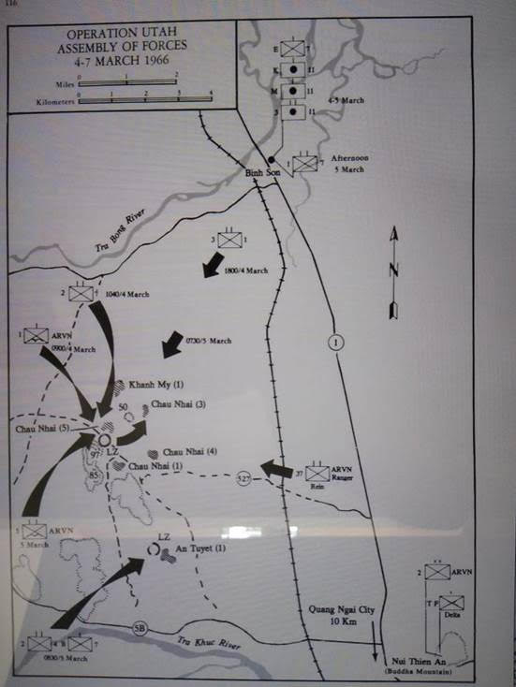

**We could not maneuver away from our position; we were tied to the downed helicopter until it was repaired or lifted out.  It acted like a magnet that drew the NVA to it.  They knew they had us pinned down.  They were like hungry wolves circling for a tasty meal!  There could be no withdrawal for us, and there would be no reinforcement at night.  How long could we hold our position without ammo resupply?  To consolidate our lines and reduce perimeter size, I passed the word that as soon as it was dark for the men to pull back and dig two man foxholes in the soft dirt.  As daylight began to fade, artillery began to replace close air support as the dominant supporting weapon.**

**I checked the platoons again to see how they were doing.  By now, each man had only a handful of bullets left, but their morale and esprit de corps were sky high.  They knew they were in a fight for their lives, one for which they had been well trained.  Their training, unit spirit, and small unit leadership were telling me that they could hold.  I ordered, "Fix bayonets!"**

**At 1830, I advised the commander of 2/4 that Bravo Company was critically low on all ammunition.  He informed me that the task force commander had approved our emergency resupply.  By the time it finally arrived at 2000, however, it was already dark, and our situation was near desperate.  As the helicopter attempted to land near our small, blinking strobe light with the sorely needed ammo, it was driven off by intense enemy fire, including three .50 caliber machine guns that covered our position in a cross fire.  After the pilot, 1stLt. Terril J. Richardson, coordinated for a well-planned, low altitude air drop, his aircraft made a very low pass over our company position while crewmen pushed ammo boxes out.  Enemy fire again opened up from all around.  "It seemed as though the whole world started firing at us." later commented Lieutenant Richardson, ironically from Utah, a pilot in Marine Medium Helicopter Squadron 364.  Despite the precautions, his helicopter was hit numerous times by enemy fire during its daring flight, but the drop was executed perfectly.  A UH-34 helicopter normally carried sixteen hundred pounds, but Richardson said he carried an extra six hundred pounds because it was an "Emergency Resupply."**

**Lieutenant Richardson flew his UH-34 aircraft over an hour after that with no problems, but when a warning light came on, he taxied to the flight line and shut it down.  A bullet had hit a tail rotor gear box, cracked the casing, and was about to fail.  If that had happened while Richardson was airborne, he "most probably would have lost control of the helicopter and crashed."  Without the ammunition that he delivered, Bravo Company had little chance of survival.  Inspection showed over forty bullet holes in his machine (including eight through the cockpit and fourteen through the troop compartment), but miraculously, not a single crewman was scratched.**

**The ammunition was quickly distributed to the men.  We knew now that we could hold out through the night against all odds!  Moreover, a U.S. Air Force flare plane came on station about this time and provided us with very effective illumination until daylight.**

**Meanwhile, Bravo Company was coming under increasing pressure.  About 2130, under mortar barrages, the NVA launched heavy probing attacks from all sides.  These continued until about 2300 when the mortar barrages became extremely heavy, exceeding one hundred rounds across our position.  This shelling was swiftly followed by coordinated frontal infantry assaults as the enemy closed in around us.  Their main assaults came from the north, west, and south, and were each estimated at a hundred or more enemy, judging from their volume of fire and the number of Vietnamese commands and whistles that we heard.  Close-in artillery and mortar barrages were again called for.  We soon heard "barroom, barroom", as we felt the concussion and ground shake from the nearby impact of the shells.  Our artillery lieutenant adjusted 155mm and 105mm rounds to within fifty meters in front of us (the minimum safe distance because of flying shrapnel) with outstanding effect!  To avoid such fires, however, some of the enemy crept to within about fifteen meters of our position by using the protection of rice paddy dikes.  Most of these were taken care of by our hand grenades.**

**With the ammo resupply and the help of supporting Marine and ARVN artillery, Bravo Company repulsed these violent assaults that lasted until about 0130 the next morning.  At that time, the enemy abruptly broke contact with us.  Around 0500 we again received heavy mortar and automatic weapons fire that lasted about twenty minutes.  But this time, the NVA engaged us by fire only, and it gradually played out.  The enemy attack had finally been broken!  This last engagement by fire only was, no doubt, to provide cover for the withdrawal of what was left of the main enemy force.  Before the NVA slipped over the ridge line under the concealment of last darkness, they customarily recovered as many of their casualties as they could without taking more casualties.**

**At BMNT (beginning of morning nautical twilight), each platoon sent out a patrol to its front.  The 1st and 3rd Platoons encountered only a few fleeing enemy, while the 2nd Platoon ran into a few snipers and suffered three wounded.  PFC Shelton recalls watching one of our rocket launchers make a direct hit, blowing up a nearby Vietnamese hut and the NVA machine gunner that was using it.**

**The sun rose bright orange and relentlessly hot over us.  We were again exposed to the burning sun.  There was nothing that made any shade in the barren rice field except ourselves when we stood up.  We were now able to evacuate our casualties on the four helicopters that delivered water, canned rations, and more ammunition about 0830.  Aircraft mechanics and equipment arrived by helicopter at 1000 to prepare the disabled UH-34 helo for lift out.  Soon we heard the "whomp ... whomp ... whomp" of another larger chopper coming in.  Within minutes it hooked up the crippled bird in a sling and lifted it safely away.**

**Meanwhile, 2/4 had started overland back to our position, arriving about 1515.  We occupied the ridge line with 2/4 that night (March 6th), which was fairly quiet with only occasional small arms fire.  Bravo Company moved out by foot the next morning with 2/4 to the well-known Highway 1.  After walking several long and hot hours we arrived at the rendezvous point where 6x6 trucks finally picked us up.  They returned us to our normal company position south of Chi Lai, arriving finally at 1915 that evening ... dirty, tired, and hungry, but victorious.**

**Isolated in a rice field in no man's land, an under strength infantry rifle company of 165 young Marines fought one of the most intense battles in the Vietnam War against an estimated five hundred or more elite North Vietnamese soldiers.  Surrounded by an NVA battalion and under almost constant fire and pressure throughout the day and night, Bravo Company fought for its life.  By well-directed use of supporting arms (including Vietnamese Army artillery and a U.S. Air Force flare plane) the intense enemy attacks were repulsed.  The forward air controller with Bravo Company directed twenty one air strikes of rockets, bombs, napalm, and strafing by A-4 and F-4 jets and gunships, the most in one day in Vietnam to that date.  The flare plane dropped beautiful flares (like giant sparklers swinging on a small parachute) that slowly descended around us casting eerie shadows and providing illumination throughout the night that helped us see enemy movements.**

**But it was the daring and heroic helicopter delivery of ammunition by Lieutenant Richardson and his crew that turned the tide of the battle and saved us.  There is strong doubt that we would have survived the long night without the ammunition resupply.  At that time we were not fighting for our country or the Corps ... we were fighting for each other!  We knew that we were accountable for our actions and deeds to our team members and fellow Marines.  They were dependent upon us, as we were upon them.  We were not about to let one another down.  We not only saved the essential helicopter, but at the same time, we dealt a severe blow to the enemy.**

**A conservative count of enemy casualties during this battle was thirty six confirmed dead by body count, at least another 103 probable killed, and many more possibly killed.  The enemy who escaped no doubt also carried away a goodly number of dead and wounded, as was their custom.  Captured were a variety of weapons, a cross section of equipment, and valuable documents, as well as a female nurse.  The NVA soldiers were characterized as, "They're not supermen, but they can fight."**

**In comparison, Bravo Company's casualties were miraculously only five killed and twenty four wounded.  Outstanding combined arms support and resupply, being dug in, and our Marine training no doubt kept casualties to a minimum.  The good Lord was surely watching over us!  The names of the five killed are forever etched in black marble on the Vietnam Veteran's Memorial (panel 05E, lines 112 to 124) in Washington, D.C., and are also listed below.  All five Marines were killed in action from hostile fire in the brave performance of their duties on March 5, 1966, in Quang Ngai Province, Republic of Vietnam.  They were honorable and dedicated young men who took pride in their service.  Let us always remember them, and that, "All gave some ... Some gave all."**

**In Memory Of**

**Sergeant Charles Frederick Setzenfand, age 24, married, from Butler, Pennsylvania.  
Corporal Mario Clayton Kitts, age 19, single, from Fort Wayne, Indiana.  
Corporal Roy John Higgins, Jr., age 24, single, from Phoenix, Arizona.  
Private First Class John Henry Bell, age 21, single, from Peoria, Illinois.  
Private First Class Gary Ercil Sooter, age 19, single, from Independence, Missouri.**

**Copyright 2004 by R. C. Prewitt.  All rights reserved.**[**prewitt77@sbcglobal.net**](mailto:prewitt77@sbcglobal.net)

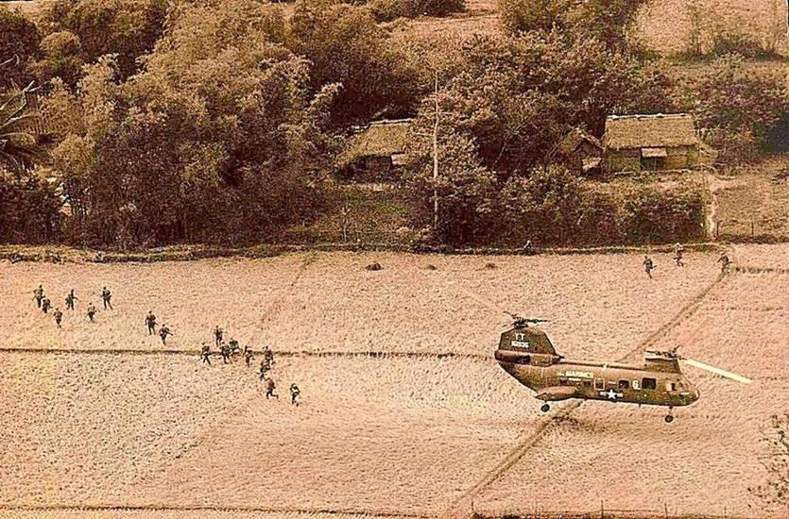

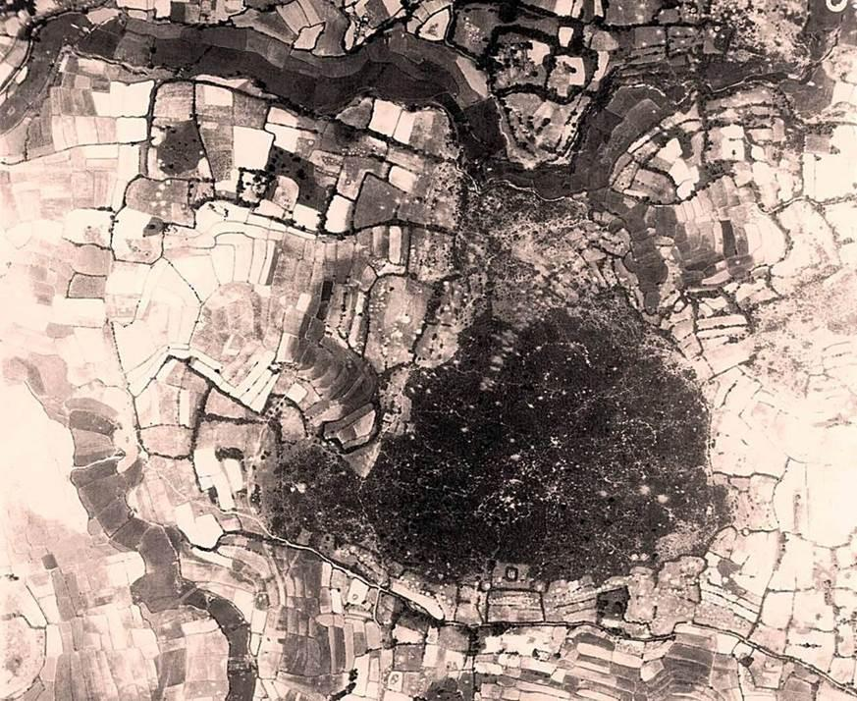

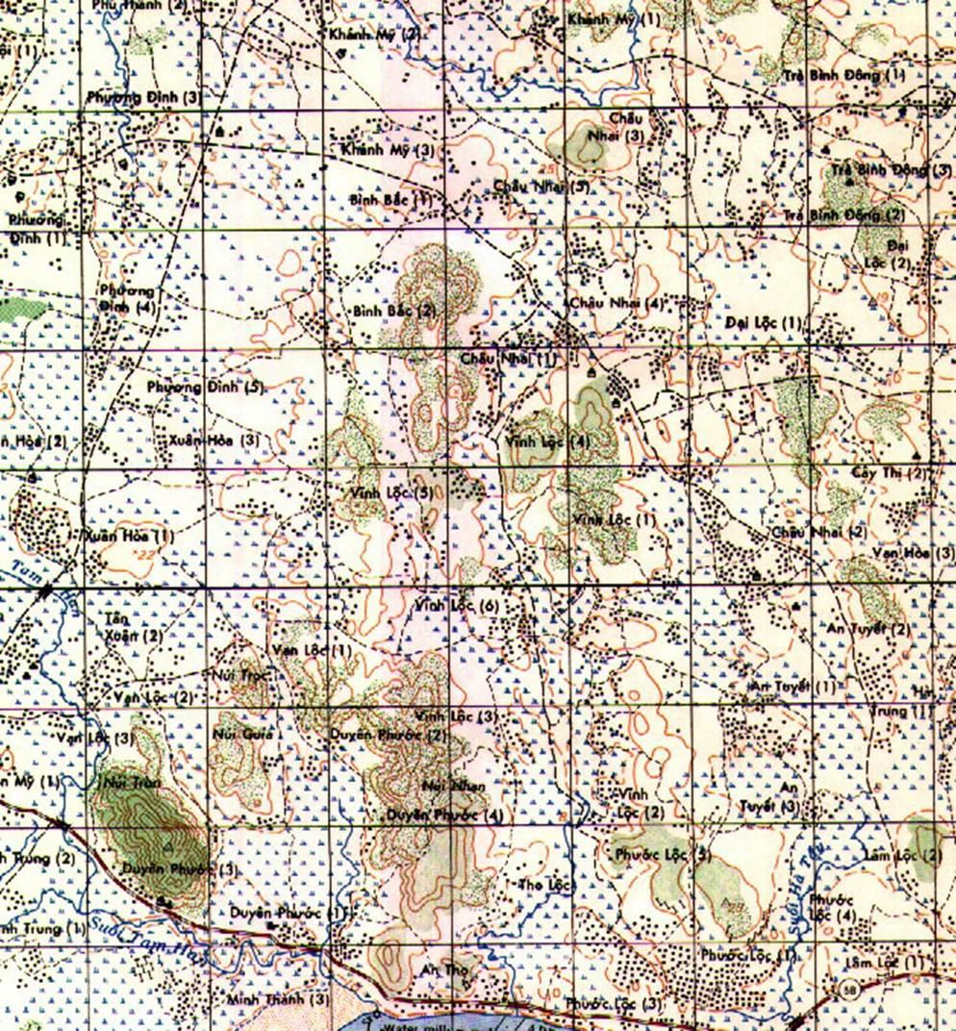

**Sources:  
1.  Personal knowledge, Robert C. Prewitt, 3705 Whispering Oaks, Temple Texas 76504; he was then a Marine captain and commanding officer of Company B, 1st Battalion, 7th Marine Regiment (B/1/7).  
2.  Special Combat Operations After Action Report on B/1/7 during Operation Utah, March 5-7, 1966.  
3.  Jack Shulimson, U.S. Marines in Vietnam, an Expanding War, 1966 (Washington, D.C.: U.S. Government Printing Office, 1982), 109-119.  
4.  B/1/7, 3rdMarDiv (Rein), FMF, RU-11214, Unit Dairy No. 22-66 dated March 8, 1966.  
5.  Telephone conversation on January 4, 2003, and e-mail on January 5, 2003, between R. C. Prewitt and Terril J. Richardson of Mesquite, Nevada.  
6.  Edward Hymoff, First Marine Division Vietnam, (New York, N.Y.: Lads Publishing Company, 1967), 32-34.  
7.  Numerous telephone conversations between R. C. Prewitt and David Shelton of Kennesaw, Georgia during 2003.**