**Japanese Pre-Surrender**

**Rare photos of a fascinating piece of history.**

**This was overshadowed by the Tokyo Bay surrender ceremony a few weeks later.  But what rare photos (and some personal descriptions of that event).**

**Interesting photos of the preparation of Surrender of Japan in August 1945. (Officially signed on the USS Missouri in the Tokyo Bay, September 2, 1945).**

**A delegation of Japanese Representatives flew to an American Base close to Okinawa.  The Japanese planes were requested to be painted in white and have the "Meatballs" replaced by a Green Cross. Really rare archives.**

**Here are photographs of some of those *Green Cross*flights and *Green Cross*aircraft, starting with the most photographed of them all "The Green Cross Bettys of Iejima"**

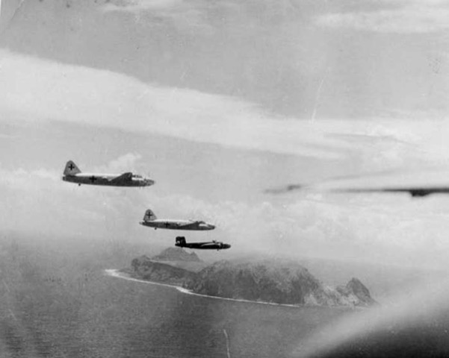

**Let the surrender begin. B-25J Mitchell bombers of the 345th Bomb Group (The Apaches) lead two Green Cross Mitsubishi G4M "Betty" medium bombers into the island of Iejima (called I.e. Shimaby the Americans). The 345th Bomb Group (the 498th, 499th, 500th and 501st Squadrons) was based on Iejima and was given the task and the very special honor of escorting the Bettys from Tokyo to the rendezvous with United States Army Air Force C-54s, which would take the Japanese officers and envoys on to Manila to meet with no less than Douglas MacArthur himself.**

**Photo: USAF**

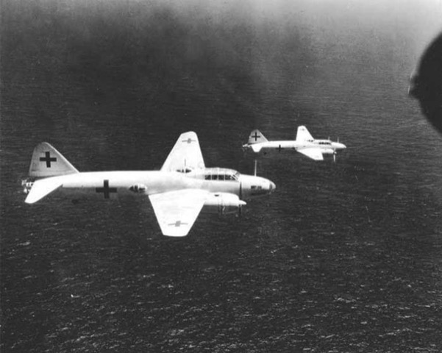

**The two Bettys (ironically and deliberately given the call signs *Bataan 1* and *Bataan 2* by the Americans) fly low over the East China Sea, inbound for Iejima wearing their hastily painted white surrender scheme and green crosses.  One can only imagine what is going on in the conflicted minds of the Japanese airmen as they fly over their own territory in the company of the hated enemy, headed for an event of profound humiliation in front of thousands of enemy soldiers. These two Bettys would become the most photographed *Green Cross* surrender aircraft of the end of the war.**

**Photo: US Navy**

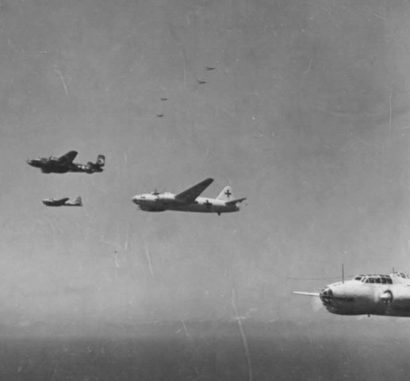

**A photograph taken from the same 345th Bomb Group Mitchell that is depicted in the first photograph, looking back at another B-25 Mitchell and a B-17.  Above, P-38 Lightings provide top cover. The top cover was needed because some Japanese officials had ordered the remnants of the Japanese Army Air Force to attack and bring down their own bombers rather than surrender. Instead of flying directly to Iejima, the two Japanese planes flew northeast, toward the open ocean, to avoid their own fighters**

**Photo via** [**warbirdinformationexchange.org**](https://eur02.safelinks.protection.outlook.com/?url=http%3A%2F%2Fwarbirdinformationexchange.org%2F&data=02%7C01%7C%7C1698a02966664681abc108d6c816ba9f%7C84df9e7fe9f640afb435aaaaaaaaaaaa%7C1%7C0%7C636916397338908961&sdata=5AnQ64d%2BReXLCyaKFs%2BotLR5vRAH%2B7ga%2Fgm41DkctKo%3D&reserved=0)

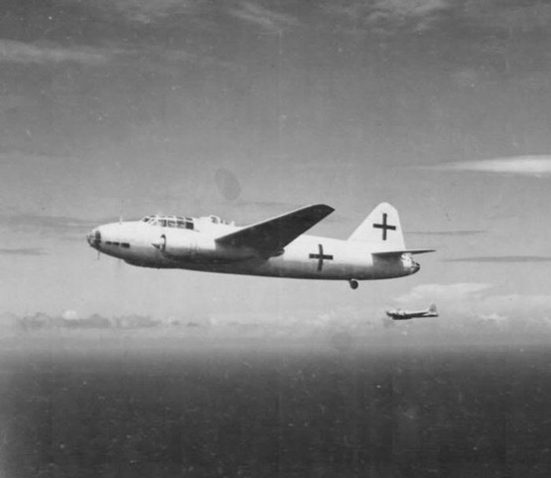

**The Betty was officially known as the"Type-1 land-based attack aircraft", but to its Japanese Navy crews, it was lovingly known as the *Hamaki (*Cigar), the reason for which is obvious in this photograph (also because one could light it up fairly easily). The Betty was a good performer, but it was often employed in low level, slow-speed operations such as torpedo attacks and it had a tendency to explode into flames when hit by even light enemy fire, leading some unhappy pilots to call them the "Type One Lighter" or "The Flying Lighter". We can clearly see that the Betty's traditional armament: nose, tail, waist and dorsal guns, have been removed as demanded by the Americans.**

**The B-17 in the distance is from 5th Air Force, 6th Emergency Rescue Squadron carrying a type A-1 lifeboat. The A-1 was dropped by parachute and was motorized. It seems that American authorities did not want to lose these men in the event of a ditching**

**Photo via** [**warbirdinformationexchange.org**](https://eur02.safelinks.protection.outlook.com/?url=http%3A%2F%2Fwarbirdinformationexchange.org%2F&data=02%7C01%7C%7C1698a02966664681abc108d6c816ba9f%7C84df9e7fe9f640afb435aaaaaaaaaaaa%7C1%7C0%7C636916397338928984&sdata=Ex0cQC1pkpPLOlmoah94qhKc3DEa2TrSkChbLhy6qOg%3D&reserved=0)

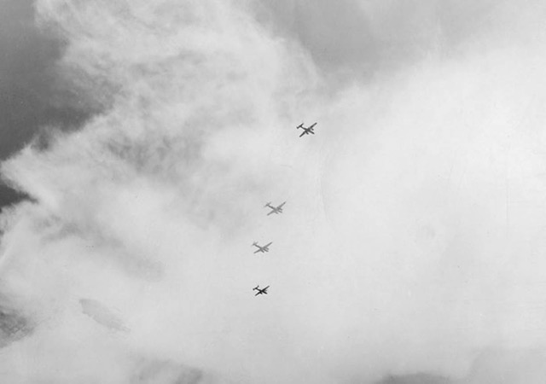

**As thousands of American soldiers, airmen, sailors, dignitaries and press photographers on the island of Iejima look to the sky, the two 345th Bomb Group B-25J Mitchells escort the two white *Green Cross*Bettys over the airfield before setting up for a landing.**

**Photo: James Chastain, 36 Photo Recon Squadron**

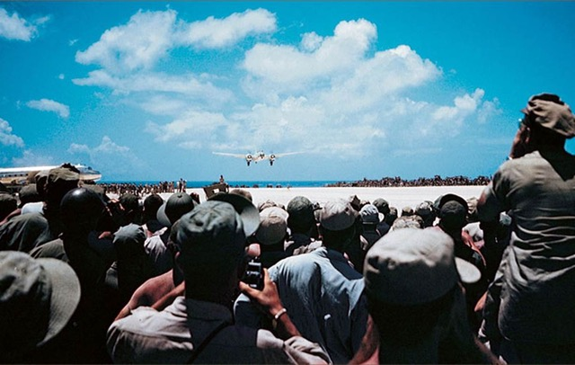

**As thousands of suspicious, curious and anxious young men look on, the Japanese pilot brings his Mitsubishi Betty down on to the bleached coral airfield of Iejima. Note the all-metal Douglas C-54 waiting for their arrival. Photo via Pinterest**

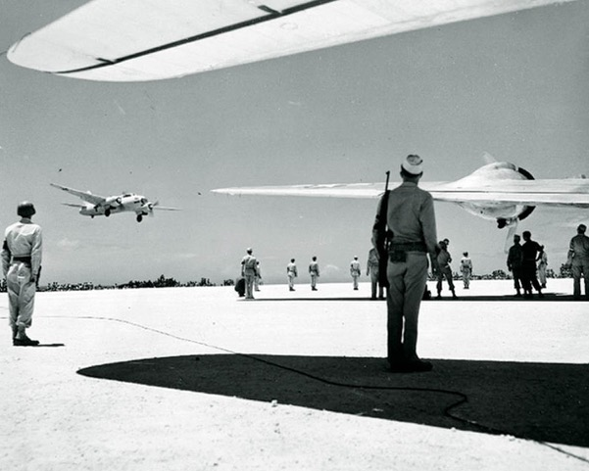

**It is plainly obvious that in August of 1945, on the island if Iejima, it was brutally hot the day the Green Cross Bettys landed. Here one of the two aircraft drops on to the runway as soldiers, the formal welcoming committee and pressmen wait, finding shade where they could. Photo: U.S. Naval Historical Center The second of the two Green Cross Bettys makes its final approach while press photographers and reporters capture the long-awaited moment.**

**Photo: James Chastain, 36 Photo Recon Squadron**

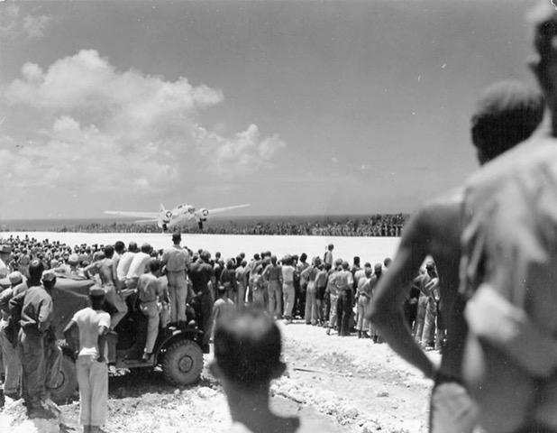

**As the second Betty alights on the coral airstrip, every eye on the island is trained on them. One cannot even imagine what this scene looked like to these Japanese as they looked out from the aircraft windows at a sea of mistrust and a new, grim reality.**

**Photo: James Chastain, 36 Photo Recon Squadron**

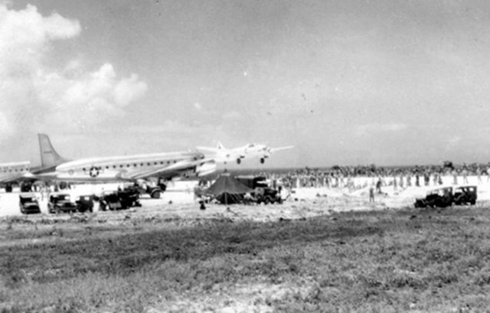

**Another view taken farther back at Iejima shows the two massive and beautifully kept Douglas C-54 aircraft waiting for the passengers of the landing Betty.**

**Image via** [**wwiivehicles.com**](https://eur02.safelinks.protection.outlook.com/?url=http%3A%2F%2Fwwiivehicles.com%2F&data=02%7C01%7C%7C1698a02966664681abc108d6c816ba9f%7C84df9e7fe9f640afb435aaaaaaaaaaaa%7C1%7C0%7C636916397338938995&sdata=NyavXHHMciE1VXy7MkTq2eS8%2Fz%2FPkNnSSrlYmHAI97k%3D&reserved=0)

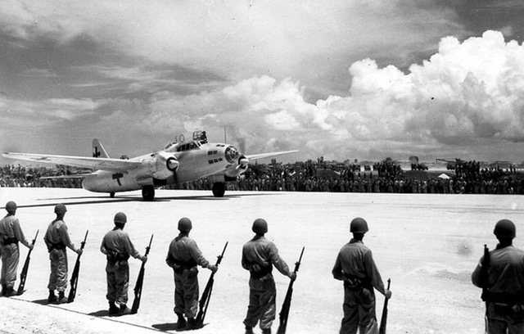

**With its clamshell canopy open and her Captain standing up to direct his co-pilot through the crowd, the first Green Cross Betty to land at Iejima taxis past a seemingly endless line of enemy soldiers. The scene is one of abject humiliation and intimidation. That pilot must surely have felt the mistrust of the thousands of pairs of eyes burning as he rolled by.**

**Photo: USAAF**

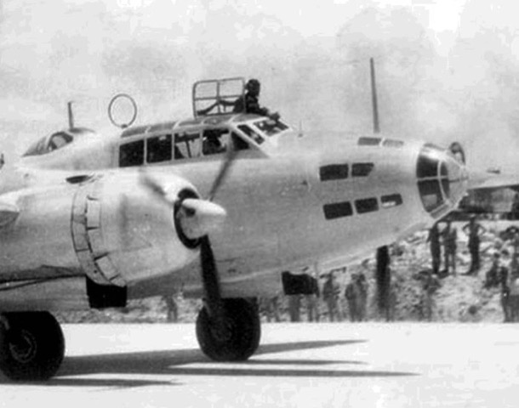

**A close-up of the Betty taxiing along in front of the thousands of suspicious American servicemen. This had to be intimidating to the Japanese, especially to the lone pilot standing up and accepting the glares of all.  Photo: USAAF**

**I found the personal family memoirs of Army combat engineer Leigh Robertson on the web.**

**Leigh was an eyewitness to the arrival on Leshima of the *Green Cross* surrender aircraft. The following link to his memory of that day is perfect as he immediately wrote it down in a letter back home to his parents:**

***Sunday, August 19th 1945***

***Dear Folks,***

***I don't know how long it will be until I can mail this letter. I am writing it now, while things are fresh in my mind. I have just seen what the most important event in the world today is probably. It was the arrival of the Japanese envoys on their way to Manila, to sign the preliminary peace agreement with Gen. MacArthur.***

***We had known for the last three days that they were going to land here. We expected them yesterday, but they were delayed, for some reason. We went to work this morning as usual, and worked until about ten. Then the word went around that the Japs were coming. We piled into trucks and drove up to the airstrip. We waited expectantly for over an hour.***

***Finally, word went out once more that they would not arrive until 1:30 P.M, so we decided to come on back to camp and eat lunch (we had baked ham, by the way).***

***Just before we left us watched two giant four engine transports (C-54s) circle the field and land. These were the planes that would take the Japs on to Manila.***

***Just as I was leaving the mess hall, the news came over the radio that the Jap planes were circling the island, and sure enough, they were! I ran to my tent, put away my mess gear, grabbed my cap and climbed on a truck.***

***It is about two miles to the airstrip, but we made pretty good time, because all the traffic was going the same way. As we came closer to the field, we became part of a strange procession. Directly in front and to the rear of us were two P-38s (twin engine fighter aircraft). Further on down the line there were tractors, motor graders, and in fact, most every kind of vehicle you can imagine--all loaded with G.I.s.***

***We parked the truck about a quarter mile from the strip and ran the rest of the way. I got separated from the rest of the men, and stopped on a high spot about 75 yards from the strip. I had scarcely gotten settled when the planes started in for a landing.***

***The planes themselves were Japanese "Betty" bombers, with two engines, bearing some resemblance to our B-26. They were painted white, with green crosses. It had been a hasty paint job -- you could still see the red of the rising sun showing through the white.***

***Naturally, the planes had been stripped of all armament. They were escorted by two B-25s, and I don't know how many P-38s, probably a hundred or more. The latter continued to circle the field for an hour or more, until all the excitement was over.***

***Both planes made perfect landings, rolled to the far end of the strip, turned and taxied back to our end. They parked right alongside the two large transports that had arrived earlier. They were dwarfed by comparison to our transports.***

***We were not permitted within a hundred yards or so of the four airplanes. There were several hundred people gathered around the planes, most likely photographers and Air Corps officers. They pretty well hid from view the events of the next few minutes. I could see various people boarding the transport, but couldn't tell much about them.***

***Presently they towed one of the Jap planes up a taxiway to a parking area close to where I was sitting. One of our boys pulled his truck right up to the fence, and raised the dump bed. This gave us a grandstand seat, about 15 feet off the ground. When the plane came to rest, the crew started climbing out. There were five in all, dressed in heavy flying clothes. There were two jeeps waiting to take them away. Evidently they didn't speak English, for there was much waving of hands and shrugging of shoulders.***

***About this time two or three thousand soldiers broke through the ring of guards and started for the Japs. They didn't have any bad intentions, just curiosity, and wanting to take pictures. I know that if I had been in the place of those Japs, I would have been just a wee bit scared! At any rate, they lost no time in getting into the Jeeps and away from the mob!***

***Finally, they managed to get the crowd back far enough to bring the other "Betty" over to the parking area. After a few minutes one of the C-47s (edit C-54s?) warmed up its engines and taxied onto the strip. With a mighty roar, she started down the runway. Before she got halfway down the runway, she was in the air, on her way to Manila.***

***It was a great show, and one I don't think I shall ever forget, for it is part of the last chapter of this war that has caused so many hardships, and so many heartbreaks. Thank God it is all over.***

***I wish that you would save this letter for me, or make a copy of it. What I saw today is one of the few things that I have seen, or will see, while I'm in this army that will be worth remembering.***

***Just as soon as I find out from the censor that it is O.K., I'll mail this. You will probably have read about it in the newspapers, and seen it in the newsreel, but this may give you a little different slant on it.***

***I sure do think of you folks a lot. Maybe it won't be too long now till I can be back with all of you again. I want to write to Barbara tonight, so I'll end this now.***

***Love, Leigh***

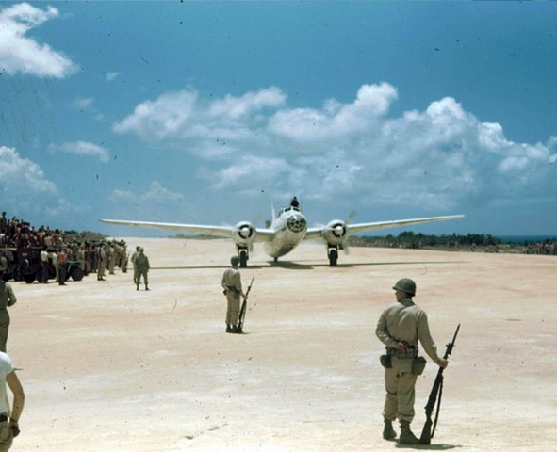

**The captain of the second Mitsubishi Betty also stands up to direct his co-pilot through the crowds waiting and watching. We can tell this is a different Betty as the previous one has a window panel just behind the nose glazing under the chin of the aircraft. This one does not have that particular window pane.**

**Photo: Fred Hill, 17th Photo Recon Squadron**

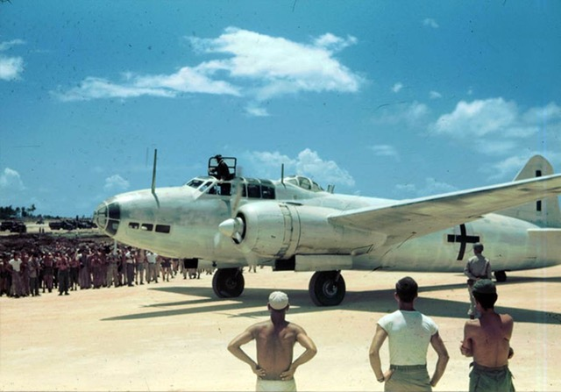

**With his twin Kasei 14-cylinder engines thundering, the Japanese pilot guides the Betty through the crowded taxi strip.**

**Photo: Fred Hill, 17th Photo Recon Squadron**

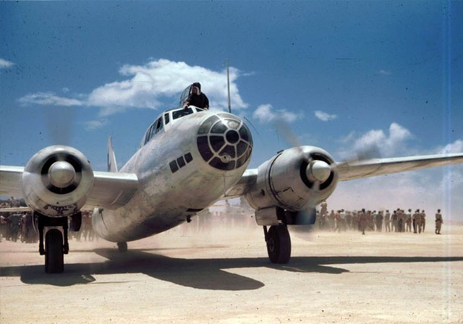

**Guiding his co-pilot from his perch above the Betty, the commander of the second Green Cross Betty commands him to swing round into position near the awaiting C-54 transports of the Americans. In doing so he blasts the crowd of American sailors and airmen. We can see in this photo that all of the men in the background have their backs turned against the dust storm. Perhaps this was the one satisfying moment for the Japanese crews in this most humiliating of days.**

**Photo: Fred Hill, 17th Photo Recon Squadron**

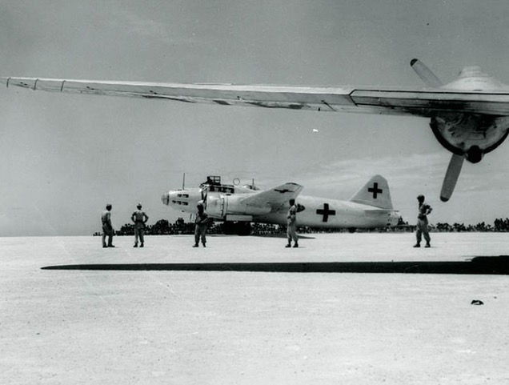

**One of the two Bettys comes to a stop across from the waiting Douglas C-54 aircraft that will take the envoys to Manila.**

**Photo: U.S. Naval Historical Center**

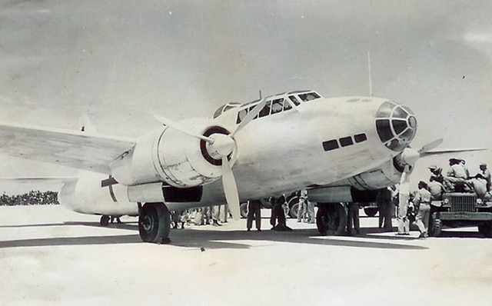

**The second *Green Cross* Betty to land at Iejima begins to unload its passengers and crew, while American soldiers crowd around. The distinguishing features that help us tell this Betty from the other are the different glazing panels on the nose and the fact that this does not have the Radio Direction Finding (RDF) loop antenna on the top of the fuselage.**

**Photo via** [**leighrobertson.net**](https://eur02.safelinks.protection.outlook.com/?url=http%3A%2F%2Fleighrobertson.net%2F&data=02%7C01%7C%7C1698a02966664681abc108d6c816ba9f%7C84df9e7fe9f640afb435aaaaaaaaaaaa%7C1%7C0%7C636916397338949000&sdata=FUPtgIh637mDLoKTtpMoIKBs1ZXbzDfzLz0copwADow%3D&reserved=0)

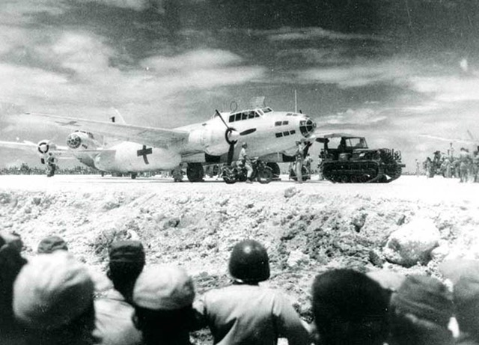

**The two Green Cross aircraft are stared at by thousands of American soldiers, who watch from the gullies surrounding the airstrip, hoping to get a close look at the once hated, now defeated, Japanese airmen. Note the RDF loop antenna at the top of the fuselage.**

**Photo: U.S. Naval Historical Center**

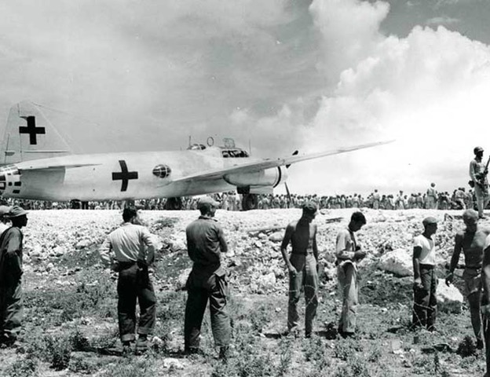

**American soldiers and airmen, in daily working gear, gawk at the once-hated Mitsubishi G4M Betty painted white like a flag of surrender and no longer wearing her proud red rising sun roundels known as the Hinomaru. Instead they are required to wear green crosses -- Christian symbols if there ever were any. With her RDF loop, this is clearly the first of the two Bettys.**

**Photo: U.S. Naval Historical Center**

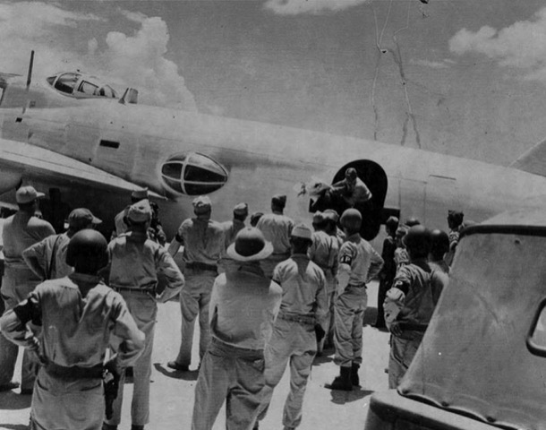

**Moments after the second all-white Betty shuts down on the leshima ramp in the blistering sun, she is surrounded by airmen and plenty of Military Police (MPs). While some of the Japanese stand on the ground, a young airman steps out of the doorway carrying two large bouquets of flowers as a peace offering to the American delegation. The offer of the flowers was rejected by the Americans who felt that it was too soon to make nice with the once haughty Japanese who had treated Allied POWs so roughly. It would be like Auschwitz survivors accepting flowers from the SS, but you have to feel sorry for the young man bearing the gift.**

**Photo via** [**warbirdinformationexchange.org**](https://eur02.safelinks.protection.outlook.com/?url=http%3A%2F%2Fwarbirdinformationexchange.org%2F&data=02%7C01%7C%7C1698a02966664681abc108d6c816ba9f%7C84df9e7fe9f640afb435aaaaaaaaaaaa%7C1%7C0%7C636916397338959005&sdata=5GRDz%2FTv5Ua6kze8WtNA4%2FCU3ZbQ74QkyBUMyw9c4oE%3D&reserved=0)

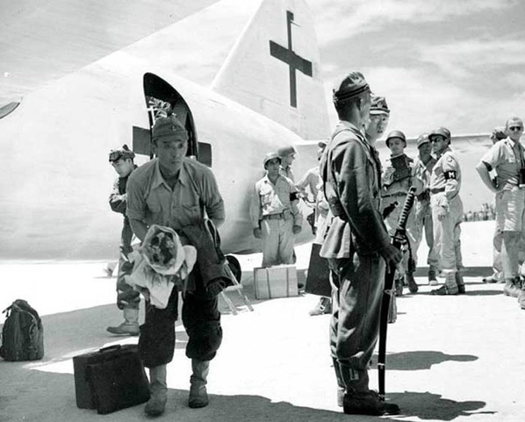

**Looking more than a little worried and even terrified, the young Japanese soldiers look about them to see only angry, disdainful faces. The soldier on the left is the one who has just had his gift of flowers rejected and is no doubt looking for a place to hide.**

**Photo: U.S. Naval Historical Center**

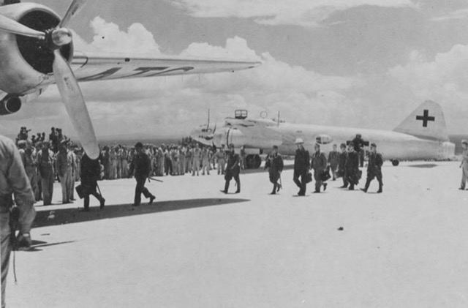

**Japanese officers and leaders, with a mandate to negotiate their surrender, cross from their Mitsubishi Betty to awaiting C-54 aircraft which will take them to Manila. The truth is there were no negotiations. Surrender was unconditional. But they were there to accept the orders of surrender. The formal signing of the surrender would take place aboard the USS *Missouri*in Tokyo Bay on 2 September 1945 (two weeks later).**

**Photo: U.S. Naval Historical Center**

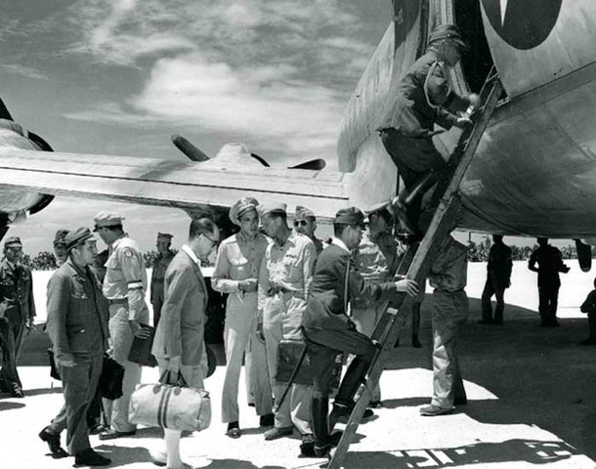

**Formalities on the ground were quickly performed and within 20 minutes, the eight official commissioners were guided up a ladder into a massive Douglas C-54 transport aircraft, a luxurious accommodation when compared to the Japanese Bettys. They were then flown to Manila in the Philippines to meet with MacArthur.**

**Photo: U.S. Naval Historical Center**

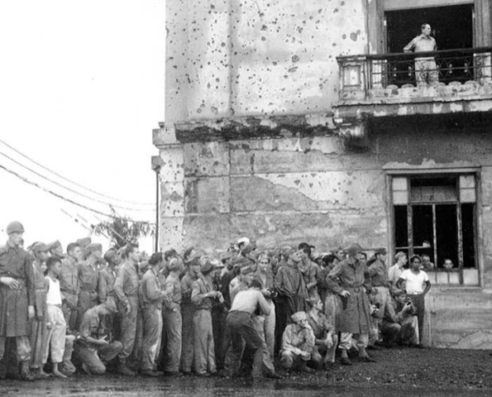

**After the Japanese delegates boarded the American C-54 Skymaster at Iejima, they were flown 1,500 kilometers over the South China Sea to Manila, the capital of the Philippines.  Here, we see General Douglas MacArthur watching the arrival of the Japanese entourage from the balcony of the ruined Manila City Hall. Most of the city's fine old Spanish-style buildings were destroyed in the battle to retake the city from the Japanese in February and March of that year. Americans and Filipino citizens look on warily. More than 100,000 Manilans and 1,000 Americans were killed battling the Japanese, so this crowd would not be considered to be welcoming.**

**Photo: U.S. Naval Historical Center**

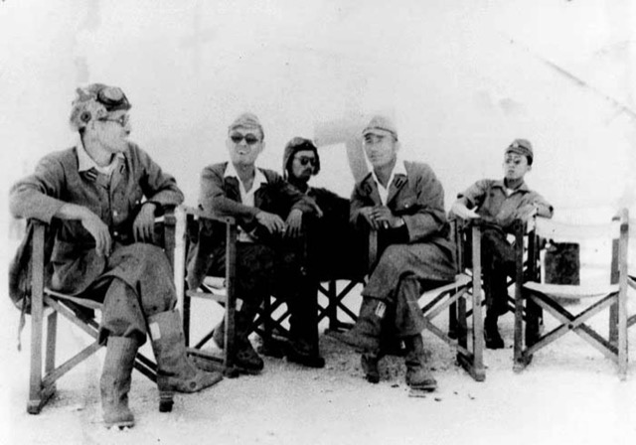

**The entire background washed out. However, we can just make out the green cross on the fuselage and one higher on the tail. Notice how none of the airmen are looking directly at the photographer, indicating submission. Photo: U.S. Naval Historical Center**

**Chief Warrant Officer James Chastain, an air force photographer/photo lab**

**The aircrew from one of the *Green Cross* Bettys shelter from the sun under the wing of their aircraft. With such extreme sunlight, white coral airstrip and white airplane, it is easy to see how the photographer, exposing for the men,**

## **Source: delta air lines**

[**Rare photos of the Japanese pre-surrender, really interesting.**](https://deltavan1.wordpress.com/2017/04/06/rare-photos-of-the-japanese-pre-surrender-really-interesting/)

April 6, 2017

On Sunday, March 26, 2017 6:01 AM, J D Anderson <jadave@hughes.net> wrote: