**Throw a Nickel On the Grass…Save a Fighters Pilot’s Ass**

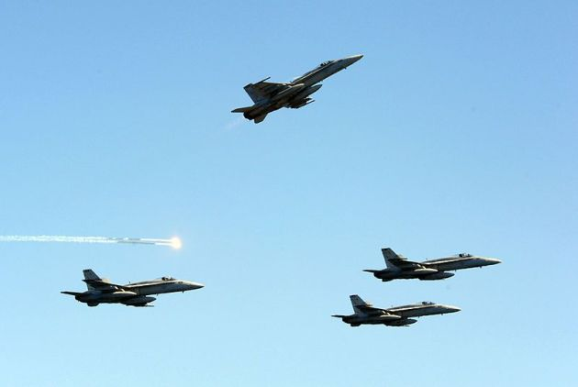

|  |  |
| --- | --- |
| |  | | --- | | Greek mythology states that the ferryman of Hades, Charon,, requires payment of one coin to ferry a soul across the River Styx that separates the worlds of the living and the dead. Coins were typically placed in the mouths of loved ones before burial to ensure safe passage to the underworld. Over time this has been adopted in various forms across societies. Today, a coin left on a headstone signifies that somebody stopped by to pay their respects.  While there are various informal military coin denomination hierarchies circulating today (a penny if you knew the person, quarter if you were present when they passed, etc.), to the Airman it is a moot point. There is only one coin that matters: the nickel. Of all the fighter pilot traditions and accompanying heritage, the phrase "nickel on the grass"is easily held in the highest regard of all. The phrase, a chorus from an old fighter pilot song, has evolved to become synonymous with remembering a fallen aviator.   In early twentieth century London, the Salvation Army worked their way through the streets collecting donations and were sometimes confronted with unruly crowds. A family of musicians found a creative solution and began working with the local Salvation Army and played music to distract the crowds. By 1915, the Salvation Army bands migrated to the United States and had grown in popularity in outside the bars on college campuses. After playing songs, the band would come though the bars and pass around an upside-down tambourine while repeating,  "Throw a nickel on the drum and you'll be saved."  Eventually and inevitably, the drunken students caught onto this and the parody,"Throw a nickel on the drum, save another drunken bum" became popular--more popular than the Salvation Army band's original version. This itself inspired several colorful limerick spin-offs in the 1920's.  Years later, a talented F-86 pilot named William Starr conceived, wrote, and sung similar limericks while assigned to the 336th Fighter Squadron. During his time in Korea at K-14 air base in 1954 he continued to write and his compositions grew in popularity. While he was surely not the first to pen limericks about flying, he was by far the most popular; his notebook was appropriately titled "The Fighter Pilot's Hymn Book." One day he came across an article from a military folk song singer named Oscar Brand who purported that while the other services had traditions and songs, the Air Force was much too young to have equal representation. Starr got into contact with Brand and unloaded his now-popular songs--all 238 of them! In 1959, this effort produced the album "The Wild Blue Yonder" by Oscar Brand with the Roger Wilco Four. The first, and most popular, song on the album:"Save a Fighter Pilot's Ass."  The title of the song serves as the chorus to verses that tell varying tales of precarious flying situations that all inevitably end with the ultimate sacrifice. The verses, remind us of the daily risk aviators take. The chorus embodies a mark of mutual respect and remembrance for a downed flyer. This message, combined with the melody of the Salvation Army band tune, made it an instant classic.  Save a Fighter Pilot's Ass  Chorus:  Oh, Halleliua, Halleliua Throw a nickel on the grass--Save a fighter pilot's ass. Oh, Halleliua, Oh, Halleliua Throw a nickel on the grass and you'll be saved.  I was cruising down the Mekong, doing six and twenty per When a call came from my wingman, Oh won 't you save me sir? Got three flak holes in my wing tips, and my tanks ain't got no gas Mayday, mayday, mayday, I got six MIGS on my ass.  Chorus  I shot my traffic pattern, and to me it looked all right, The airspeed read one-thirty, I really racked it tight! Then the airframe gave a shudder, the engine gave a wheeze, Mayday, mayday, mayday, spin instructions please.  Chorus  It was split S on my Bomb run, and I got too God Damn low But I pressed that bloody button, and I let those babies go Sucked the stick back fast as blazes, when I hit a high speed stall I won't see my mother when the work is done next fall.  Chorus  They sent me up to Hanoi, the pre-brief said "no ack" by the time that I arrived there,all I saw was flak. Then my engine coughed and sputtered, it was too cut up to fly Mayday, mayday, mayday, I'm too young to die.  Chorus  During the Vietnam War, these popular lyrics were changed by units to reflect their aircraft and mission of the time. In an F-4 squadron: "The Yalu" was modified to "The Mekong", "Major" was replaced by "My Wingman", "Pyongyang" was replaced with "Saigon", and "Sabre" replaced by "Phantom."  Sometime after the war, this chorus phrase made the leap from song to toast, immortalized by an unknown author's closing words in his tribute to the fighter pilot:  "So here's a nickel on the grass to you, my friend, and your spirit, enthusiasm, sacrifice and courage -- but most of all to your friendship. Yours is a dying breed and when you are gone, the world will be a lesser place." | |