Tom Dunne sent this post to us. The sketch was created by M. Razali Ahmad. It is a Classic.

This is my original sketch of the A-4 Skyhawk at the point of moment at velocity = ZERO. Everything will come to a standstill, and something will continue forward due to momentum‼️.   
By definition, an arresting gear, or arrestor gear, is a mechanical system used to rapidly decelerate an aircraft as it lands. Arresting gear on aircraft carriers is an essential component of naval aviation.   
This is at this moment when the hook engages the cable during a normal arrestment, the tail hook engages the wire and the aircraft's kinetic energy is transferred to hydraulic damping systems attached below the carrier deck.

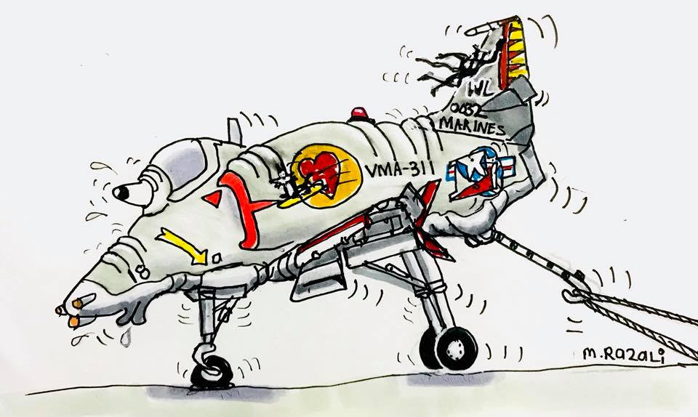

Sgt. Thomas M. Dunne, USMC

H&MS-12, MAG-12, 1st MAW

Chu Lai, South Vietnam and Iwakuni, Japan

July ’69 - July ‘70

H&MS-14, MAG-14, 2nd MAW

MCAS Cherry Point, NC

January ’68 – May ‘69

