**Floyd Bennett Field Today is the**[**Gateway National Recreation Area**](https://www.nps.gov/gate/index.htm)

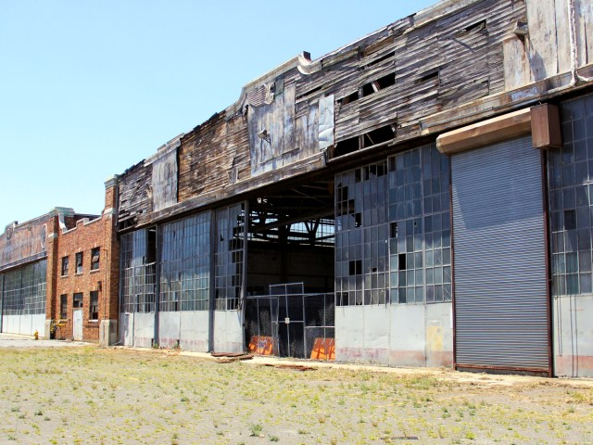Credit: [Ark. Neyman – NV Media](https://www.alamy.com/search/imageresults.aspx?pseudoid=%7bF82CA4D6-4CED-4EF4-ADBF-F207D5BD0603%7d&name=Ark.%2bNeyman%2b-%2bNV%2bMedia&st=11&mode=0&comp=1)/ Alamy Stock Photo

Inaugurated in 1931 on the shores of Jamaica Bay in [Queens](https://dailypassport.com/five-boroughs-of-nyc-guide/), Floyd Bennett Field was the first municipal airport in New York City. Named after a pioneering naval aviator, the airport became [synonymous with record-breaking feats](https://www.nps.gov/gate/learn/historyculture/floyd-bennett-field-historic-flights.htm). In 1931, Russell N. Boardman and John Polando flew a then-record 5,011.8 miles from the airport to Istanbul without refueling. In 1933, Wiley Post landed here after completing the first solo round-the-world flight.

Nowadays, the airport is part of the [Gateway National Recreation Area](https://www.nps.gov/gate/index.htm). The old administrative and passenger terminal building has been restored and serves as a reminder of the [golden age of aviation](https://dailypassport.com/golden-age-air-travel-what-flying-used-to-be-like/). Among the 1,300 acres of grasslands, salt marshes, and tidal flats that encompass the airfield, popular activities include biking, boating, bird-watching, fishing, and snowshoeing in winter.

Many more pictures can be viewed at:

[https://www.alamy.com/stock-photo/floyd-bennett-field%2C-new-york.html?comp=1&mode=0&name=Ark.+Neyman+-+NV+Media&pseudoid={F82CA4D6-4CED-4EF4-ADBF-F207D5BD0603}&sortBy=relevant&st=11](https://www.alamy.com/stock-photo/floyd-bennett-field%2C-new-york.html?comp=1&mode=0&name=Ark.+Neyman+-+NV+Media&pseudoid=%7bF82CA4D6-4CED-4EF4-ADBF-F207D5BD0603%7d&sortBy=relevant&st=11)

***Memories of the Marine Old Timers Club:***

**Tom S**.

Wow! Your report below of a family outing many years ago certainly made for some interesting reading. The best part of it was that you had no idea just how important that particular site was going to be in regards to your future. And to learn that the specific job of a family relative was to fly reporters of the NY Daily News to important news sites was something for your family to be proud of. I guess Aviation was in your genes from the very beginning.

﻿Hey Joe, many thanks for this film that your son found when I was very young person. Oh, I guess around 1939 or 1940. My dad took me over to Floyd Bennett as we had a relative that was flying out of there. He was a pilot for the New York daily news, and used to fly the reporters you know to where they were going to do a story. This is a great film clip and I thank you talk more later Tom.

**Joe H.**

Sun, October 20th, 2024

10:00am — 2:00pm

Description

Experience the Golden Age of Aviation at Floyd Bennett Field! Now part of the National Park Service’s Gateway National Recreation Area, Floyd Bennett Field served as New York City’s first municipal airport beginning in 1931. The Ryan Visitor Center, formerly the administration building and glamorous terminal for the airport, has been restored by the NPS. The terminal was a marvel of its time, and it now houses a museum telling the story of the airfield and the famous aviators, Amelia Earhart and Howard Hughes among them, who flew there.

Visitors may tour the museum and take a peek at the tunnels underneath the runways, not generally open to the public, where airport staff transported travelers’ luggage to their planes. Visitors can also enter the restored control tower, also not generally open to the public, offering panoramic views of Jamaica Bay and the airport’s runways and grasslands. It’s one of the best views in Brooklyn!

Rangers will also be available at Hangar B, on the shores of Jamaica Bay, approximately one mile east of the Ryan Visitor Center. Home of Floyd Bennett Field’s Historic Aircraft Restoration Project (HARP), Hangar B contains dozens of restored and model aircraft.

Access Notes

Access to tower and tunnel will require use of stairs. No elevator is available. The Ryan Visitor Center is accessible by bus (Q35) along Flatbush Avenue, but Hangar B is approximately one mile east of Flatbush Avenue by car, bike, or on foot.

**Joe H’s son Danial:**

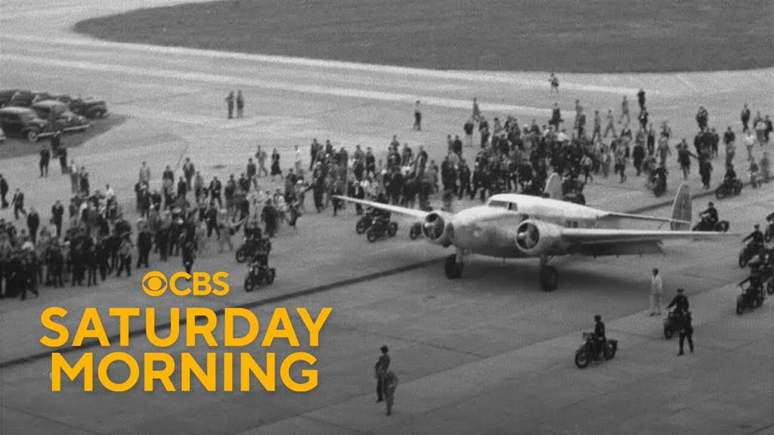

﻿

https://www.youtube.com/watch?v=AhmSzcKL6l0&authuser=0

**Brian P.**

As a child, in the summer my mother would take my brother Jack and me to Riis Park beach. We passed NAS NY on the Flatbush Avenue Extension, and then crossed the Marine Parkway Bridge to the beach to Riis Park which was the original location of NAS, NY. There were fighters and bombers parked very closely, as far my eyes could see. All were left over from WWII awaiting to go to the boneyard. I would press my face to the window for a better view.

Can’t help to think this experience this was part of the reason that Jack and I enlisted in our USMC, there at NAS NY.