
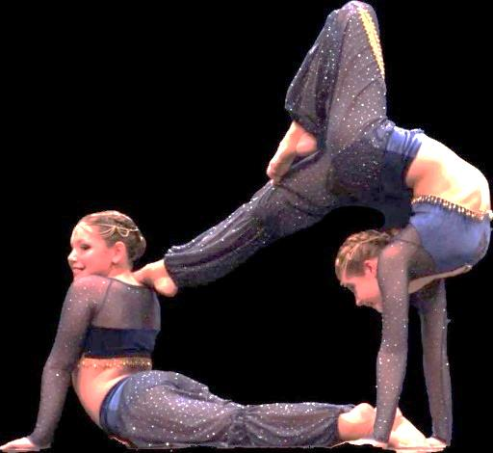

Registration: www.deborahsdanceworkshop.com
ddwdancers@att.net (860)489-8776
August, 3-7, 2026
5:00 – 6:30PM
Acro Workshop
Summer
$135
Per Child
Super fun summer activity!
Ages 7 and up

Deborah’s Dance Workshop
789 Winsted Road
Torrington, CT

