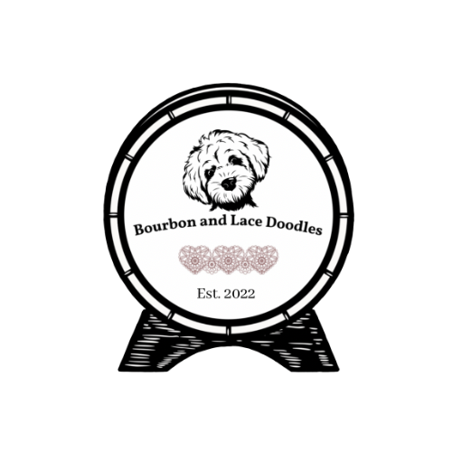
Bourbon & Lace Doodles
Phone: 541-550-3687
Email: Bourbonandlacedoodles@gmail.com
Website: www.bourbonandlacedoodles.com

Puppy Reservation Fee Agreement

Buyer Name: ____________________________________
Address: ________________________________________
Phone: __________________________________________
Email: ___________________________________________
Litter or Dam (if applicable): ________________________
Reservation Fee Amount: $500
Date Paid: _____________________________

1. Purpose of Reservation Fee
The Buyer agrees to pay a non-refundable reservation fee of $500 to reserve a placement on Bourbon & Lace Doodles’ upcoming or planned litter list. This fee holds the Buyer’s position in the selection order and contributes toward the overall purchase price of a puppy.
2. Non-Refundable Nature of Fee
The Buyer understands and agrees that the $500 reservation fee is non-refundable under any circumstances, including but not limited to a change of mind, life event, or decision not to move forward with a purchase. This fee compensates Bourbon & Lace Doodles for administrative time, communication, and management of the litter lists.
If the Buyer completes a purchase, the $500 reservation fee will be applied toward the total purchase price of the puppy.
3. Missed Pregnancy or Puppy Availability
If a planned dam does not conceive, has a smaller litter than expected, or there is no suitable puppy available (for example, based on coat type, temperament, or gender preferences), the Buyer may transfer their reservation to a future litter.
The Buyer may transfer their reservation up to two (2) times. After two skips, the Buyer forfeits their reservation and will be removed from the list without refund.
4. No Guarantees of Timing, Color, or Gender
The Buyer understands that timing, coat color, size, and gender cannot be guaranteed. Breeding outcomes are subject to nature and cannot be precisely predicted. If these preferences are non-negotiable, the Buyer acknowledges that additional patience may be required to wait for a suitable match in a future litter.
5. Reservation Priority
Placement on the list is determined by the order in which reservation fees are received. The Breeder reserves the right to retain first pick(s) from any litter.
6. Acknowledgment
By signing below, the Buyer acknowledges that they have read, understand, and agree to the terms of this Reservation Fee Agreement.

Buyer Signature: _____________________________ Date: ________________
Breeder Signature: ___________________________ Date: ________________

