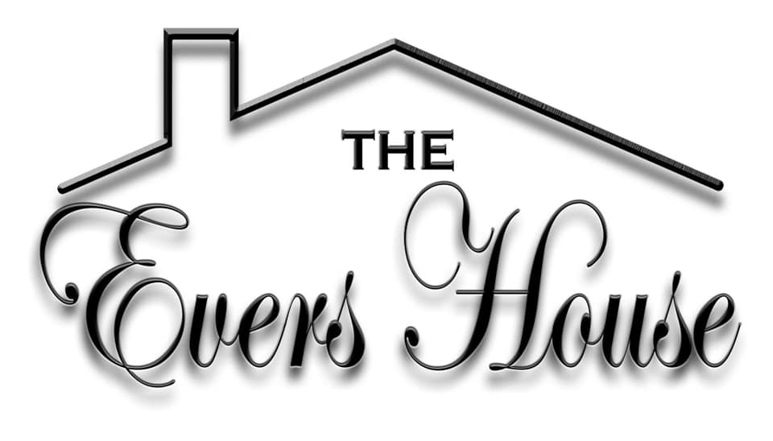
We are a non-profit 501c3 sober-living facility. We prepare women for re-entry to society, most often after long-term incarceration or in-patient rehab.
What we offer-
- Faith & Bible based education, counseling, and study group meetings.
- Individual Case Management
- Group meetings
- Mental Health Services Support
- Public Assistance Services Support
- Medical Services Support
- Legal Counsel Services Support
- Employment Services Support
- Continued Education Support
- Financial Planning
- Family Planning
- Growth & Development
- Community Involvement
- Sober Independent Living
- Transportation
If you or a loved one is in need of help visit www.evershouse.com for an application.
Cathy McClellan, Director & CEO of The Evers House-8506307820, Jennifer Hartley 8508665739

