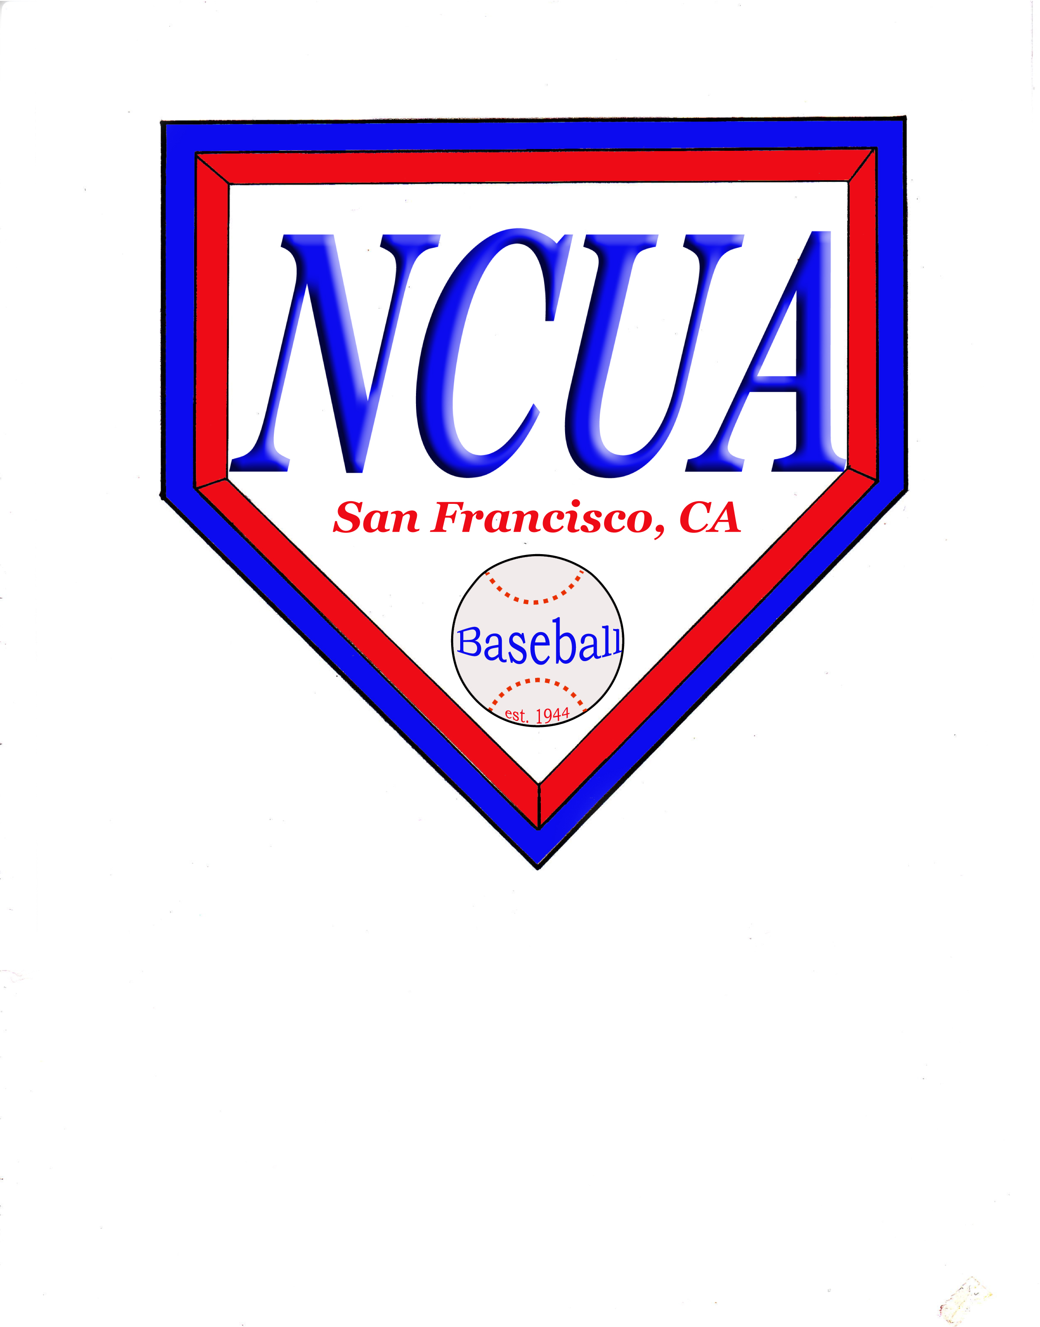
NCUA Baseball
COVID – 19
Policies

Introduction

Covid 19 is a highly contagious disease in which science has not fully investigated to determine the spread or the containment as of this point. Even though we have vaccines
available to some, and hopefully to everyone, it is the purpose of these policies to unsure the best available safety procedures to all umpires to fulfill their assignments.
All the below policies are not to be randomly executed, but to be strictly followed. Any deviation will result in automatic forfeiture of all game assignments.

We must follow the guidelines of many various agencies and entities that govern our health and safety. This includes all health and safety offices of the counties that we supply umpires. Baseball is a sport that can be played when the county has entered the red tier for a constant time of their choosing.

Policies

1. Face Coverings – Face covering must be worn at all times. Even though some may have gotten vaccinated, face coverings shall be worn. The face covering shall be solid in color either, grey, blue or black. Other face covering could be worn under the original face covering in any color that is deemed to be effective for additional protection.

2. Observe Social Distancing – Social Distancing shall be adhered to at all times. When communication is necessary each participant shall be at least 6 feet apart. There will be no line up exchange at homeplate. At games that require line up cards (High School), the umpires will at check in leave a clipboard at any area behind homeplate for coaches to leave the lineup card prior to the game. There is no need for umpires to tear the line up cards and distribute as in the NFHS rulebook. Between innings, the umpires will assume their positions without visiting with each other.

3. Ball Rotation - Each team shall provide a ball rotation station to be manned by a qualified person. When on defense, each ball that is out of play shall be given to the qualified person to be placed in the dirty ball bucket where balls are disinfected. Umpires shall not touch baseballs. It is imperative that each team supply the proper baseballs for the game and not interchange with the other team.

4. Team Dugouts / Team Area – Coaches, game personnel and players are the only ones allowed in the team area. Social Distancing and masks are to be observed in the dugout/team area. Dugout and team area maybe enlarged to outside the immediate area to practice social distancing. This includes moving into the spectator area. Spectators are not allowed in the team area. **NOTE: IT IS NOT THE UMPIRES JOB TO MONITOR THESE AREAS. IF THE UMPIRE IS CONCERNED, HE SHOULD FIND THE GAME ADMINISTRATOR AND HAVE THE ADMINSTRATOR DEAL WITH IT.
TEAMS THAT DO NOT HAVE A GAME ADMINSTRATOR OTHER THAN THE HEAD COACH SHALL REPORT THE TEAM TO THE ASSIGNOR AND/OR BOARD MEMBER IMMEDIATELY.

5. Scorekeeps – There shall be an official scorekeeping area limited to (1) one person from each team and must observe social distancing behind the backstop or other designated area. **NOTE: IT IS NOT THE UMPIRES JOB TO MONITOR THESE AREAS. IF THE UMPIRE IS CONCERNED, HE SHOULD FIND THE GAME ADMINISTRATOR AND HAVE THE ADMINSTRATOR DEAL WITH IT.
TEAMS THAT DO NOT HAVE A GAME ADMINSTRATOR OTHER THAN THE HEAD COACH SHALL REPORT THE TEAM TO THE ASSIGNOR AND/OR BOARD MEMBER IMMEDIATELY.

6. Uniforms - It is encouraged that umpires wear long sleeves to prevent skin contact with the ball. After each game, the umpires’ uniform shall be sanitized either by spray and dry, or washing. All garments including those that protect skin contact such as long johns and undershirts shall be sanitized after use.

7. Equipment & Accessories – Permissible face masks must be worn at all times by all attendees present other than those when engaged in the competition. **NOTE: IT IS NOT THE UMPIRES JOB TO MONITOR THESE AREAS. IF THE UMPIRE IS CONCERNED, HE SHOULD FIND THE GAME ADMINISTRATOR AND HAVE THE ADMINSTRATOR DEAL WITH IT.
TEAMS THAT DO NOT HAVE A GAME ADMINSTRATOR OTHER THAN THE HEAD COACH SHALL REPORT THE TEAM TO THE ASSIGNOR AND/OR BOARD MEMBER IMMEDIATELY.
Players shall use their own personal bin for all personal gear in the dugout/ team area.
**NOTE: IT IS NOT THE UMPIRES JOB TO MONITOR THESE AREAS. IF THE UMPIRE IS CONCERNED, HE SHOULD FIND THE GAME ADMINISTRATOR AND HAVE THE ADMINSTRATOR DEAL WITH IT.
TEAMS THAT DO NOT HAVE A GAME ADMINSTRATOR OTHER THAN THE HEAD COACH SHALL REPORT THE TEAM TO THE ASSIGNOR AND/OR BOARD MEMBER IMMEDIATELY.
Minimize the usage of sharing of playing equipment such as bats, batting helmets, catcher’s gear. **NOTE: IT IS NOT THE UMPIRES JOB TO MONITOR THESE AREAS. IF THE UMPIRE IS CONCERNED, HE SHOULD FIND THE GAME ADMINISTRATOR AND HAVE THE ADMINSTRATOR DEAL WITH IT.
TEAMS THAT DO NOT HAVE A GAME ADMINSTRATOR OTHER THAN THE HEAD COACH SHALL REPORT THE TEAM TO THE ASSIGNOR AND/OR BOARD MEMBER IMMEDIATELY.
****UMPIRE NOTE **** UMPIRING GEAR WORN BY EITHER UMPIRE SUCH AS SHIN GUARDS, CHEST PROTECTORS, FACE MASK /FACE MASK HELMET COMBO SHALL BE DESINFECTED AFTER EACH GAME USE.
Batting Gloves – The use of batting gloves by players are encouraged to minimize the contact with bats, balls and bases. Pitchers by rule are not allowed to use batting gloves on their pitching hand. The use of a batting glove under their pitcher’s glove will be allowed as long as it not distracting to the batter. This is an umpire’s judgment now and not to be used as a distraction from an opposing coach. If a pitcher decides that he can pitch with a glove, then this should be allowed since the CIF and the NFHS encourage the use of gloves. We should not climb that slippery slope.

8. Testing and Vaccinations - NCUA Baseball shall assist and notify all umpires of the requirements of each league about each league’s requirement of testing. If the league requires testing, then the umpire shall be tested at their request and reporting will be made to the either the association or league as required. Currently the testing should be at no cost to the umpire. Vaccinations maybe required of umpires, if the umpire chooses not to receive the vaccination they are not allowed to be assigned to those leagues. If the umpire is vaccinated and changes status, then he will be assigned to those leagues in the next assigning period. NCUA Baseball will not require any umpire to be vaccinated. Umpires who are vaccinated still must follow all policies; vaccinations are not a guarantee of 100 percent (100 %) protection against COVID -19.
9. Policies are in effect immediately and can be added to reduced as each client sends us their requirement. It is each umpire’s duty to notify the assignor, board member, or President of any issues that may help or reduce the fear of working games.

