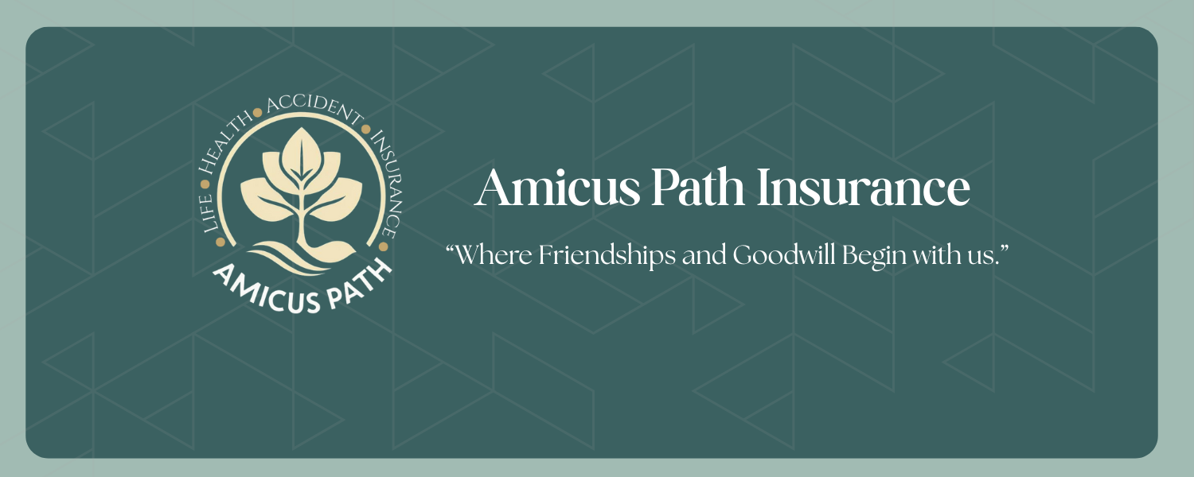
Medicare Made Simple Checklist

Need Help with your Medicare?
Click Link > Permission- To-Contact to complete a Permission-To-Contact Form and email to amicus.ins@the-aplife.com



Candice Bailey-Hunter | Amicus Path Insurance
Licensed Life and Health Insurance Agent

NPN 21001152
931-302-3281
candice.bhunter@the-aplife.com

