

**820304, 820306**

**OP SERIES**

**2:1 RATIO TRANSFER PUMP**

**OPERATIONS MANUAL**

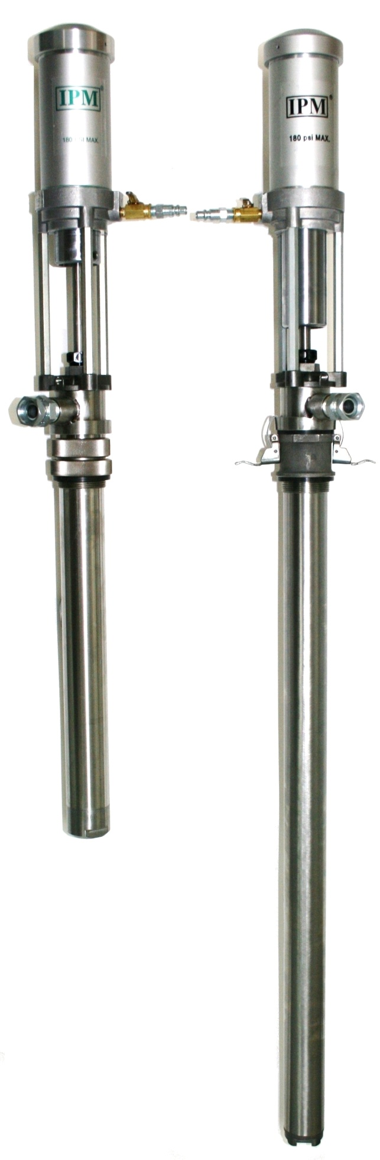

**IPM INC.**

**Manufactured by: International Pump Manufacturing, Inc.**

**Covers: 820304, 820306 Manual Number: MOP2102010**

**OP Series**

**2:1 RATIO TRANSFER PUMP**

**OPERATIONS MANUAL and**

**PARTS IDENTIFICATION DRAWINGS**

**This manual contains IMPORTANT WARNINGS and INSTRUCTIONS. Read and retain for reference.**

**International Pump Mfg, Inc.**

**3107 142nd Avenue East Suite 106,**

**Sumner, WA 98390**

**U.S.A.**

**TEL: (253) 863 2222**

**FAX: (253) 863 2223**

**Website :** [www.ipmpumps.com](http://www.ipmpumps.com/)

**For technical service call your local distributor**

**Copyright 2004 by: International Pump Mfg, Inc.**

**Revised: July 2011**

***\*\*\*WARNING\*\*\****

The equipment described herein must only be operated or serviced by properly trained individuals thoroughly familiar with the operating instructions and limitations of the equipment.

Notice: All statements, information and data given herein are believed to be accurate and reliable but are presented without guarantee, warranty or responsibility of any kind expressed or implied. Statements or suggestions concerning possible use of IPM equipment are made without representation or warranty that any such use is free of patent infringement, and are not recommendations to infringe any patent. The user should not assume that all safety measures are indicated or that other measures may not be required.

TABLE OF CONTENTS

1.0 SPECIFICATIONS………………………………….…. 6

2.0 TYPICAL TRANSFER PUMP INSTALLATION

2.1 Transfer pump and hose routing with mixer…………. 7

2.2 Pro-Series proportioning unit (H-20/35)..……………... 8

2.3 Wall mounted illustration (OP200S)……………………... 9

3.0 OPERATIONAL INFORMATION

3.1 Illustrated physical operation (OP232C and OP2342A)..…... 10

4.0 INSTALLATION……………………………..………….. 12

4.1 Shut down…………………………………………………. 14

4.2 Disassembly………………………………………………. 15

5.0 PARTS IDENTIFICATION (OP232C/OP242A/OP200S/OP250)

5.7 Parts drawing/parts list for 820304 (Air section) 29

5.8 Parts drawing/parts list for 820304 (Fluid section)

5.9 Parts drawing/parts list for 820306 (Air section)

5.10 Parts drawing/parts list for 820306 (Fluid section)

6.0 REPAIR KITS

6.2 OP series repair kits: 820304, 820306 30

7.0 TROUBLESHOOTING…………………………………. 33

8.0 ACCESSORIES AND OPTIONS……………………… 34

9.0 TECHNICAL DATA……………………………………… 39

10.0 WARRANTY INFORMATION…………………………. 41

1. **SAFETY WARNINGS**

Please read and observe all warnings contained in this operations manual before making any attempt to operate the equipment.

**Warning**

To reduce the risk of static sparking or splashing fluid in the eyes or on the skin, follow the ***Pressure Relief Procedure*** before flushing.

For your safety, read the ***Fire or Explosion Hazard*** before flushing and follow all the recommendations.

***Misuse of equipment***

Misuse of equipment can cause serious bodily injury. Use the equipment only for its intended purpose and do not attempt to modify it in any way. Care should be taken to prevent over pressurization of the pump, hose lines and accessories connected to it. Use only IPM designated parts for re-building or repairing this equipment. Use the pump only with compatible fluids. Improper use of this equipment could result in fluid being sprayed on the skin or in the eyes of user, serious bodily injury, property damage, fire or explosion.

Daily maintenance inspection should be made on pumps and equipment and all worn or damaged parts should be re-placed immediately. Do not use pumps, components or hose lines as leverage to move equipment to avoid damage and injury. Do not alter this equipment as doing so could cause it to function incorrectly and/or cause serious injury. Altering this equipment in any way will also void any and all warranty guarantees from the manufacturer.

***Material & fluid compatibility***

Always ensure the chemical compatibility of the fluids and solvents used in the fluid section of these pumps, hoses other components. Check the chemical manufacturer’s data sheets and specification charts before using fluids or solvents in this pump to ensure compatibility with pumps, inner hose lining and outer hose covering.

***Pressurized hoses***

Because the hoses are pressurized they can present a danger should the fluid escape due to damage, worn parts or general miss-use. Escaping fluid can splash or spray operator, causing serious bodily injury and/or damage to equipment and property. Ensure that the hoses do not leak or rupture due to wear, misuse or damage.

Before each use, ensure that the fluid couplings are tight and all clips/pins/plugs are secured. Inspect the entire length of hose for wear, cuts, abrasions, bulging cover and/or loose connections. These conditions may cause the hose to fail and result in splashing or spraying of chemicals on the skin or in the eyes of operator and cause serious injury and/or property damage.

***Pressure specification***

The maximum working pressure of this equipment for fluids and air is *180 psi (12.5 bars)*. Ensure all equipment and accessories used with this pump are rated to withstand the maximum working pressure of this pump. Never exceed the maximum working pressure of the pump, hose lines or any other components attached to the pump itself.

***Pressure relief procedure***

In order to avoid the risk of serious injury to operators from splashing/spraying chemicals, the following safety procedures should be used. This procedure should be used when shutting down the pump, performing general maintenance, repairing a pump or other components of the system, replacing components or when pumping operation is ceased.

1. Close the air valve to the pump.

2. Use the air bleed down valve (see INSTALLATION) to relieve the air pressure in the system.

3. Relieve the fluid pressure by holding a grounded metal pail in contact with the metal part of the fluid dispense valve and slowly opening the valve.

4. With a container ready to catch the fluid, open the drain valve (see INSTALLATION).

5. It is a good practice to leave the drain valve open until it is time to dispense fluid again.

If you are unsure that the fluid pressure has been relieved due to a blockage in a component or a hose, carefully relieve the pressure by carefully loosening the hose end coupling to allow the fluid pressure to escape slowly. After the pressure has been relieved, the fitting can then be removed and any blockages removed. If the pump is to remain idle for only a short period of time, it is not necessary to empty the wet cup.

#### *Flush the pump before initiating operation*

1. The pump is tested with lightweight DOP oil, which is left in to protect the pump parts. If the fluid you are pumping may become contaminated by oil, flush oil from pump with a compatible solvent before use. Follow the flushing instruction below.

2. When pumping fluids that set up or solidify, flush the system with a compatible

solvent as often as necessary to remove build-up of solidified chemicals in the pump or

hoses.

3. If the pump is being used to supply a circulating system, allow the solvent to circulate through the entire system for at least 30 minutes every 48 hours or more often if necessary to prevent settling and solidification of chemicals.

1. Always fill the wet-cup 1/2 full of throat seal liquid (TSL) or compatible solvent to keep the fluid from drying on the displacement rod and damaging pump throat packing.
2. Lubricate the throat packing frequently, when you are pumping a non-lubricating fluid or are shutting down for more than one day.

1. IPM transfer pumps incorporates a wet tube, the purpose of which is to prevent the build-up of chemical and dirt on the pump shaft which would damage the packing as the shaft reciprocates through them. This wet tube must be full when a pump that has not been thoroughly flushed and cleaned is stored outside the protected environment of a sealed drum as well as when the pump is in use. Should a pump be installed in a partially filled drum where the liquid level is below the top of the wet tube, the tube must be manually filled with the proper chemical prior to inserting into the drum.

#### *Shut down & care of pump*

For overnight shut down, follow the *Pressure Relief Procedure* (page 5). Always stop the pump at bottom of the stroke to prevent the fluid from drying on the exposed displacement rod and damaging the throat packing**.**

***Hazards from fire or explosion***

Hazards exist where sparks can ignite vapors or fumes from combustible chemicals or other hazardous conditions exist such as explosive dust, etc. Every part of the equipment must be properly grounded to prevent static electricity from generating a spark and causing the pump or system to become hazardous. These sparks can cause a fire, explosion, property and equipment damage and serious bodily injury. Ensure that the pump and all components and accessories are properly grounded and that electrical supply cords are not plugged in or unplugged when these hazards exist.

Should any evidence of sparks or static electricity exist, discontinue pump operation immediately. Investigate the source of the static electricity and correct the grounding problem. Do not use the system until the grounding problem is repaired.

***Grounding the pump***

Always use the following procedures for grounding the pump. Loosen the lock screw to allow insertion of one end of a minimum sized 12 gauge wire into the bore hole of the grounding lug. Insert wire and tighten the lock screw securely. Secure the other end of the ground to a true earth ground. Grounding of the pump and all components is necessary to minimize the possibility of sparks due to static electricity. Grounding must be in compliance with local electrical codes. Check with the local authorities for requirements in your area and with the type of equipment being used.

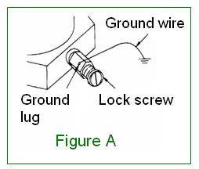

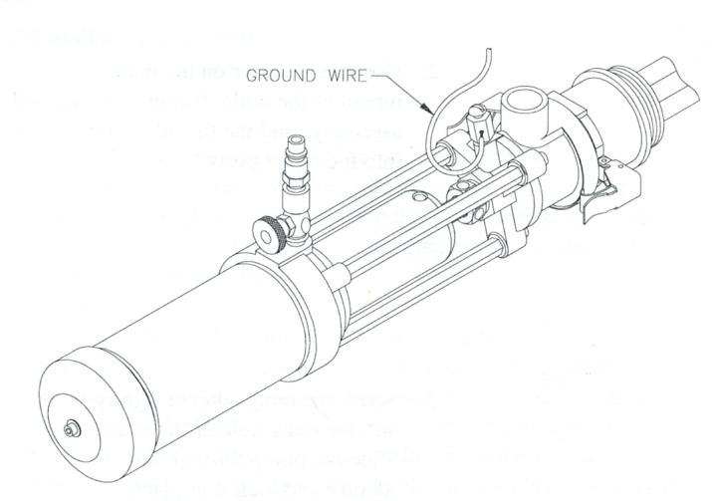

Ensure that all the following equipment is grounded correctly:

1. Air compressor: Follow the grounding procedures as recommended by the compressor manufacturer.

2. Air hoses: Always use grounded air hoses.

1. Fluid container used to

supply the system: Grounding must be done according to local electrical codes.

4. Pump: Follow the procedures referred to in Figure A (page 6).

5. Fluid Hoses: Always use grounded fluid hoses.

6. Dispensing Valve: The valve must be metal to conduct through the fluid hose to the pump which must be properly grounded.

7. Dispensing Point: Grounding must be done according to local electrical codes.

8. Solvent Containers Grounding must be done according to local electrical codes. use only metal: conductive pails that are properly grounded.

9. Grounding while

dispensing, cleaning Maintain conductivity by firmly securing the metal part of the

or relieving pressure: dispensing valve to the side of a grounded metal container

***Hose grounding***

It is very important that the hoses used for both air and fluid dispensing be a grounding type and that ground continuity is maintained at all times during operation. Regular checks of the hose ground resistance (with a resistance meter using a suitable range) and a comparison to the manufacturer’s specification will ensure that the ground is within specifications. If it is not within specified limits it should be replaced immediately.

***Solvent cleaning***

While cleaning the system with solvent, secure the metal part of the dispensing valve in contact with a grounded metal pail to minimize the possibility of splashing/spraying of chemicals on the skin, in the eyes and around static sparks. Use low fluid pressure for additional safety.

***Hazards from moving parts***

Use the *Pressure Relief Procedure* to prevent the pump from starting un-intentionally or

unexpectedly. Be aware of moving parts that present a pinching hazard to fingers or other body parts. Stay clear of these moving parts at all times when starting or operating the pump.

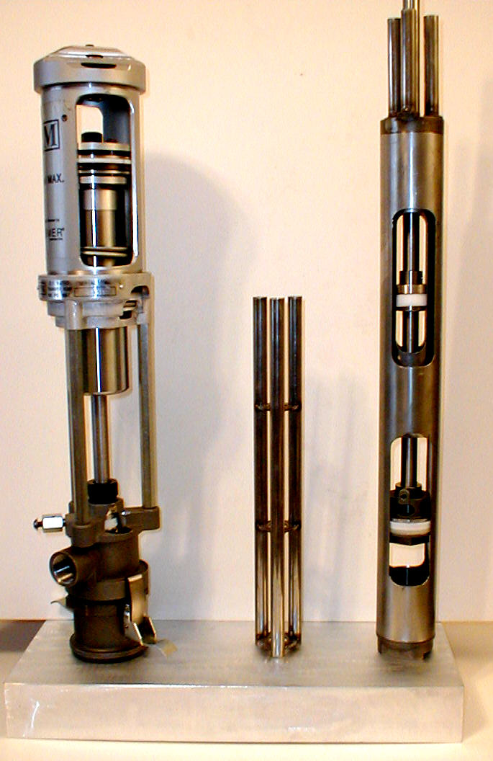

***Safety standards***

Safety standards have been established by the United States Government under the Occupational Safety and Health Act. These standards should be consulted as they apply to the hazards and type of equipment being used.

1. **INSTALLATION**

**D**

**B**

**2.1 Typical wall mounted system with drum mixer**

# 820304

Transfer pump

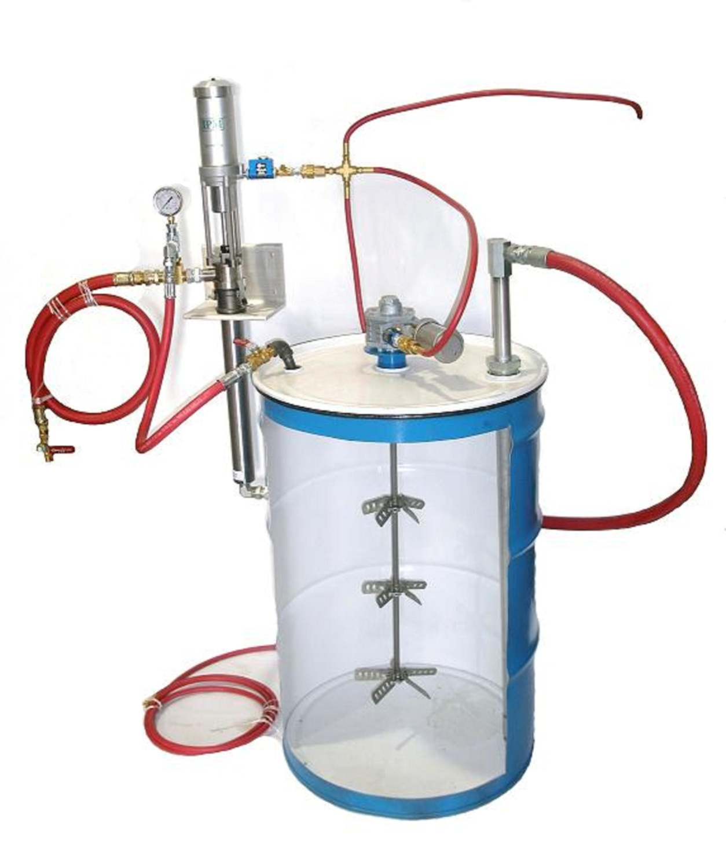

610036

¾” brass “T”

#608005

Fluid pressure gauge

# 610046

Wall mounting plate

# 602004

In-line lubricator

H

L

K

J

E

F

D

|  |  |  |  |  |  |  |
| --- | --- | --- | --- | --- | --- | --- |
|  | **Description** | **P/N** |  |  | **Description** | **P/N** |
| **A** | **OP200S Pump** | **820304** |  | **H** | **1/4" Female Cross** | **610012** |
| **B** | **Outlet Pressure Gauge** | **608005** |  | **H** | **1/4" X 10' air hose** | **609002** |
| **C** | **3/4" Brass Tee (F X F X M)** | **610036** |  | **H** | **1/4" X 36" air hose** | **609001** |
| **C** | **Bushing 3/4" X 1/2"** | **610037** |  | **H** | **1/4" MP X 1/4" FP adaptor** | **610011** |
| **C** | **1/2" Carbon Steel Tee (F X F X M)** | **610038** |  | **H** | **1/4" female quick disconnect** | **610003** |
| **C** | **90 degree elbow** | **610039** |  | **I** | **Aluminum mounting plate** | **610046** |
| **C** | **Bushing 1/2" X 1/4"** | **610040** |  | **J** | **3/4" X 6' hose (MPS X MPS)** | **609046** |
| **D** | **3/4" X 10' Hose (MP X MP)** | **609012** |  | **J** | **90 degree elbow (FP X FP)** | **610048** |
| **D** | **3/4" Ball Valve (FP X MP)** | **610041** |  | **J** | **1" X 36" aluminum tube** | **610049** |
| **D** | **3/4" adaptor (MP X FP Swivel)** | **610001** |  | **J** | **Foot valve coupling** | **501605** |
| **E** | **1/2" X 3' Hose (MPS X MPS)** | **609045** |  | **J** | **Foot valve** | **500290** |
| **E** | **1/2" Ball Valve (FP X MP)** | **610042** |  | **J** | **O-Ring (for foot valve)** | **500237** |
| **E** | **1/2" 90 Degree FP X FP Elbow** | **610043** |  | **J** | **90 degree Elbow (MP X FPS)** | **610050** |
| **E** | **1/2" X 6" pipe nipple** | **610044** |  | **K** | **2" X 1" bung adaptor** | **610051** |
| **E** | **1/2" pipe cap** | **610045** |  | **K** | **Bung adaptor O-Ring** | **610052** |
| **F** | **DM-101 Pneumatic mixer** | **604011** |  | **L** | **In-line lubricator** | **602005** |
| **G** | **In-line lubricator (MP X FP)** | **602004** |  |  |  |  |

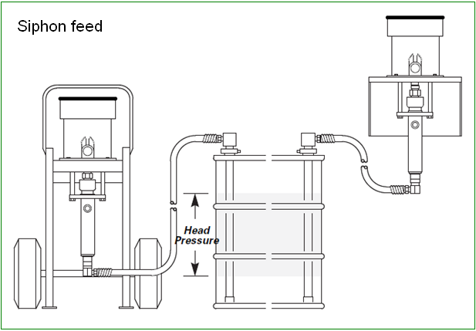

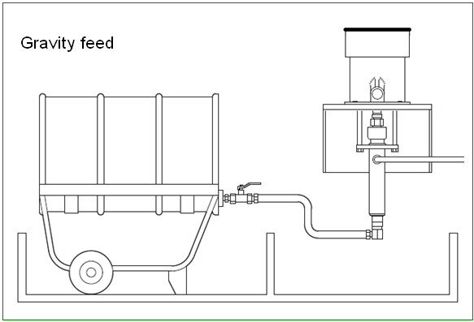

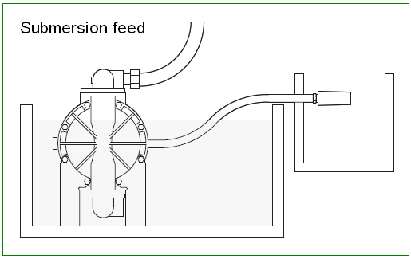

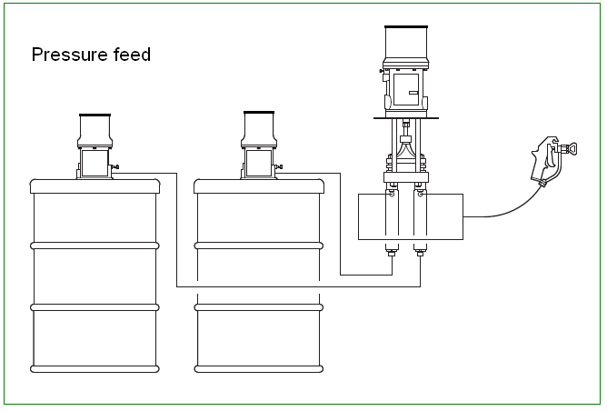

**3.0 OPERATIONS**

**3.1 Working principle of transfer pump**

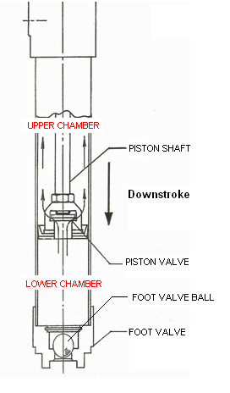

**Downstroke:** When the PISTON SHAFT is in the downstroke motion, the fluid that is present in the lower chamber of the cylinder moves the FOOT VALVE BALL into the closed position. The entrapped fluid then lifts the PISTON VALVE up as it flows into the upper chamber and to the fluid outlet in **Figure B** (page 9).

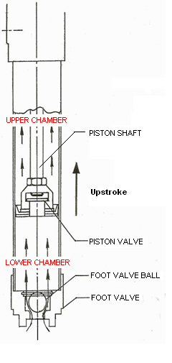

**Upstroke:** During the upstroke motion, the PISTON VALVE is closed and fluid present in the upper chamber is transferred to the outlet port. At the same time, the FOOT VALVE BALL is opened by incoming pressure and fluid is then drawn into the lower chamber

**Each IPM transfer pump is a 2 stage pump system. They are designed to pump fluid on both the up stroke and down stroke during operation for optimum efficiency and output.**

** **

**3.2 Start up and adjustment of transfer pump**

1. Ensure that the air control valve is closed then open the bleed-type master air valve. Connect the quick disconnect coupler to the male fitting.

2. For safety, open the dispensing valve slowly, then drain fluid into a grounded metal container. Ensure metal-to-metal contact is maintained between the container and the valve at all times.

3. Adjust the air control valve slowly for just enough pressure to start running the pump. This is to prime all air within the system. After all the air has been expelled from the lines, close the dispensing valve. During the priming of the pump, the pump operates when the dispensing valve is opened and stops when the valve is closed.

4. Turn the air regulator slowly until sufficient flow from the dispensing valve is achieved. Remember to always run the pump at the lowest possible speed necessary to achieve what is desired. Never exceed the maximum working pressure of any component in the system.

1. The pump should not be left to run dry of the fluid being worked upon. When running empty, the operating speed will rise rapidly, increasing the chance of damage to the pump and/or components. During operation should the pump be found to run too fast, stop it immediately and ensure the fluid supply is not too low or the drum is empty. If air has gone into the system, repeat the priming procedure. Ensure that all air has been expelled from the lines before beginning operation again. Flush the pump or leave it filled with a compatible solvent when not in use.
2. Always follow the Pressure Relief Procedure should the pump be put away for any period of time or during system shut off at the end of the day.

**3.3 Shut down procedure**

1. Relieve the air pressure with the air regulator.
2. Open the air needle valve.
3. Bleed off residual pressure in the system with the bleed-off master air valve.
4. Open the drain valve to relieve fluid pressure in the system. Use a container to collect the fluid drained off. **Be especially careful as the fluid may still be under pressure**. Hold the metal fluid drain valve against the side of the grounded container while relieving the pressure.

**Note: For long periods of shut-down, flush the pump thoroughly with an appropriate cleaning fluid to prevent solidified chemical build-up.**

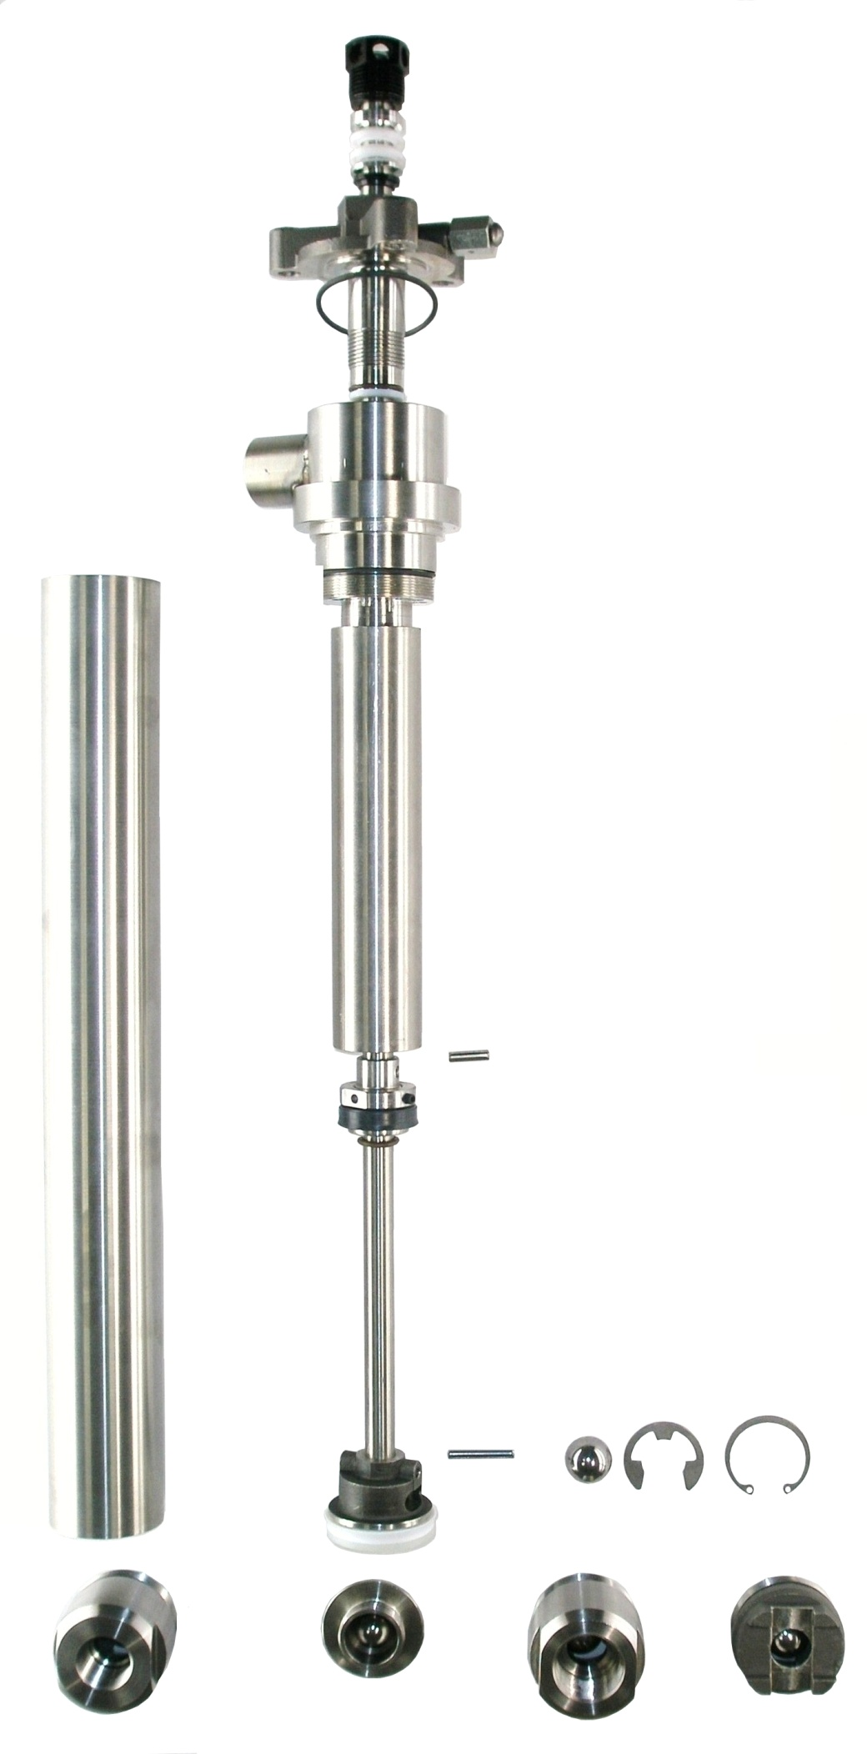

**4.0 FOOTVALVES**

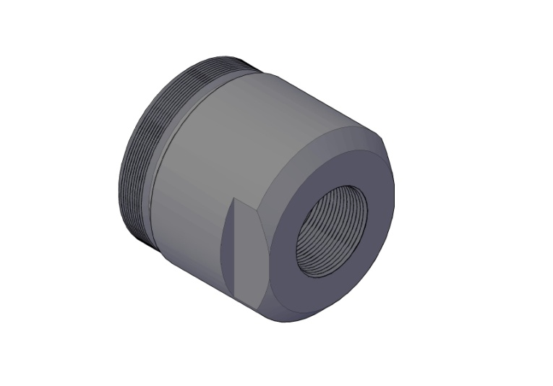

For the OP200S, remove the foot valve housing using

a 1-3/4” open end wrench. This foot valve is offered

in two different sizes; a ¾” female threaded (500087)

or a 1” female threaded (500194).

|  |  |
| --- | --- |
| **5.0 2011 IPM PUMP IDENTIFICATION LIST** | |
|  |  |
| **Part #** | **Description** |
| 810101 | Drum length Carbon steel 1:1 transfer pump |
| 810102 | Stubby length Carbon steel 1:1 transfer pump |
| 810103 | Drum length Stainless steel 1:1 transfer pump |
| 810104 | Stubby length Stainless steel 1:1 transfer pump |
| 810105 | Pail length Carbon steel 1:1 transfer pump |
|  |  |
| 810201 | Drum length Carbon steel 2:1 transfer pump |
| 810202 | Stubby length Carbon steel 2:1 transfer pump |
| 810203 | Drum length Stainless steel 2:1 transfer pump |
| 810204 | Stubby length Stainless steel 2:1 transfer pump |
|  |  |
| 820301 | Drum length Stainless steel 2:1 transfer pump |
| 820302 | 30 GAL. drum, 3/4 length stainless steel 2:1 transfer pump |
| 820303 | Low ceiling, drum length Stainless steel 2:1 transfer pump |
|  |  |
| 820304 | Wall mount, Stubby length Stainless steel 2:1 transfer pump |
| 820306 | Drum length stainless steel 2:1 transfer pump |
|  |  |
| 830802 | Drum length Stainless steel 5:1 transfer pump |
| 830803 | Stubby length Stainless steel 5:1 transfer pump |
|  |  |
| 840902 | Drum length Stainless steel 10:1 transfer pump |
| 840903 | Stubby length Stainless steel 10:1 transfer pump |
|  |  |
| 841001 | Stubby length Stainless steel 15:1 transfer pump |
|  |  |
| 841101 | Stubby length Stainless steel 30:1 transfer pump |

**6.0 PARTS DIAGRAMS**

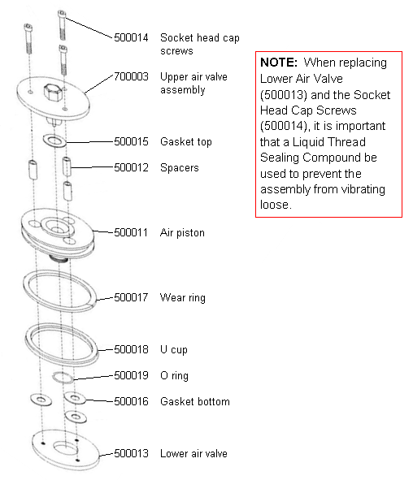**6.1 Air motor assembly**

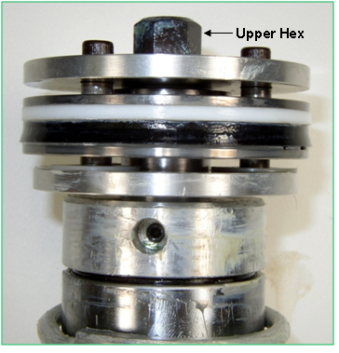

**Note: Upper hex nut is a permanent part of upper air valve plate (#700003). Do not use a wrench on hex nut during disassembly, assembly or maintenance of air motor assembly.**

**5.3 Parts drawing for OP series air section**

**820304 & 820306**

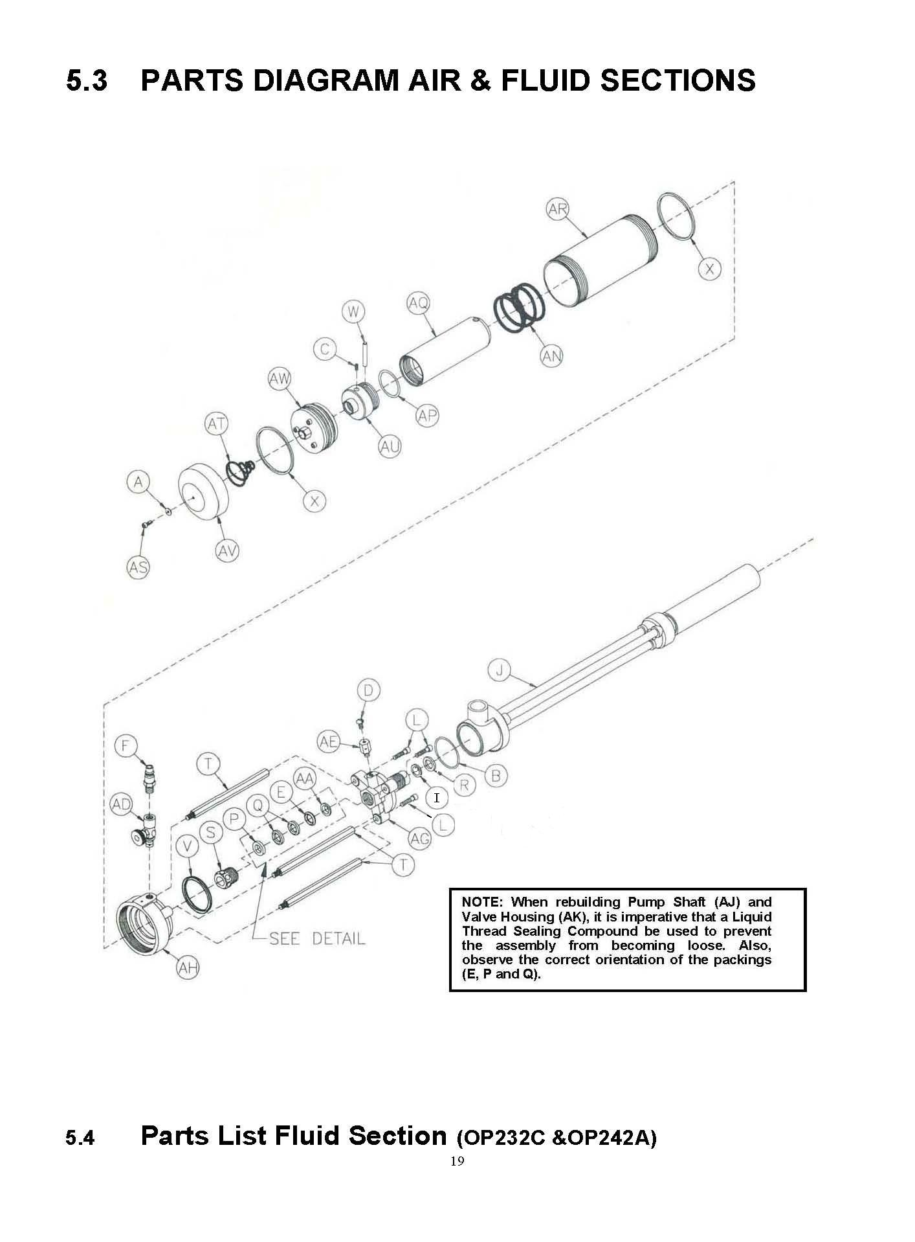

Letter “I” is only used for OP200S and OP250 pumps

**5.4 Parts List Fluid Section (OP232C/OP242A&CD/OP200S/OP250)**

|  |  |  |  |  |  |  |
| --- | --- | --- | --- | --- | --- | --- |
|  | **PART LETTER** | **NEW P/N** | **OLD P/N** | **DESCRIPTION** | | **QTY** |
|  | A | 500002 | 579-6 | | Fiber Washer | 1 |
| * | B | 500042 | 1484-5 | | O-Ring | 1 |
|  | C | 500021 | 1512-5-2 | | Socket Set Screw | 1 |
|  | D | 500039 | 4605-10 | | Round Head Machine Screw | 1 |
| * | E | 500035 | 5812 | | Seal Expander | 1 |
|  | F | 500029 | 6745-2 | | Male Plug | 1 |
|  | G | 500062 | 12119 | | Soft Point Set Screw | 1 |
|  | H | 700009 | OP233A-2 | | Bung Adapter Clamp (Includes M & N) | 2 |
|  | I | 501610 | N/A | | O-Ring **(OP200S/OP250 pump only)** | 1 |
| ** | J | 700012 | OP231A-1-11 | | Pump Body **(OP232C)** | 1 |
|  |  | 700007 | OP241A-1-11 | | Pump Body **(OP242A & OP242CD)** | 1 |
|  | J |  |  | | **For OP200S/OP250 see page 25** |  |
| * | K | 500053 | OP200-2-2-2 | | Gasket *(Available in Nylon )\*\*\** | 2 |
|  | L | 500040 | OP231-1-1 | | Socket Head Cap Screw | 3 |
|  | M | 500051 | OP231-1-12-4 | | Roll Pin | 2 |
|  | N | 500052 | OP231-1-12-5 | | Roll Pin | 2 |
|  | **(H,K,M,N,AF)** | 700008 | OP233A | | Complete Bung Assembly | 1 |
| * | P | 500033 | OP231-1-13 | | Seal Retainer | 1 |
| * | Q | 500034 | OP231-1-14 | | FE Packing | 2 |
| * | R | 500041 | OP231-1-15 | | Gasket (Tefon) | 1 |
|  | S | 500031 | OP231A-1-17 | | Packing Nut | 1 |
|  | T | 500032 | OP231-1-18 | | Standoff | 3 |
|  | U | 500067 | OP231-1-2 | | Suction Tube (All pumps except OP250) | 1 |
|  | U | 501611 | N/A | | Suction Tube **(OP250)** |  |
| * | V | 500030 | OP231-1-20 | | U-Cup | 1 |
|  | W | 500022 | OP231-1-22 | | Dowel Pin | 1 |
| * | X | 500006 | OP231-1-23 | | O-Ring | 2 |
| * | Y | 500064 | OP231-1-26 | | Wear-Ring | 1 |
| * | Z | 500066 | OP231-1-28 | | O-Ring | 2 |
| * | AA | 500036 | OP231-1-33 | | Wiper | 1 |
| * | AB | 500063 | OP231-1-4 | | U-Cup | 1 |
| * | AC | 500061 | OP231-1-8 | | Piston U-Cup Packing | 1 |
| * | AC | 501609 | N/A | | Lip Seal **(OP200S/OP250)** | 1 |
|  | AD | 500028 | OP231-2 | | Needle Valve | 1 |
|  | AE | 500038 | OP231-3 | | Grounding Lug | 1 |
|  | AF | 500048 | OP231A-1-12-1 | | Bung Adapter | 1 |
|  | AG | 500037 | OP231A-1-16 | | Air Cylinder Mounting Flange | 1 |
|  | AG | 501608 | N/A | | Air Cylinder Mounting Flange  **(OP200 and OP250)** | 1 |

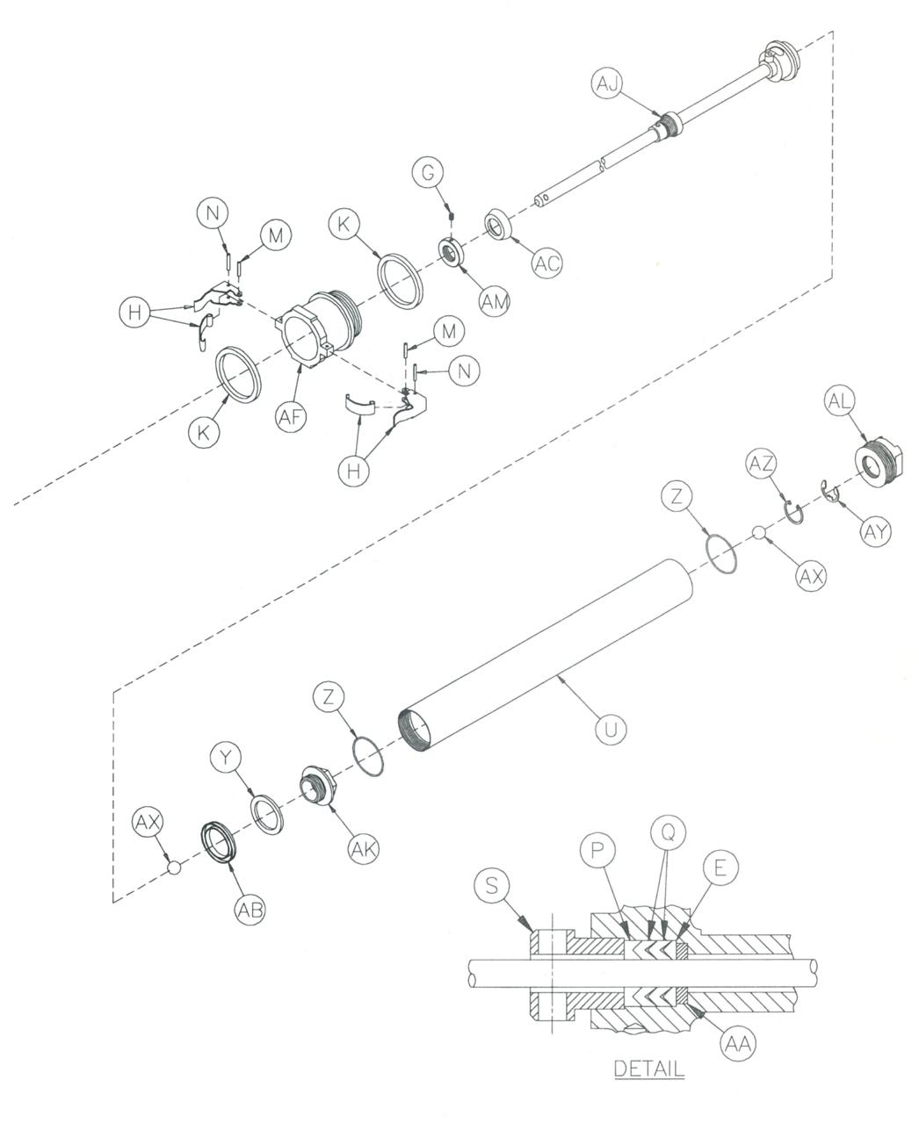**5.4 Parts drawing for OP series fluid section**

Nylon available- see the note***.

**(820301, 820302, 820303)**

More detail on AJ in shown on page 26

.

**Parts List Fluid Section Continued (OP232C/OP242A/OP200S)**

Nylon available- see the note***.

|  |  |  |  |  |  |
| --- | --- | --- | --- | --- | --- |
|  | **PART LETTER** | **NEW PART NUMBER** | **OLD PART NUMBER** | **DESCRIPTION** | **QTY** |
|  | AH | 500027 | OP231A-1-19 | Air Cylinder Base | 1 |
|  |  |  |  | Pump Shaft **(OP232C & OP250)** | 1 |
|  | AJ | 700013 | OP231A-1-25 | Includes BA, BB, BC, BF &BG |  |
|  |  | 700010 | OP241A-1-25 | Pump Shaft **(OP242A & OP242CD)** Includes BA, BB, BC, BF & BG | 1 |
|  |  | 700074 | None | Pump Shaft **(OP200S)** Includes BA, BB, BC, BF & BG) |  |
|  | AK | 500065 | OP231A-1-3 | Mat’l. Piston Valve Housing | 1 |
|  | AL | 500191 | OP231A-1-31X | Foot Valve Housing | 1 |
|  | AM | 501604 | OP231A-1-9 | U-Cup Retaining Collar | 1 |
|  | AN | 500026 | OP232-1-15 | Spring | 1 |
| * | AP | 500023 | OP232-1-18 | O-Ring | 1 |
|  | AQ | 700005 | OP232-1-19 | Displacement Plunger | 1 |
|  | AR | 700002 | OP232-1-2 | Air Cylinder | 1 |
|  | AS | 500001 | OP232-1-20 | Press Relief Screw | 1 |
|  | AT | 500005 | OP232-1-22 | Compression Spring | 1 |
|  | AU | 500020 | OP232-1-9 | Plunger Top | 1 |
|  | AV | 700001 | OP232A-1-1 | Air Cylinder Cap | 1 |
|  | AW | 700004 | OP237A | Air Motor Assembly | 1 |
|  | AX | 500269 | 02-101-917 | Ball Check, S/Steel (7/8”) | 1 |
|  | AX-2 | 500068 | OP601-1-2 | Ball Check, S/Steel (3/4”) | 1 |
|  | AY | 500192 | OP601-1-3X | E-Clip | 1 |
|  | AZ | 500193 | OP601-1-4X | Snap Ring | 1 |
|  | ZZ | 500068 | OP601-1-2 | Upper Ball Check (3/4”) | 1 |
|  |  | *See pump* | *shaft details on* | *page 26* |  |
| * | BA | 500056 | 9435-24 | O-Ring | 1 |
| * | BB | 500054 | OP231-1-24 | Roll Pin (Lower) | 1 |
| * | BC | 500055 | OP231-1-29 | Roll Pin (Upper) | 1 |
|  | BD | 500072 | OP232-1-14 | Spanner Pin | 2 |
| * | BE | T200003 | 15841 | Loctite Sample | 1 |
|  | BF | 500059 | OP231A-1-7 | Upper Material Piston Bottom | 1 |
|  | BG | 500057 | IPOP231A-1-5 | Material Piston Housing | 1 |
|  |  |  |  |  |  |

**5.5 Parts drawing for OP series fluid section**

**(820304, 820306)**

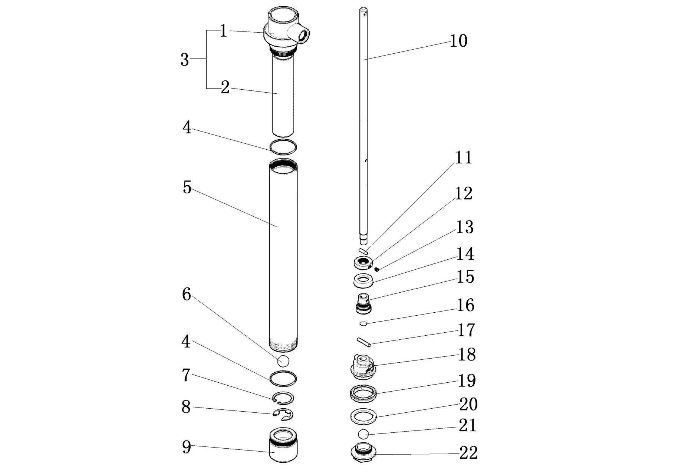

**The only difference between the OP200S and the OP250 pumps are numbers 2, 5 and 10.**

|  |  |  |  |  |  |  |  |  |
| --- | --- | --- | --- | --- | --- | --- | --- | --- |
| **REF NO** | **Part No** | **Description** | **QTY** |  | **REF NO** | **Part No** | **Description** | **QTY** |
| **1** | 500342 | OP200S/OP250 Base | 1 |  | **10** | 500058 | Main Shaft (OP250) | 1 |
| **2** | 500047 | Pump Press. Cyl. OP200S | 1 |  | **11** | 500055 | Roll Pin | 1 |
| **2** | 501612 | Pump Press. Cyl. OP250 | 1 |  | **12** | 501604 | U-Cup Retaining Collar | 1 |
| **3** | **700083** | **Pump Body (OP200S)** | **1** |  | **13** | 500062 | Soft Point Set Screw | 1 |
| **3** | **700084** | **Pump Body (OP250)** | **1** |  | **14** | *501609 | Lip Seal | 1 |
| **4** | *500066 | O-Ring | 2 |  | **15** | 500059 | Upper Material Piston Bottom | 1 |
| **5** | 500067 | Suction Tube (OP200S) | 1 |  | **16** | *500056 | O-Ring | 1 |
| **5** | 501611 | Suction Tube (OP250) | 1 |  | **17** | 500054 | Roll Pin | 1 |
| **6** | 500269 | S/S Ball | 1 |  | **18** | 500057 | Material Piston Housing | 1 |
| **7** | 500192 | E-Clip | 1 |  | **19** | *500063 | U-Cup | 1 |
| **8** | 500193 | Snap Ring | 1 |  | **20** | 500064 | Wear Ring | 1 |
| **9** | 500087 | Foot Valve Housing (Stubby) | 1 |  | **21** | 500068 | S/S Ball | 1 |
| **10** | 501603 | Main Shaft (OP200S) | 1 |  | **22** | 500065 | Piston Valve Housing | 1 |

**6.0 Component maintenance and breakdown**

**6.3 820304 & 820306 lubrication procedure**

1. Turn off main air supply to pump.
2. Release the bung adapter clips.
3. Lift the pump up three to four inches to expose the lubricating hole.
4. Squirt 2 strokes of lubricant into the 5/16” hole under the outlet port. Recommended lubricants are any plasticizer such as TSL.
5. Set the pump back down into the bung adapter.
6. Re-attach the clips.
7. You are ready to continue.

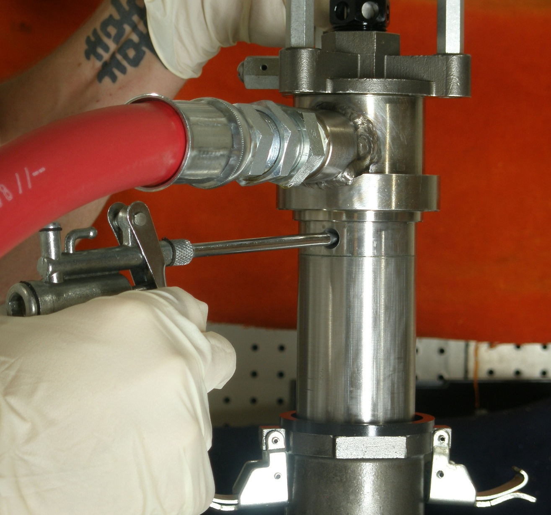

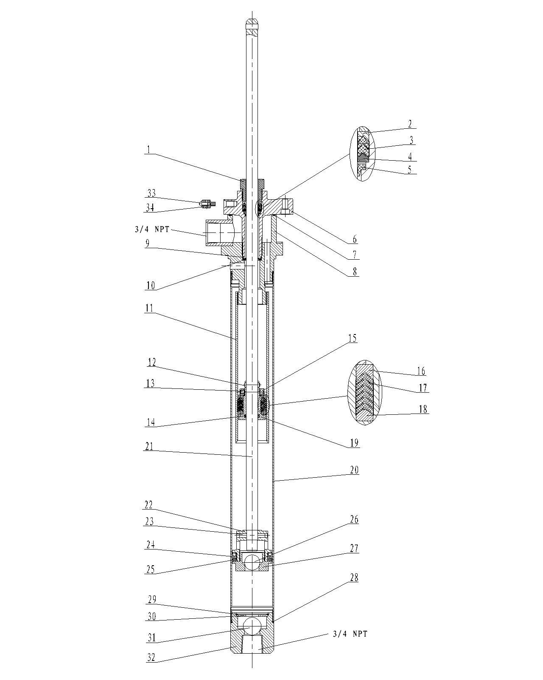

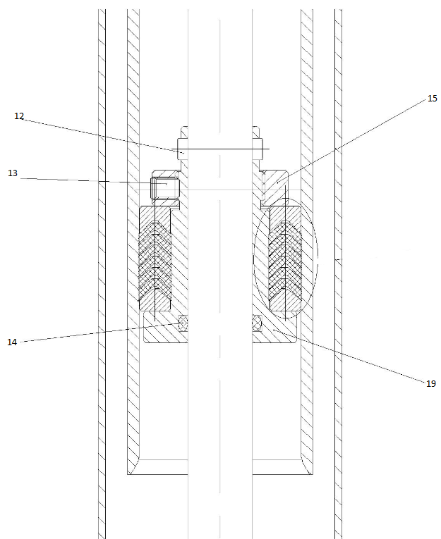

|  |  |  |  |
| --- | --- | --- | --- |
| Fluid Section Assembly（700096） | | | |
| Item | Part Number | Description | Quantity |
| 1 | 500031 | Packing Nut | 1 |
| 2 | 500033 | Seal Retainer | 1 |
| 3 | 500034 | FE Packing | 2 |
| 4 | 500035 | Seal Expander | 1 |
| 5 | 500036 | Wiper | 1 |
| 6 | 500037 | Air Cylinder Mounting Flange | 1 |
| 7 | 500042 | O-Ring | 1 |
| 8 | 500342 | OP200 S Base | 1 |
| 9 | 501610 | O-Ring | 1 |
| 10 | 500041 | Gasket | 1 |
| 11 | 500047 | Pump Pressure Cylinder | 1 |
| 12 | 500055 | Roll Pin | 1 |
| 13 | 500062 | Soft Point Set Screw | 1 |
| 14 | 500056 | O-Ring | 1 |
| 15 | 501619 | U-Cup Retaining Collar | 1 |
| 16 | 501622 | Female Gland | 1 |
| 17 | 501620 | V-Packing | 6 |
| 18 | 501621 | Male Gland | 1 |
| 19 | 501618 | Upper Material Piston-Bottom | 1 |
| 20 | 500067 | Suction Tube | 1 |
| 21 | 501603 | Main Shaft | 1 |
| 22 | 500057 | Material Piston Housing | 1 |
| 23 | 500054 | Roll Pin | 1 |
| 24 | 500063 | U-Cup | 1 |
| 25 | 500064 | Wear Ring | 1 |
| 26 | 500068 | Ball3/4" | 1 |
| 27 | 500065 | Piston Valve Housing | 1 |
| 28 | 500066 | O-Ring | 2 |
| 29 | 500193 | Snap Ring | 1 |
| 30 | 500192 | E-Clip | 1 |
| 31 | 500269 | (SST) 7/8"Ball | 1 |
| 32 | 500087 | Foot Valve Housing (Stubby) | 1 |
| 33 | 500039 | Round Head Screw | 1 |
| 34 | 500038 | Grounding Lug | 1 |

**6.0 REPAIR KITS**

**6.1 OP series repair kits for pumps 820304 & 820306**

|  |  |  |  |
| --- | --- | --- | --- |
| **601018** | Air section repair kit | | |
|  | Fits: 820304, 820306 | | |
|  | Components include | | |
|  | Part # | Description | Qty |
|  | 500006 | Buna O-ring | 2 |
|  | 500015 | Nylon 1010 gasket | 1 |
|  | 500016 | Nylon 1010 gasket | 3 |
|  | 500017 | Teflon wear ring | 1 |
|  | 500018 | NBR U-cup | 1 |
|  | 500019 | Viton O-ring | 1 |
|  | 500023 | NBR O-ring | 1 |
|  | 500030 | NBR U-cup | 1 |
|  | T200003 | Loctite, tube | 1 |

|  |  |  |  |
| --- | --- | --- | --- |
| **601036** | Fluid section repair kit | | |
|  | Fits: 820304, 820306 | | |
|  | Components include | | |
|  | Part # | Description | Qty |
|  | 500033 | Aluminum seal retainer | 1 |
|  | 500034 | Teflon FE packing | 2 |
|  | 500035 | Aluminum seal expander | 1 |
|  | 500036 | Shaft wiper ring | 1 |
|  | 500041 | Teflon gasket | 1 |
|  | 500042 | FKM O-ring | 1 |
|  | 500053 | Viton gasket | 2 |
|  | 500054 | Lower roll pin | 1 |
|  | 500055 | Upper roll pin | 1 |
|  | 500056 | Viton O-ring | 1 |
|  | 500063 | Teflon U-cup | 1 |
|  | 500064 | Teflon wear ring | 1 |
|  | 500066 | Viton O-ring | 2 |
|  | 501609 | Lip seal | 1 |
|  | 501610 | O-ring | 1 |
|  | T200003 | Loctite, tube | 1 |

**7.0 TROUBLESHOOTING**

|  |  |  |
| --- | --- | --- |
| **Problem** | **Causes** | **Recommended Solutions** |
| Pump does not operate. | Air supply or pressure is inadequate. Air lines restricted. | Increase air pressure. Check for any restrictions in air line. |
|  |  |
| Dispensing valve is not open or clogged. | Open and/or clear foot valve. |
|  |  |
| Clogged fluid lines, valves, hoses or damaged air | Follow pressure relief procedure to clear obstruction. |
| motor. | Service air motor. Replace parts as necessary. |
| Depleted or exhausted fluid supply. | Refill fluid. Prime system or flush it. |
| Worn or damaged air motor gasket, packing, seal, etc | Service air motor. Replace parts as necessary. |
| Non-stop air exhaust. | Intake valve or packing worn off. | Replace worn parts |
| Erratic pump operation. |  |  |
| Intake valve is not completely closed. | Clear obstruction and service pump. Replace parts as necessary. |
| Held open or worn intake valve. | Clear obstruction and service pump. |
| Low output on upstroke. | Replace parts as necessary. |
| Held open or worn piston valve. | Clear obstruction and service pump. |
| Low output on down stroke. | Replace parts as necessary. |
| Restriction in air lines or air pressure low. | Increase air pressure or supply. |
| Low output on both strokes. |  |  |
| Closed or clogged valves. | Open valve or clear valve. |
|  |  |
| Fluid supply is insufficient or exhausted. | Refill fluid. Prime system or flush it. |
| Obstructions in fluid lines, hoses, valves, etc. | Follow pressure relief procedure, then clear obstruction. |

**8.0 TECHNICAL SPECIFICATIONS**

**8.1 Recommended application chart**

|  |  |  |
| --- | --- | --- |
| **Industry** | **Application** | **Viscosity Range(cps)** |
|  | Alcohol | 0-100 |
| Dye | 0-1000 |
| Methyl Chloride | 0-200 |
| Solvents | 0-500 |
|  | Paint(Latex) | 100-1000 |
| Paint(Oil base) | 100-800 |
| Sealer(Wood) | 100-800 |
| Stain(Oil base) | 100-1000 |
|  | Anti-Freeze | 30-100 |
| Die Lubricant | 30-50 |
| Gear Oil | 200-1000 |
| Lubricant | 100-1500 |
| Mold Release Agent | 30-100 |
| Oil | 100-500 |

**Air pressure requirements:** For optimum pump performance, 80 – 100 PSI should be supplied to the OP series transfer pumps.

*Pump viscosity guide*

All calculations in Centipoise (cps)

IP01 series pumps: 1 – 2,000 cps

IP02 series pumps: 1 – 4,000 cps

OP series pumps: 1 – 4,000 cps

IP05 series pumps: 1 – 10,000 cps

IP10 series pumps: 1 – 20,000 cps

Calculations are based on the following general guidelines

* Inbound air pressure: 100 psi
* Pressure at dispense point: 0 psi
* Hose/pipe length w/smooth inner surface = L: 25 feet
* Hose size = D: ¾”
* Flow rate = Q: 2 gpm
* Viscosity = V:
* Pressure loss in hose/pipe (psi), P: P = 0.0273QVL/D4

The above viscosity values are only general guidelines. Other factors should always be taken into consideration such as; dispensing valves, fittings, hose unions, elevation, outside ambient temperature, etc.

**8.2 OP series pump dimensions**

|  |  |  |  |  |
| --- | --- | --- | --- | --- |
| **Pump** | **A** | **B** | **C** | **D** |
|  |  |  |  |  |
|  |  |  |  |  |
|  |  |  |  |  |
|  |  |  |  |  |
| **820304** | **17”** | **8.30”** | **23”** | **38”** |
| **820306** | **34”** | **8.34”** | **36.75”** | **55”** |
|  |  |  |  |

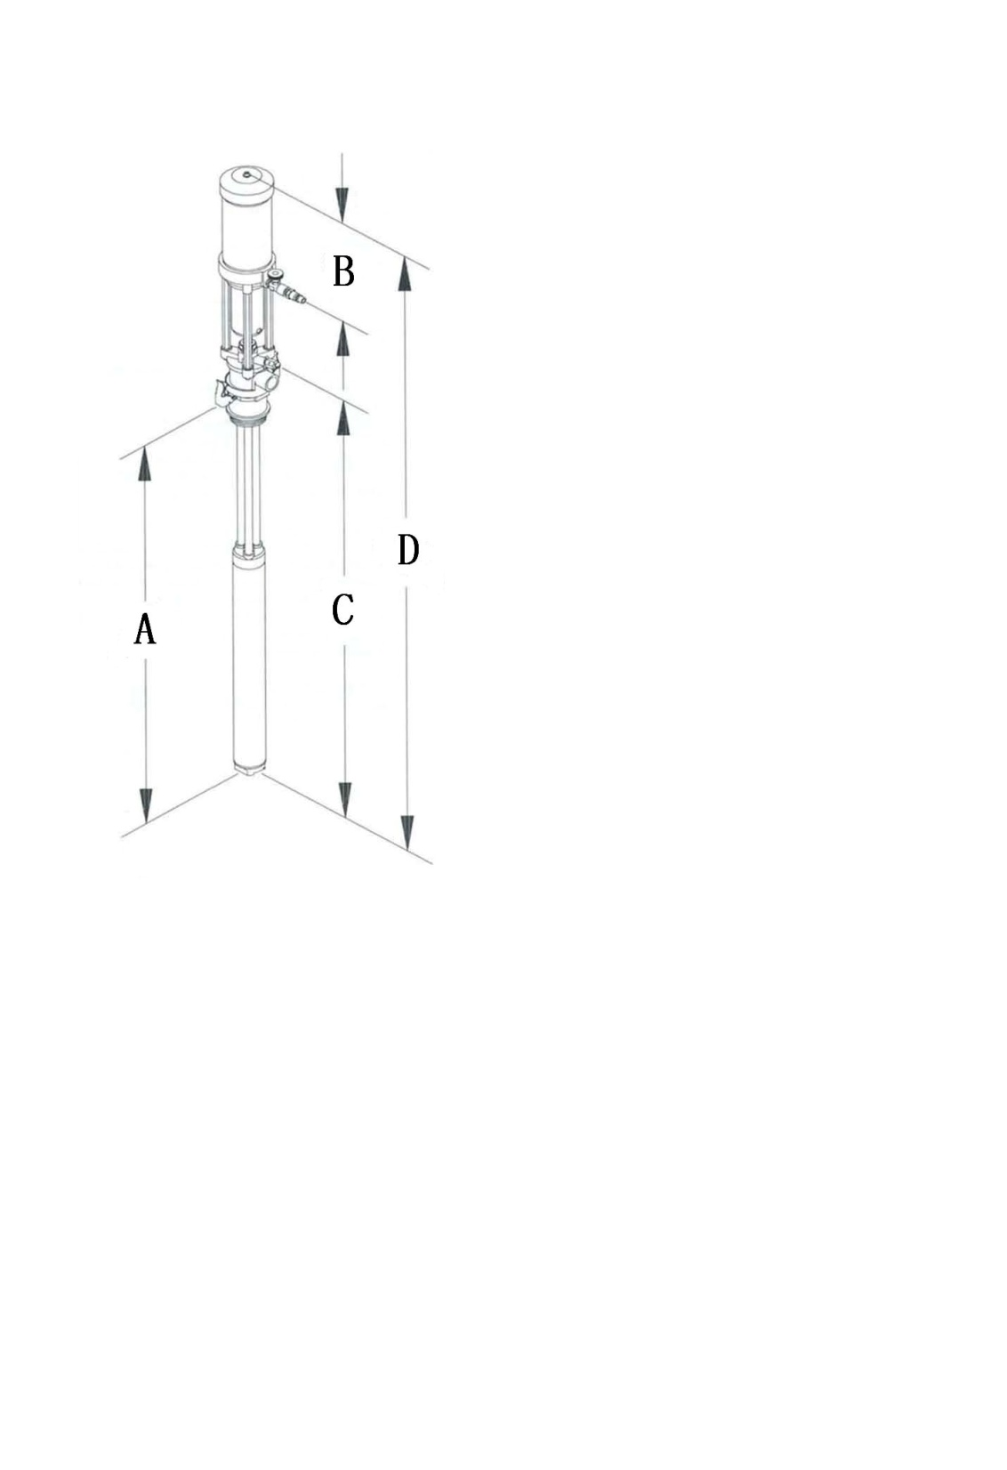



**9.0 WARRANTY AND DISCLAIMER**

***WARRANTY***

International Pump Manufacturing, Inc. (hereafter designated IPM) warrants the equipment it manufactures to be free of defects in materials and workmanship for a period of one (1) year from the date of sale from IPM to an authorized IPM distributor or to the original end user and/or purchaser. IPM will, at its discretion, repair or replace any part of the equipment proven to be defective. This warranty applies only when the equipment is used for the intended purpose and has been installed, operated and maintained in accordance with written operating procedures.

A condition of the warranty is the prepaid return of the equipment to an authorized distributor of IPM who shall provide verification of the warranty claim. IPM will repair or replace free of charge any parts found and verified to be defective or damaged upon receipt of equipment. Shipping will be prepaid for the repaired or replaced parts under warranty. Should inspection of the equipment reveal no defects in material or workmanship repairs will be made at the standard IPM rate, which will include parts, inspection, labor, packaging and shipping.

The warranty does not apply nor shall IPM be liable for damage, operational wear, malfunction of equipment caused by improper installation, misuse, chemical abrasion or corrosion, operator negligence, accident, tampering or altering of equipment, lack of improper maintenance and/or by substitution of non-IPM parts. Additionally, IPM shall not be liable for nor does the warranty apply to operational wear, damage or malfunction caused by incompatibility of accessories, components, structures, equipment or materials not supplied by IPM. The warranty does not apply to nor will IPM be responsible for the improper operation, maintenance, design, manufacture, installation of components, accessories, equipment or structures not supplied by IPM.

The warranty is void unless the Warranty Registration Card is properly completed and returned to IPM within ONE (1) month of the date of the sale.

***LIMITATIONS AND DISCLAIMERS***

This warranty is the sole and exclusive remedy for the purchaser. No other warranties, expressed or implied, warranties for fitness of purpose or merchantability, or non-contractual liabilities are made by IPM, including product liability, whether on negligence or a strict liability basis. Liability for directly special or non-contractual damages or loss is expressly excluded and denied. IPM’s liability shall in no case exceed the amount of the purchase price.

IPM does not warrant and disclaims implied warranties of merchantability and fitness for a particular purpose, components, accessories, equipment, materials sold but not manufactured by IPM. These parts (valves, hoses, fittings, etc.) are subject to the provisions within the warranty of the actual manufacturer of these items. IPM will provide reasonable assistance with warranty claims on these items.



**3107 142nd Avenue East, Suite 106**

**Sumner, Washington 98390**

**Telephone: (253)863-2222 Fax: (253)863-2223**

**Website: www.ipmpumps.com**

**Revised: July 2011**