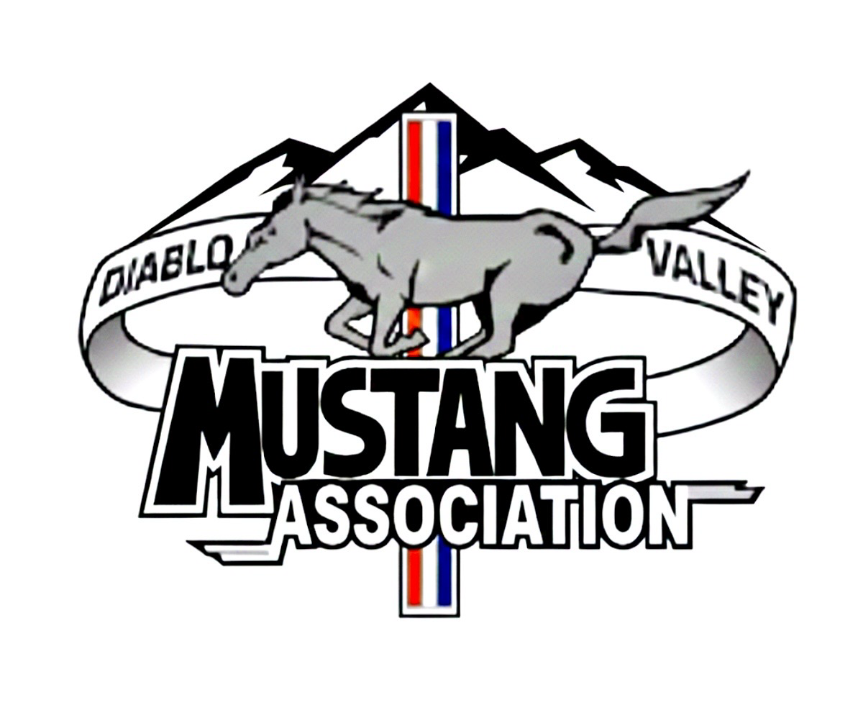
Hello business owner / manager,
The Diablo Valley Mustang Association is excited to present its Annual All-Ford Car Show hosted at The Cobra Experience Museum in Martinez on October 10, 2026, from 10:00am to 3:00pm. This show will feature some of the most beautiful Mustangs and Ford powered cars in the Bay Area. We are targeting 150+ show participants and expect hundreds of car enthusiasts and spectators to attend.

We are looking for sponsors to help DVMA make this car show a smashing success. As a sponsor, you will not only benefit from your company’s exposure in our car show program during this exciting show, but you will have even more options for exposure depending on the Sponsor Level you choose. Please review the Sponsor Levels below and make your decision as to which Sponsor Level you would like to sign up for.

We are also most appreciative and happy to receive any prize donations you could offer to help make the show’s raffle baskets more desirable. Donations with your company name such as water bottles, towels, mugs, pens, magnets, or other souvenirs to be included in the participants’ goodie bags are also needed.

Please contact Frank Powell @ 925-323-5476 with any questions or if you would like to have any donations picked up.

Thank you for your support!
DVMA Car Show Committee

2026 Car Show Sponsor Levels

Platinum Level - $1,000 Donation (only one Platinum Sponsorship is available) includes:
• 1-time full page article about your business in our monthly newsletter “The Feed Bag”.
• 1/4-page ad in “The Feed Bag” and business name featured on the DVMA website for 1 year.
• Your business name featured in car show program and promotional materials.
• One 10’ x 10’ vendor space at the October 11 car show, canopy and product sales are allowed.

Gold Level - $500 Donation includes:
• 1/8-page ad in “The Feed Bag” and business name featured on the DVMA website for 1 year.
• Your business name featured in car show program and promotional materials.

Silver Level -$300 Donation includes:
• Business Card Size ad in “The Feed Bag” and business name on the DVMA website for 1 year.
• Your business name featured in car show program and promotional materials.

Bronze Level - $100 Donation includes:
• Your business name featured in “The Feed Bag” and on the DVMA website for 1 year.
• Your business name featured in car show program and promotional materials.

Please make checks payable to DVMA
Mail check and your business information to:
DVMA c/o Car Show Committee
PO Box 21674, Concord, CA 94521

Diablo Valley Mustang Association, PO Box 21674, Concord, CA 94521
www.DVMA.org

