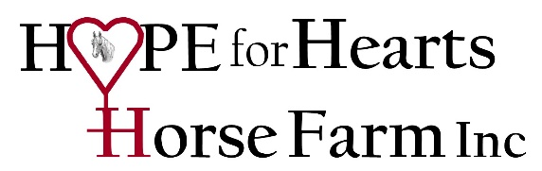

COVID-19 Pandemic Procedures

The health and safety of all our staff, volunteers and clients is always top priority. As we continue to monitor the situation around COVID-19, Hope for Hearts Horse Farm is taking proactive measures to reduce the spread of COVID-19 at our facility; yet there are still risks associated with participating in the programs offered that may increase exposure due to required personal contact and person-to-person interaction. All individuals, including you, shall follow the pandemic procedures and guidelines.

* Pre-screening: All staff, volunteers and clients will pre-screen themselves prior to each session (clients) or day of sessions (for staff and volunteers). Pre-screening at home before arriving to the farm includes the following and if the answer to any criteria is YES, then staff, volunteer or client will not come to Hope for Hearts Horse Farm for at least 2 weeks.
  + Temperature > 99.5 degrees
  + Coughing
  + Sore Throat
  + Body Aches
  + Shortness of Breath
  + Congestion/Sneezing
  + Exposure to someone with any of the above symptoms in the past 14 days.
* Upon arrival to the farm:
  + Individuals will put their own mask on prior to getting out of their vehicle. The mask must be worn during the duration of time at the farm and MUST cover the nose and mouth for it to be effective. All other family/friends must wait in their vehicle and should not enter the barn facility.
  + Staff, volunteers and participants will have their temperature taken upon arrival with a non-contact forehead infrared thermometer. Anyone with a temp > 99.5 will not be allowed to enter the facility.
  + Individuals will enter through the welcome area door and proceed directly to the sink in the conference room where they will wash their hands with anti-bacterial soap for at least 30 seconds.
  + Individuals will go directly to the arena for their session where grooming and EAL activities will occur. Staff and volunteers will lead horses from stalls to the arena and back.
  + At the end of each session, all equipment used during the session will be disinfected with bleach spray including, grooming tools, lead ropes and halters by staff and volunteers.
  + Clients will wash hands with anti-bacterial soap for at least 30 seconds prior to leaving barn facility.
  + Once back in vehicle, clients can remove their masks.
* Other considerations:
  + Sessions will be scheduled on the hour but will only last 45 minutes to allow time for disinfecting of equipment, door handles, etc in between clients.
  + Clients will not be allowed to hang out at the barn before or after their scheduled sessions.
  + 6 ft social distancing should be observed during sessions as an extra safe-guard unless a safety issue arises with a client/horse.
  + Staff and volunteers will wear masks the entirety of time they are at the farm and will properly wash and sanitize their hands immediately before the session starts, and immediately after the session ends.
  + Wear closed toed shoes to sessions as we will not be loaning any boots during this time.