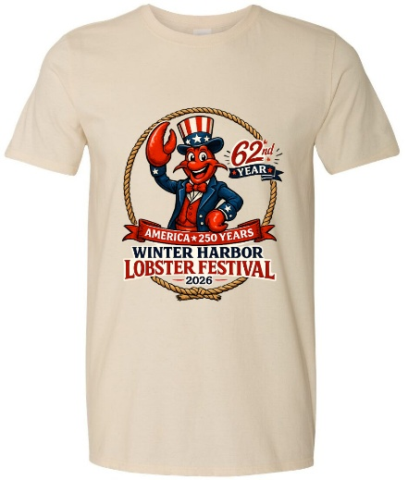
WINTER HARBOR LOBSTER FESTIVAL 2026
T-Shirt Pre-Order Form

Shirt Pricing
Adult Shirts
- Small (S), Medium (M), Large (L), XL — $25 each
- 2XL, 3XL — $28 each
Youth Shirts
- Youth Small (YS), Youth Medium (YM), Youth Large (YL), Youth XL (YXL) — $20 each
Customer Information
Name: ______________________________________________
Phone: ______________________________________________
Email: ______________________________________________

Adult Shirts
Size | Quantity
Small (S) | ______
Medium (M) | ______
Large (L) | ______
XL | ______
2XL | ______
3XL | ______

Youth Shirts
Size | Quantity
Youth Small (YS) | ______
Youth Medium (YM) | ______
Youth Large (YL) | ______
Youth XL (YXL) | ______

Order Summary
Total Adult Shirts: __________
Total Youth Shirts: __________
Grand Total Due: $________________

Payment Information
Payment Methods Accepted:
☐ Cash
☐ Check
☐ Venmo (@saraliscomb)
Check Number: _______________________
Make checks payable to: _____________________________________
Date Payment Received: __________________

Over->
Pickup Information
☐ I will pick up my order.
☐ Please contact me when my order is ready.
Preferred Contact Method:
☐ Phone
☐ Email

Additional Notes

Festival Use Only
Date Received: _______________________
Payment Received: ____________________
Order Entered By: ____________________
Customer Notified: ___________________
Order Picked Up: _____________________
Signature/Initials: ___________________

