The Business Integrator

For Windows

Quick Start Manual

Developed by:

Geldman Computer Systems Inc.
343 Clark Ave. W. #1207
Thornhill, Ontario, Canada L4J 7K5
Tel: 647-694-0934
e-mail: support@geldman.com
web: www.geldman.com

Table of Contents:

Software installation 3
General overview 3
User Friendliness 4
Target Market 5
Available Features 5

Software Installation

Insert the CD into your drive and within a few seconds it will automatically start the installation.
If nothing happens, open windows explorer and double click on the file INTEGRAT.EXE

If you downloaded the file from the internet, double click on the file to start installation.

Follow screen prompts. Do not change the suggested install directory for the evaluation installation.
The installation will put an icon on your desktop. Use it to start the program.

General Overview

This is a multi company, multi-user and multitasking windows system. For the evaluation installation you have one company test data and therefore the company selection screen will not show at start up.

For login, use SUPERVIS as the UserId and 12345 for the password.
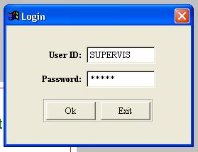

After successful login you are presented with a blank screen that has menu option at the top.

The installation version which is a full version of the software without any limitation has test data in it to enable you to appreciate the power of this software right from the start.

If you decide to lease the software after evaluation, we will remove the test data for your installation. This way, any real data you may have entered will be preserved and your investment in time will not be lost.

During evaluation, you may call for telephone technical support without charge for two months after the first initial call.

The foremost advantage of The Business Integrator is the ability to order custom modifications and additional functions. With our rich and extensive library of functions, this is more affordable then you may think. The majority of our customers are small to medium companies that have ordered custom modifications with a business justification for cost.

Any new version in the future will not impede with these custom modifications as we have developed a system by which functions are called according to a parameters table. This way any version enhancements or software corrections will be enjoyed by all customers.

We lease the software. You don’t have to put a capital investment at the beginning. Start paying monthly payments without any obligation.

We are so sure this system will be enjoyed by your company and help it grow, that we give you an unconditional warranty. Whenever you wish, you may stop using the software, delete it from your computer and you owe no more monthly payments.

We don’t charge per station. You may have 5 computers network or 150 computers and still pay the same.

As more computers you have, the cost of technical support will be higher depending on the amount of time used. If you have no calls at all, a rare occurrence, you will pay nothing for support.

Geldman Computer Systems Inc. provides a wide spectrum of computer services. If you would like us to take care of your network installation, backup administration etc. we will do that together with support for The Business Integrator.

If you need to convert existing data to The Business Integrator we will negotiate a price per time involved. Usually, the main tables: customer, vendors, inventory, salesman and similar can be done in a very short time.

The Business Integrator is written in Microsoft Visual FoxPro. This gives you the peace of mind that you are using stable technology and the fastest database engine in the computer industry. Microsoft is committed to continue development and support of Visual FoxPro for many years to come.

Geldman Computer Systems Inc. is in business since January 1986. The Business Integrator is being used by many companies for the last 17 years. In 2004 the system was re-written in Visual FoxPro to make it one of the most user friendly system in the market.

User Friendliness

The Business Integrator brings user friendly operation to new levels. This quick start manual will try to bring you the main points but you need to operate it for yourself to get the feeling for the power this system gives you.

Fonts are selectable. You may change the font of the whole user interface by pressing Windows/Font. This is important for people with vision difficulties as well as for esthetics All the windows will be adjusted automatically to the newly selected font.

Right mouse click is used extensively in the program. This allows you to do the following;

- On any date field, popup a calendar to select a date visually.
- On any grid field, find a record to match the data of that field regardless if there is an index to that field or not.
- On any field with further data you can drill down for more information. For example: when you right mouse click on customer name or number in an invoice, you get the customer record screen. On an inventory code or name you get the item information screen.
- On any amount field press “A” to add the amount to the calculator without the need to enter the number manually. The calculator is always at the right bottom corner of the screen.
- Wherever you see an “I” button you can get further information about this item.

Target Market

The Business Integrator is suitable for Wholesale, Distribution, Manufacturing etc. It is used also by retailers and small operations.

Available Features
- Order Entry
- Invoicing
- Accounts Receivables
- Inventory Control
- Bill of Materials
- Purchase Orders
- Accounts Payables
- General Ledger and Accounting
- Customer and Vendors Files
- Ship To File per Customer.
- Security Levels per Function/User
- Many customized function that can be tailored to your needs

The above are the major functions with many sub titles for each, too numerous to list here and overload your perception. This is why we give you an unlimited full version to experiment at your leisure and make your own judgment.

The evaluation version is tailored for an average distribution operation. The data is from a hardware wholesaler of wood cutting tools. All company names and vendor names and addresses have been changed to make their identification coincidental.

In this quick start manual we will try to show you a few screen shots of an order entry operation. This will enable you to use common sense in operating the rest of the program.

Order Entry Example with Screen Shots.

The following screen shots start an order entry operation until the order is posted. While the order is created you may start other operations like new customer entry or any other screen. This is a truly multitasking system.

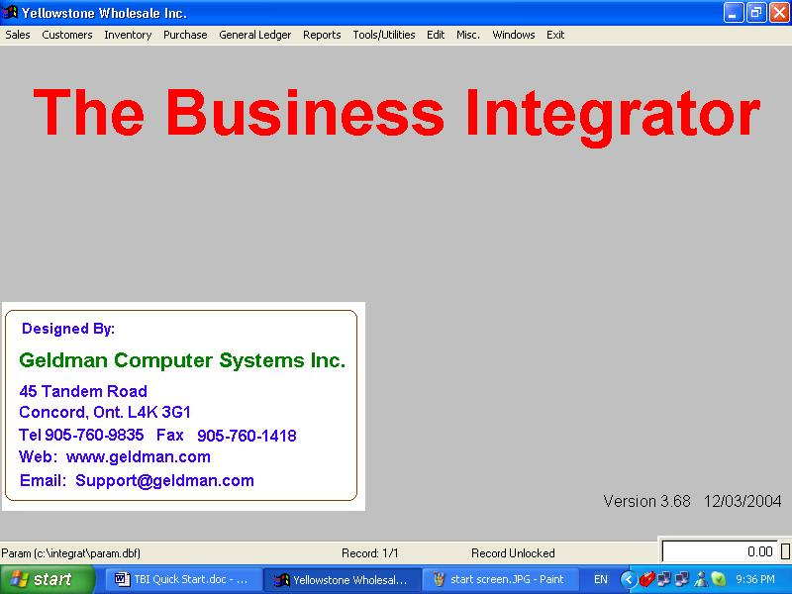

The above is the main menu screen. Select SALES from the top menu.

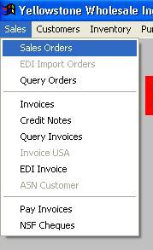

Select SALES ORDERS from the above menu.

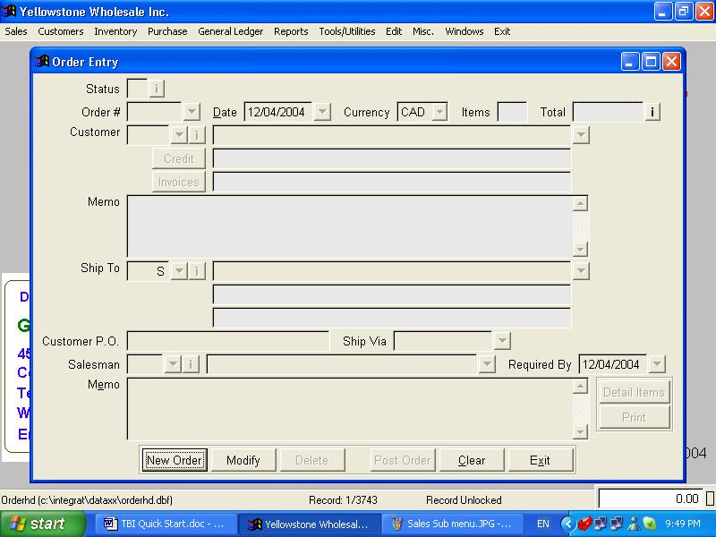

Click NEW ORDER button.

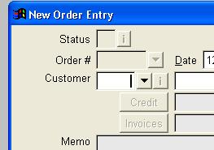

The cursor moves to customer field. Click on the triangle beside it to get the next screen. If you know the name or partial name of the customer you can select this way too but there is even a better way to do that. At this point, click the triangle.

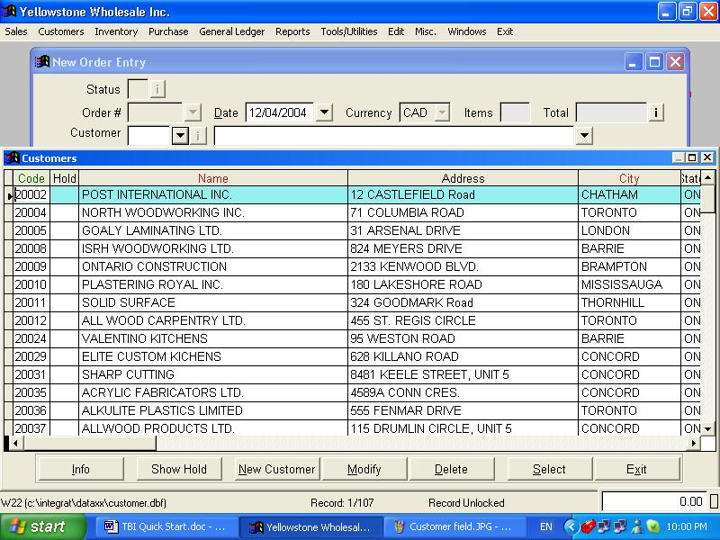

Notice that the “CODE” heading is in green while the “NAME” and “CITY” are in red. This means that the table is sorted by customer code. Click on the heading “NAME” and watch the table changing order to customer name order. This feature is available throughout the program.

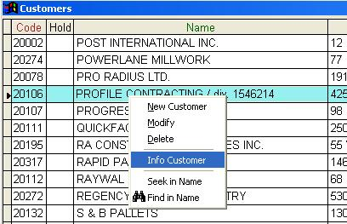

Right mouse click on any recordon the “NAME” field has brought the small window you see above. You can:
- Create a new customer
- Modify the one which is highlighted in cyan color.
- Delete the record.
- Get information screen of this record.
- Seek another customer record by name or partial name.
- If this field did not have a green or red heading, you can still fine it at a slower speed. (Most likely under one second).

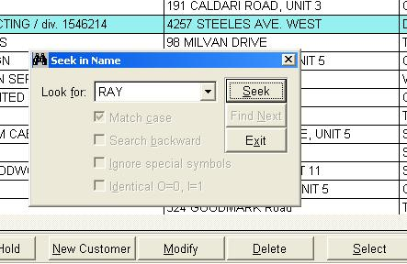

Enter partial name and click “SEEK”. The selection is now on the first record that matches “RAY”. As more characters you type as more are your chances to hit the exact recod by the seek operation.

