In Your Neighbourhood

Town Hall - Seniors Action Plan
In the fall of 2019, Victoria City Council formed a Seniors Task Force comprised of community-minded individuals ages 65 and over. The purpose of the Task Force is to inform the development of the City's Seniors Action Plan. Task Force members are focusing on the question: “How can the City of Victoria promote healthy seniors and positive aging?” This focus is guided by eight topic areas identified by the World Health Organization.
- Outdoor Spaces and Buildings
- Transportation
- Housing
- Respect and Social Inclusion
- Social Participation
- Communication and Information
- Civic Participation and Employment
- Community Support and Health Services
Thank you to all those who were able to join us in person or online for our Town Hall @ City Hall to provide feedback and share seniors issues with City Council. Missed it? Watch the archived webcast.
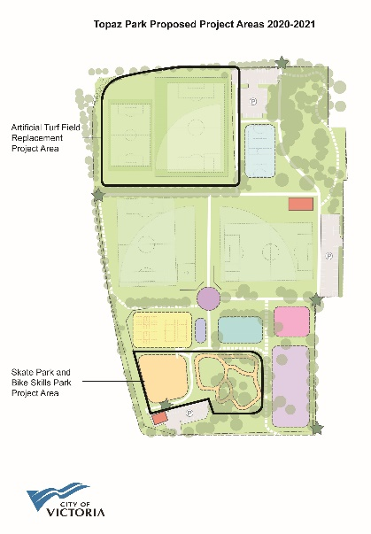
Read the Draft Recommendations for the Seniors Action Plan.
Topaz Park Improvements
At the January 23, 2020 Council meeting, City Council directed staff to invest nearly $8 million to construct a skateboard park and bike park, and replace the artificial turf sports field at Topaz Park as part of a long-term renewal plan for the park.View the draft concept plan here or click the image below. It is anticipated that the design and construction will be completed in two years and be open to the public in the summer of 2021.

Skateboard Park
The new skate park will be approximately 3,000 square metres in size, similar to the Victoria West Youth Park. The final design will be developed through a collaborative design process involving future users and is

intended to create a space that is inviting and suitable for all skill levels and styles.

Bike Park
Approximately 6,000 square metres in size, the new bike park will provide a fun and challenging riding experience for all skill levels and will serve as an all-ages social hub for the cycling community. Existing trees in the area will be integrated into the design of the facility.

New Artificial Turf Sport Field
The new artificial turf sport field facility will include a full-size soccer pitch, softball field, a mini multi-purpose field, sport lighting, and other amenities such as dugouts, player shelters, a backstop and spectator seating. The softball field will replace one that will be displaced by construction of the new skate park.

Budget. The $7.47 million in funding will be drawn from a combination of sources including the Building Infrastructure Reserve Fund and the Artificial Turf Field Reserve Fund.

Crystal Pool Replacement
Council has directed staff to explore new opportunities to locate the Crystal Pool and Wellness Centre replacement facility, consistent with prior direction that the new building will be located in the North Park or Hillside Quadra neighbourhoods. These new opportunities emerged after Council gave direction on January 9 to bring forward a report detailing the six sites that have been previously assessed. That report is available here. As such, Council has deferred consideration of this matter until the new opportunities are investigated.
Accessibility Framework
The City of Victoria is striving to make our community as inclusive as possible and is collecting important feedback from residents about accessibility in Victoria. The Accessibility Framework will outline a city-wide program to prevent and remove barriers for people with disabilities. You can watch a video-recorded presentation and look at documents here. Comments can be submitted before end of day on February 9 via:

- Email – engage@victoria.ca
- Phone – 250.361.0378
- In person at City Hall Engineering Department – 1 Centennial Square

Trees in Cities Challenge

Victoria is the first city in Canada to join the Trees in Cities Challenge. As part of this global campaign, the City of Victoria will work with the community to plant 5,000 trees on public and private land by the end of 2020. Residents and groups can join in the Trees in Cities Challenge in four easy steps: Pledge to plant, learn about tree health, plant and record your trees and become a tree champion. This can look like planting a tree in your yard, volunteering at a neighbourhood tree planting day and attending free, monthly tree-care workshops offered by the City.

Free workshops in February include, For the Love of Trees – Walking Tour and Tree Planting, which will begin in Centennial Square on Saturday, February 8 from 10 a.m. – noon and a Tree Care and Fruit Tree Pruning Workshop in Fernwood Orchard on Saturday, February 22 from 10 a.m. – 1 p.m.
Register for workshops online at www.victoria.ca/recreation. For more information visit: www.victoria.ca/treesincities.

Equity Lens

Council was presented with a staff report outlining options for advancing an equity lens for the City at its January 16 committee meeting. The report provided options for resourcing the development of an equity framework based on Council feedback provided at their October workshop on the topic and community input. In order to make progress relatively quickly, Council Committee of the Whole supported staff

recommendations to allot $75K in contracted services and to establish positions for:

- Equity and Inclusion Coordinator - 1 FTE – $107,900 (ongoing)
- Accessibility and Inclusion Recreation Role - 1 FTE – $52,000 (ongoing)
- Accessibility Coordinator – 1 FTE – $107,900 (ongoing)
- Social Planner – 1 FTE - $125,111 (ongoing)
- That Council add another FTE to focus on Equity and Inclusion $108,000

The recommendations are to be ratified at an upcoming Council meeting.

Councillor Election

On January 16, Council will receive a staff report proposing personnel appointments and budget ($170,000) for conducting a by-election to fill the vacant Council position. The proposed date for the election is Saturday April 4, 2020.

City Council Meetings
Committee of the Whole meets on February 6, 13, 20 and 27th at 9:00am. Council meets on February 13 and 27 beginning at 6:30pm.

You can also find out more about Council meetings by:
- Watching recordings of the meetings here
- Tuning into bi-weekly videos for what’s coming up for discussion at City Council
- Reviewing the decisions made at Council on our Council Highlights page
- Finding out how Councillors voted on the City Council Meeting Dashboard

