In Your Neighbourhood

VCAN Workshop
On November 16, the City hosted a workshop on directions for relationships between neighbourhoods and the City. The Working Smarter Together workshop included presentations from Toronto, Seattle and Edmonton, each providing examples of approaches to working effectively with neighbourhoods. Observations and suggestions from table discussions were recorded and shared with neighbourhood associations. This information will be used in determining next steps and the approach for an upcoming neighbourhood summit in February.

My Great Neighbourhood Grant – Fall Intake
Council has approved 29 applications for the fall intake of the 2019 My Great Neighbourhood Grant program, totalling $52,945. Of the 29 recipients, 14 are for placemaking initiatives and 15 are for activity grants. The grant program was developed to support strong, connected neighbourhoods through funding for projects and activities that bring neighbours together and empower them to shape their local area. The City provides up to $5,000 for placemaking projects to match the equivalent contribution from the neighbourhood and up to $1,000 matching funds for community development activities. Since 2016, $392,836 in My Great Neighbourhood Grant funding has been distributed to 129 community-based projects.
NeighbourHub - 709/711 Douglas Street
Office space at 709/711 Douglas Street that was formerly known as CityStudio will operate as a pilot for 2020 as the “NeighbourHub”, to be managed by the City’s Neighbourhood Team and available to all neighbourhood associations, community organizations that directly impact or are connected to neighbourhood associations, City of Victoria Youth Council, City’s Local Champions Program, City staff, and community organizations that deliver either strategic or operation requirements where capacity permits.

Local Champions

Local Champions is a new community-based leadership development program for Victoria residents to gain foundational skills, confidence, and relationships to become more active and engaged in their own neighbourhood and beyond. The inaugural cohort for the program is now full and will kick off with a weekend intensive Feb. 1st and 2nd. After completing the course in May, participants will then become the first group of Local Champions alumni. Click here for more information on the program.

Crystal Pool

On January 9th, Council will consider a staff report recommending the initiation of a feasibility study for the design and location of a new pool. The report recommends $725,000 be allocated to fund the study and that a Project Advisory Group be formed to provide advice and recommendation with regards to project options. The Project Advisory Group is to be comprised of up to 15 community members representing a diversity of groups and interests.

Newcomers and Reconciliation

This third conversation in the series will focus on what reconciliation with Indigenous Peoples means to newcomers to Canada and will ask participants to consider their own responsibilities around reconciliation. The session will be held at Crystal Garden (713 Douglas Street) on Monday January 20 at 6:00pm and will be guided by Carey Newman and Victoria City Councillor Sharmarke Dubow. Each conversation is webcast and will be available online for future viewing. To learn more and register for the event, please go to the City webpage.

Participatory Budgeting Citizens’ Group
Interested in helping your community decide how to invest a portion of the City’s budget? The City of Victoria is seeking 15 volunteers to serve on the 2020 Participatory Budgeting Steering Committee.
The Inter-Cultural Association of Greater Victoria will host this year’s Participatory Budgeting Steering Committee, which will focus on empowering the community to allocate up to $50,000 in funding for projects that benefit newcomers in the City of Victoria. The Committee develops and oversees the community-led budgeting process to engage and work with community members to develop ideas and proposals. Learn more about the 2019 fall grant recipients Drop in to learn more at a “Meet and Greet Information Session,” Thursday, Jan. 30 from 4:30 p.m. – 6 p.m. hosted at the ICA Inter-Cultural Association, 930 Balmoral Road. Applications are available at victoria.ca/pbvic and can be submitted until Friday, February 7.

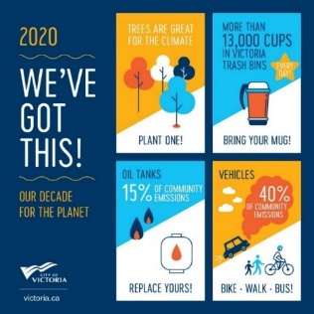
Climate Champions Program
Council has amended the Strategic Plan and providing $50,000 in funding to "Create a Climate Champions Program." The Climate Champions program will create and facilitate a network of Champions in order to share ideas, undertake partnerships, and encourage fun and innovative action to reduce the community’s greenhouse gas emissions. The focus of the program is on action, mobilization and behavior change in line with the largest emissions sources in the City’s Climate Leadership Plan.

Calling All Musicians and Community Programmers
The City is updating its rosters of local musicians and community programmers for outdoor summer concerts, events and activities at Centennial Square and Beacon Hill. To be considered for these rosters, local musicians and community programmers are invited to apply online and provide links to samples of their work by Wednesday, January 15, 2020. Preference will be given to those based in the Capital Region. For details visit victoria.ca/artsandculture.

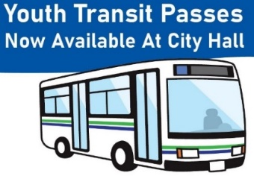
Free Youth Bus Passes
Youth 18 years of age and younger residing in the municipality of Victoria are eligible a free monthly transit pass from the City of Victoria. Passes are available for pick up Monday through Friday from 8:00am – 4:30pm from the Public Service Centre at City Hall. For details visit our Transit webpage.

City Council Meetings
Committee of the Whole meets on January 16, 23 and 30 at 9:00am. Council meets on January 30 beginning at 6:30pm.

You can also find out more about Council meetings by:
- Watching recordings of the meetings here
- Tuning into bi-weekly videos for what’s coming up for discussion at City Council
- Reviewing the decisions made at Council on our Council Highlights page
- Finding out how Councillors voted on the City Council Meeting Dashboard

