Bruce K. Benesh, CPA
Business Compensation Advisor

Curriculum Vitae
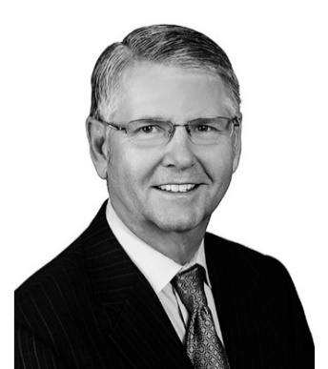

Executive Compensation Advisor and Consultant
Bruce is an executive compensation consultant with more than 45 years of experience in all facets of compensation arrangements, planning and tax planning relating to compensation arrangements and international human resource consulting. Bruce was formally the national managing partner of Grant Thornton’s Human Capital Services Practice; he was also the partner-in-charge of Arthur Andersen’s North American and Latin American Human Capital Practice and the Divisional President of a consulting practice for a publicly traded company.
Benesh Consulting Group, LLC
August 1, 2020 to Present – Managing Principal of Compensation and Benefits Consulting
Grant Thornton LLP
July 1, 2005 to July 31, 2020 – Managing Partner of Compensation and Benefits Consulting (HCS)
August 1, 2009 to Current – Managing Partner of International Expatriate Services (HCS)
Clark Consulting
May 16, 2002 to June 30, 2005 - President of Human Capital Services Practice
Arthur Andersen LLP
September 1, 1992 to May 15, 2002 – Partner in Charge of Human Capital Practice in Carolinas, Atlanta, United States and Americas
September 1 1984 to August 31, 1992 – Tax and Compensation and Benefits Manager
September 1, 1982 to August 31, 1984 – Senior Tax Staff Accountant
June 1, 1980 to August 31, - 1981 – Tax Staff Accountant, Arkansas Georgia, South Carolina

Industry and Consulting Experience
Bruce has broad consulting experience in many industries with companies ranging from closely held family businesses and family offices to multi-national corporations. His experience includes advising clients and executives on all aspects of strategic planning and compensation, benefits and human resource issues, including competitive total compensation arrangements for executives, change-of-control and severance arrangements, qualified pension, profit sharing and stock bonus plans, fiduciary and governance planning for ESOPs, life insurance planning, welfare benefit plans, nonqualified executive compensation arrangements, and employer-provided fringe benefits.
He also has extensive experience in single family offices and in the design and implementation of long-term, equity-based incentive plans for family and privately held companies, including C-Suite executives.

Professional qualifications and memberships
Bruce is a certified public accountant and a member of both national and state organizations, including
the American Institute of Certified Public Accountants

Certified Public Accountant Permits to Practice: Arkansas, Georgia, South Carolina

Education
Bruce holds a Bachelor’s degree in Business and Economics from Hendrix College in Conway, Arkansas, and a Masters in Accountancy with an emphasis in taxation from the University of Oklahoma.
Bachelor’s Degree in Business & Economics Hendrix College – May 1980
Masters in Accountancy with Emphasis in Taxation University of Oklahoma – May 1984

Link to Website:
https://beneshconsultinggroup.com/about-us

