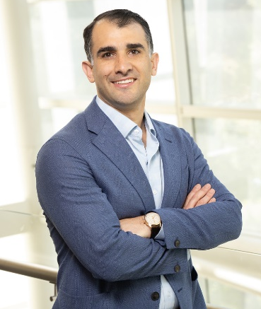


Ronald G. Nahass, Jr.
Principal
New York, NY
ronald.nahass@rsmus.com
+1 212 372 1283

Summary of experience
Ronald Nahass is a principal in RSM’s Consulting practice and a strategic growth leader with 18 years of progressive professional services experience. He leads RSM’s New York Consulting business and serves in firmwide leadership roles, including on the Family Enterprise Executive leadership team and as an Enterprise Account Leader.

Ron advises family enterprises, fund owners, financial intermediaries on complex growth, transformation and transaction-related matters. His perspective is grounded in deep financial consulting experience across business valuation, transactions, financial forensics and dispute advisory services. As a leader in RSM’s Microsoft Innovation Hub in New York, he also brings a technology-enabled advisory lens to help clients evaluate opportunities, align stakeholders and move forward with clarity.

As an Enterprise Account Leader, Ron partners with leading financial intermediaries and client stakeholders to build coordinated professional-service ecosystems and institutional-grade service programs for clients, portfolio companies and corporate divisions. He helps define strategic objectives, connect the right RSM specialists and mobilize integrated solutions for complex business issues. Ron is known for facilitating practical, outcome-focused conversations that clarify priorities, strengthen alignment and create scalable paths forward.

Professional affiliations and credentials
- Association of Certified Fraud Examiners — Certified Fraud Examiner (CFE), License #861310 (active)
- American Society of Appraisers — Accredited Senior Appraiser (ASA), License #101817 (inactive)

Education
- Executive Certificate in Family Offices and Family Enterprises, Cornell University SC Johnson Graduate School of Management
- Master of Business Administration (MBA), Finance and Data Analytics, Leonard N. Stern School of Business, New York University
- Bachelor of Arts (BA), Business and Government, Franklin & Marshall College

