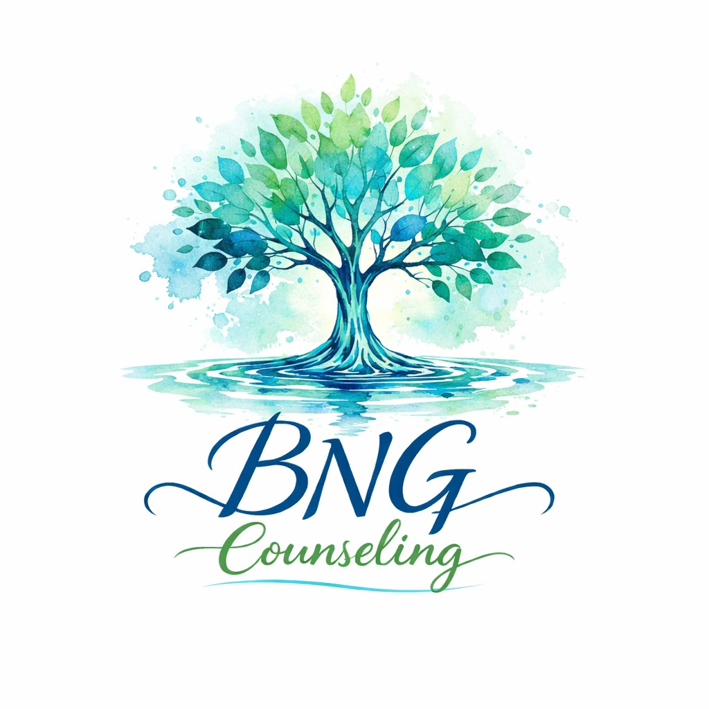
PARENT / LEGAL GUARDIAN AUTHORIZATION
FOR SCHOOL-BASED COUNSELING SERVICES
School Year Authorization Period:
This authorization is valid for the 2025–2026 school year, beginning on August 1, 2025 and ending on May 31, 2026, unless revoked in writing by the parent or legal guardian.

Student Information
Student Name: _______________________________________________
Date of Birth: ___________________________
School Name: _______________________________________________

Counseling Authorization
I, the undersigned parent or legal guardian, hereby give written consent for my child to receive school-based counseling services from BNG Counseling, provided on school grounds during regular school hours under the supervision and awareness of school officials.
I understand that counseling services are confidential, subject to Missouri law, ethical standards, and mandatory reporting requirements.

Parent / Legal Guardian Acknowledgment
Parent / Guardian Name (Print): _______________________________
Signature: ____________________________________ Date: ___________
Phone Number: _______________________________________________ Email Address: _______________________________________________

School Acknowledgment (Optional)
School Official Name & Title: _________________________________
Signature: ____________________________________ Date: ___________

