Agenda  Room 1, Dalrymple Hall  Tuesday 21st June 2022  at 7.00 pm | 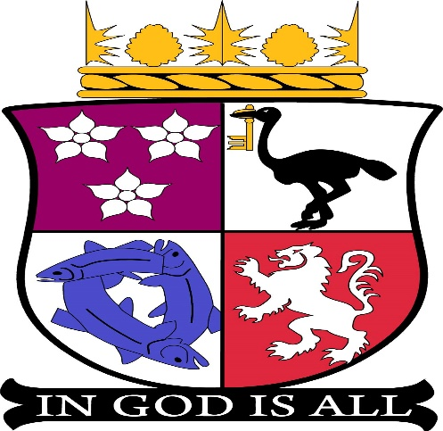

1. | Apologies & Declaration of interest
2. | Minutes of last meeting – 17th May 2022
3. | Matters Arising and Action Sheet
4. | Code of Conduct and Aldo Training
 | Approx. 7.30pm – Sandra Macrae – Exit Report for Fraserburgh 2021
5. | Roles and Responsibilities of Office-Bearers
6. | Police Scotland Report/Community Warden Report
7. | Urgent items of business
8. | Treasurers Report
9. | Sub Committees  - Resilience  - Flower Fairies  - Community Awards  - Litter Picking Group
10. | Questions for Aberdeenshire Councillors
11. | Questions from Members of the Public
12. | Correspondence
13. | Planning Applications
14. | AOB  - Membership (non-attendance at meetings)  - Broch Soup  - Doric Boards
15. | Date & Time of next meeting - 16th August 2022 at 7pm – Venue to be confirmed

