Inaugural Meeting  Of  Fraserburgh Community Council  MINUTES  Learning Room 2, Fraserburgh  Community & Sports Centre  Tuesday 24 September 2024  at 6.00 pm |  | 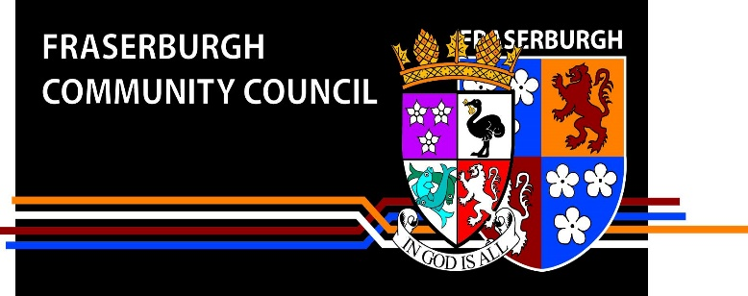
Present:

Helena Gilbert - Community Councillor
Julie Rowe - Community Councillor
Fiona Duthie -
Ken Harper - Community Councillor
Sylvia Harper - Community Councillor
Mike McDonald - Community Councillor
John Anderson - Community Councillor
Denise Taylor - Community Councillor
Jodie Summers - Community Councillor
Arthur Bowie - Prospective member
Kelly Thomson - Prospective member
Lexi Smith - Senior Pupil Fraserburgh Academy
Samuel Noble - Senior Pupil Fraserburgh Academy

Councillors: Councillor James Adams
Councillor Doreen Mair

Apologies: Dionne Whyte

1. | Welcome & Introductions
Councillor Doreen Mair took chair.
CNL DM welcomed everyone to the meeting. She set out the role of the Community Council and welcomed the new members as follows:
Denise Taylor
Dionne Whyte
Ken Harper
Sylvia Harper
Julie Rowe
Helena Gilbert
Jodie Summers

Each of the new members introduced themselves to the meeting.
The prospective members and the reps from Fraserburgh Academy also intorduced themselves.

2. | Appointment of Office bearers
The following were appointed:
Chair Helena Gilbert
Proposed - Julie Rowe
Seconded - John Amderson

Vice Chair Dionne Whyte
Proposed - Helena Gilbert
Seconded - Mike McDonald

Secretary Julie Rowe
Proposed - Sylvia Harper
Seconded – Jodie Summers

Treasurer Ken Harper
Proposed – John Anderson
Seconded – Mike McDonald
3. | Adoption of Constitution and Standing Orders
 | Confirmation was given of the adoption of the new constitution and standing orders.
4. | Meeting dates
The following meeting dates were agreed:
15 October
19 November
21 January
18 February
18 March
15 April
20 May
17 June (AGM)

5. | Induction training information
 | CLR DM informed CC members that there was training available online via Aberdeenshire website. There is also a handbook and modules available via Local Area Office.

