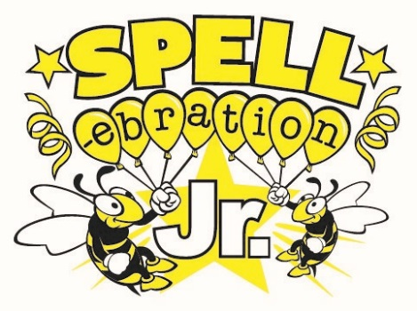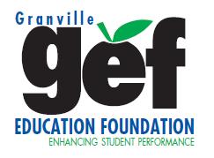
SPELLebration Jr. Team Participation Form
School Name:_______________________________________________________________________________
Contact Person:_____________________________________________________________________________
Address:___________________________________________________________________________________
Phone:____________________________ E-mail:_________________________________________________
Team Nickname:____________________________________________________________________________
Student Team Members:
3rd Grade:_____________________________________________________
4th Grade:_____________________________________________________
5th Grade:_____________________________________________________
SPELLebration Jr.- Thursday, October 24, 2019, 6:00pm
Butner-Stem Middle School Gymnasium
A spelling competition for teams of 3 students from each elementary school, competing by working
together as a team to write down their guess of the spelling of each word called.
Event Details:
- Team consists of a 3rd, 4th, and 5th grader- Each school is responsible for determining who will be on the school’s team(s). School can have up to THREE teams in competition.
- No Registration Fee
- Each team will receive 3 Free Word Coupons
- A food voucher will be provided to each of the student team members (Pizza, Chips, & Drink)
- Concessions will be available
- FREE Admission to the event for spectators
- Participants are encouraged to come dressed in Halloween Costumes!
- Winning Team will take home the SPELLebration Jr. Trophy to be displayed at their school and a reward for each individual team member!
- Doors open at 5:15pm & Competition will start at 6:00pm

Please Return the Form by Friday, October 18, 2019

Contact GEF with any questions!
Phone: 919.693.7047 Email: GranvilleEdFoundation@outlook.com
Mail: P.O. Box 2056, Oxford, NC 27565 Website: www.GranvilleEdFoundation.org

