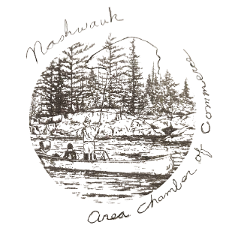
NASHWAUK AREA CHAMBER OF COMMERCE
FROM TIMBER TO TACONITE
P.O. BOX 156-NASHWAUK, MINNESOTA 55769
2025 MEMBERSHIP APPLICATION
(MEMBERSHIP AND RENEWALS DUE BY March 20,2025)
NEW: __________ RENEWAL: __________

DATE: ________________
BUSINESS/ORGANIZATION NAME: ___________________________________________________________
ADDRESS: __________________________________________________________________________________
CITY: ____________________________________ STATE: ____________________ ZIP CODE: ___________
PHONE NUMBER: ___________________________________________________________________________
EMAIL: _____________________________________________________________________________________
CONTACT PERSON: _________________________________________________________________________
TYPE OF BUSINESS OR ORGANIZATION: ______________________________________________________
NAME VOTING REPERSENTIVE FOR YOUR BUSINESS/ORGANIZATION: __________________________
MEMBERSHIP OPTIONS:
PLEASE SELECT YOUR APPROPRITE MEMBERSHIP TYPE (IF YOU ARE UNSURE OF YOUR MEMBERSHIP TYPE, PLEASE CONTACT US)
MEMBERSHIP TYPE COST AMOUNT PAID
( ) INDIVIDUAL $25 $_____________
( ) SOLE PROPRIETOR(NON-BUSINESS) $40 $_____________
( ) BUSINESS $60 $_____________
( ) NON-PROFIT GROUP $35 $_____________
( ) GOVERNMENT $60 $_____________

PAYMENTS MUST ACCOMPANY APPLICATION, CHECKS CAN BE WRITTEN OUT TO NACC AND SENT TO THE ADDRESS LISTED AT THE TOP OF THIS FORM.
ANY QUESTIONS PLEASE CONTACT US AT: NASHWAUKCHAMBER@GMAIL.COM
THE INFORMATION ON THIS FORM WILL BE USED TO UPDATE OUR CONTACT LIST AND WEBSITE.
OFFICE USE ONLY DATE RECEIVED: _____________ PAYMENT AMOUNT: ____________
CHECK NUMBER: __________

