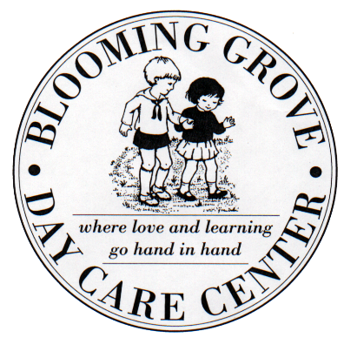
Blooming Grove Day Care Center
P.O. Box 13
Route 94 and Old Dominion Road
Blooming Grove, NY 10914
(845) 496-6663

Photographs: The Blooming Grove Day Care Center staff has my permission to take pictures of my child while he/she is enrolled in the program. These photographs may be used on the BGDCC Facebook page.

Please check off the appropriate box below:

_________ _________
YES NO

__________________________________ ___________
Child’s Name Age
__________________________________ ___________
Parent’s Signature Date

