Lansdowne Conservancy Awarded $19,300 Grant

The Loudoun Invasive Plant Species Management Program (IPSMP) awarded a $19,300 grant on June 24, 2026, to Lansdowne Conservancy. The funding will support a multi-year effort to treat and remove invasive plant species and restore the area with native plants.

Invasive plant species are non-native plants that reproduce rapidly and cause harm to the environment, the economy, or human health. They outcompete native plants for light, water, and soil nutrients, leaving native insects, birds, and animals without food or shelter. Many invasive plants were originally introduced for landscaping or erosion control before their aggressive nature was realized.

The focus is on the pond near the old stone pumphouse on Woodridge Parkway. The few native plants currently growing in the pond buffer are threatened by the density and aggressiveness of invasive species. Stilt grass, lespedeza, Multiflora rose, and Bradford pear are the predominant invasive species.

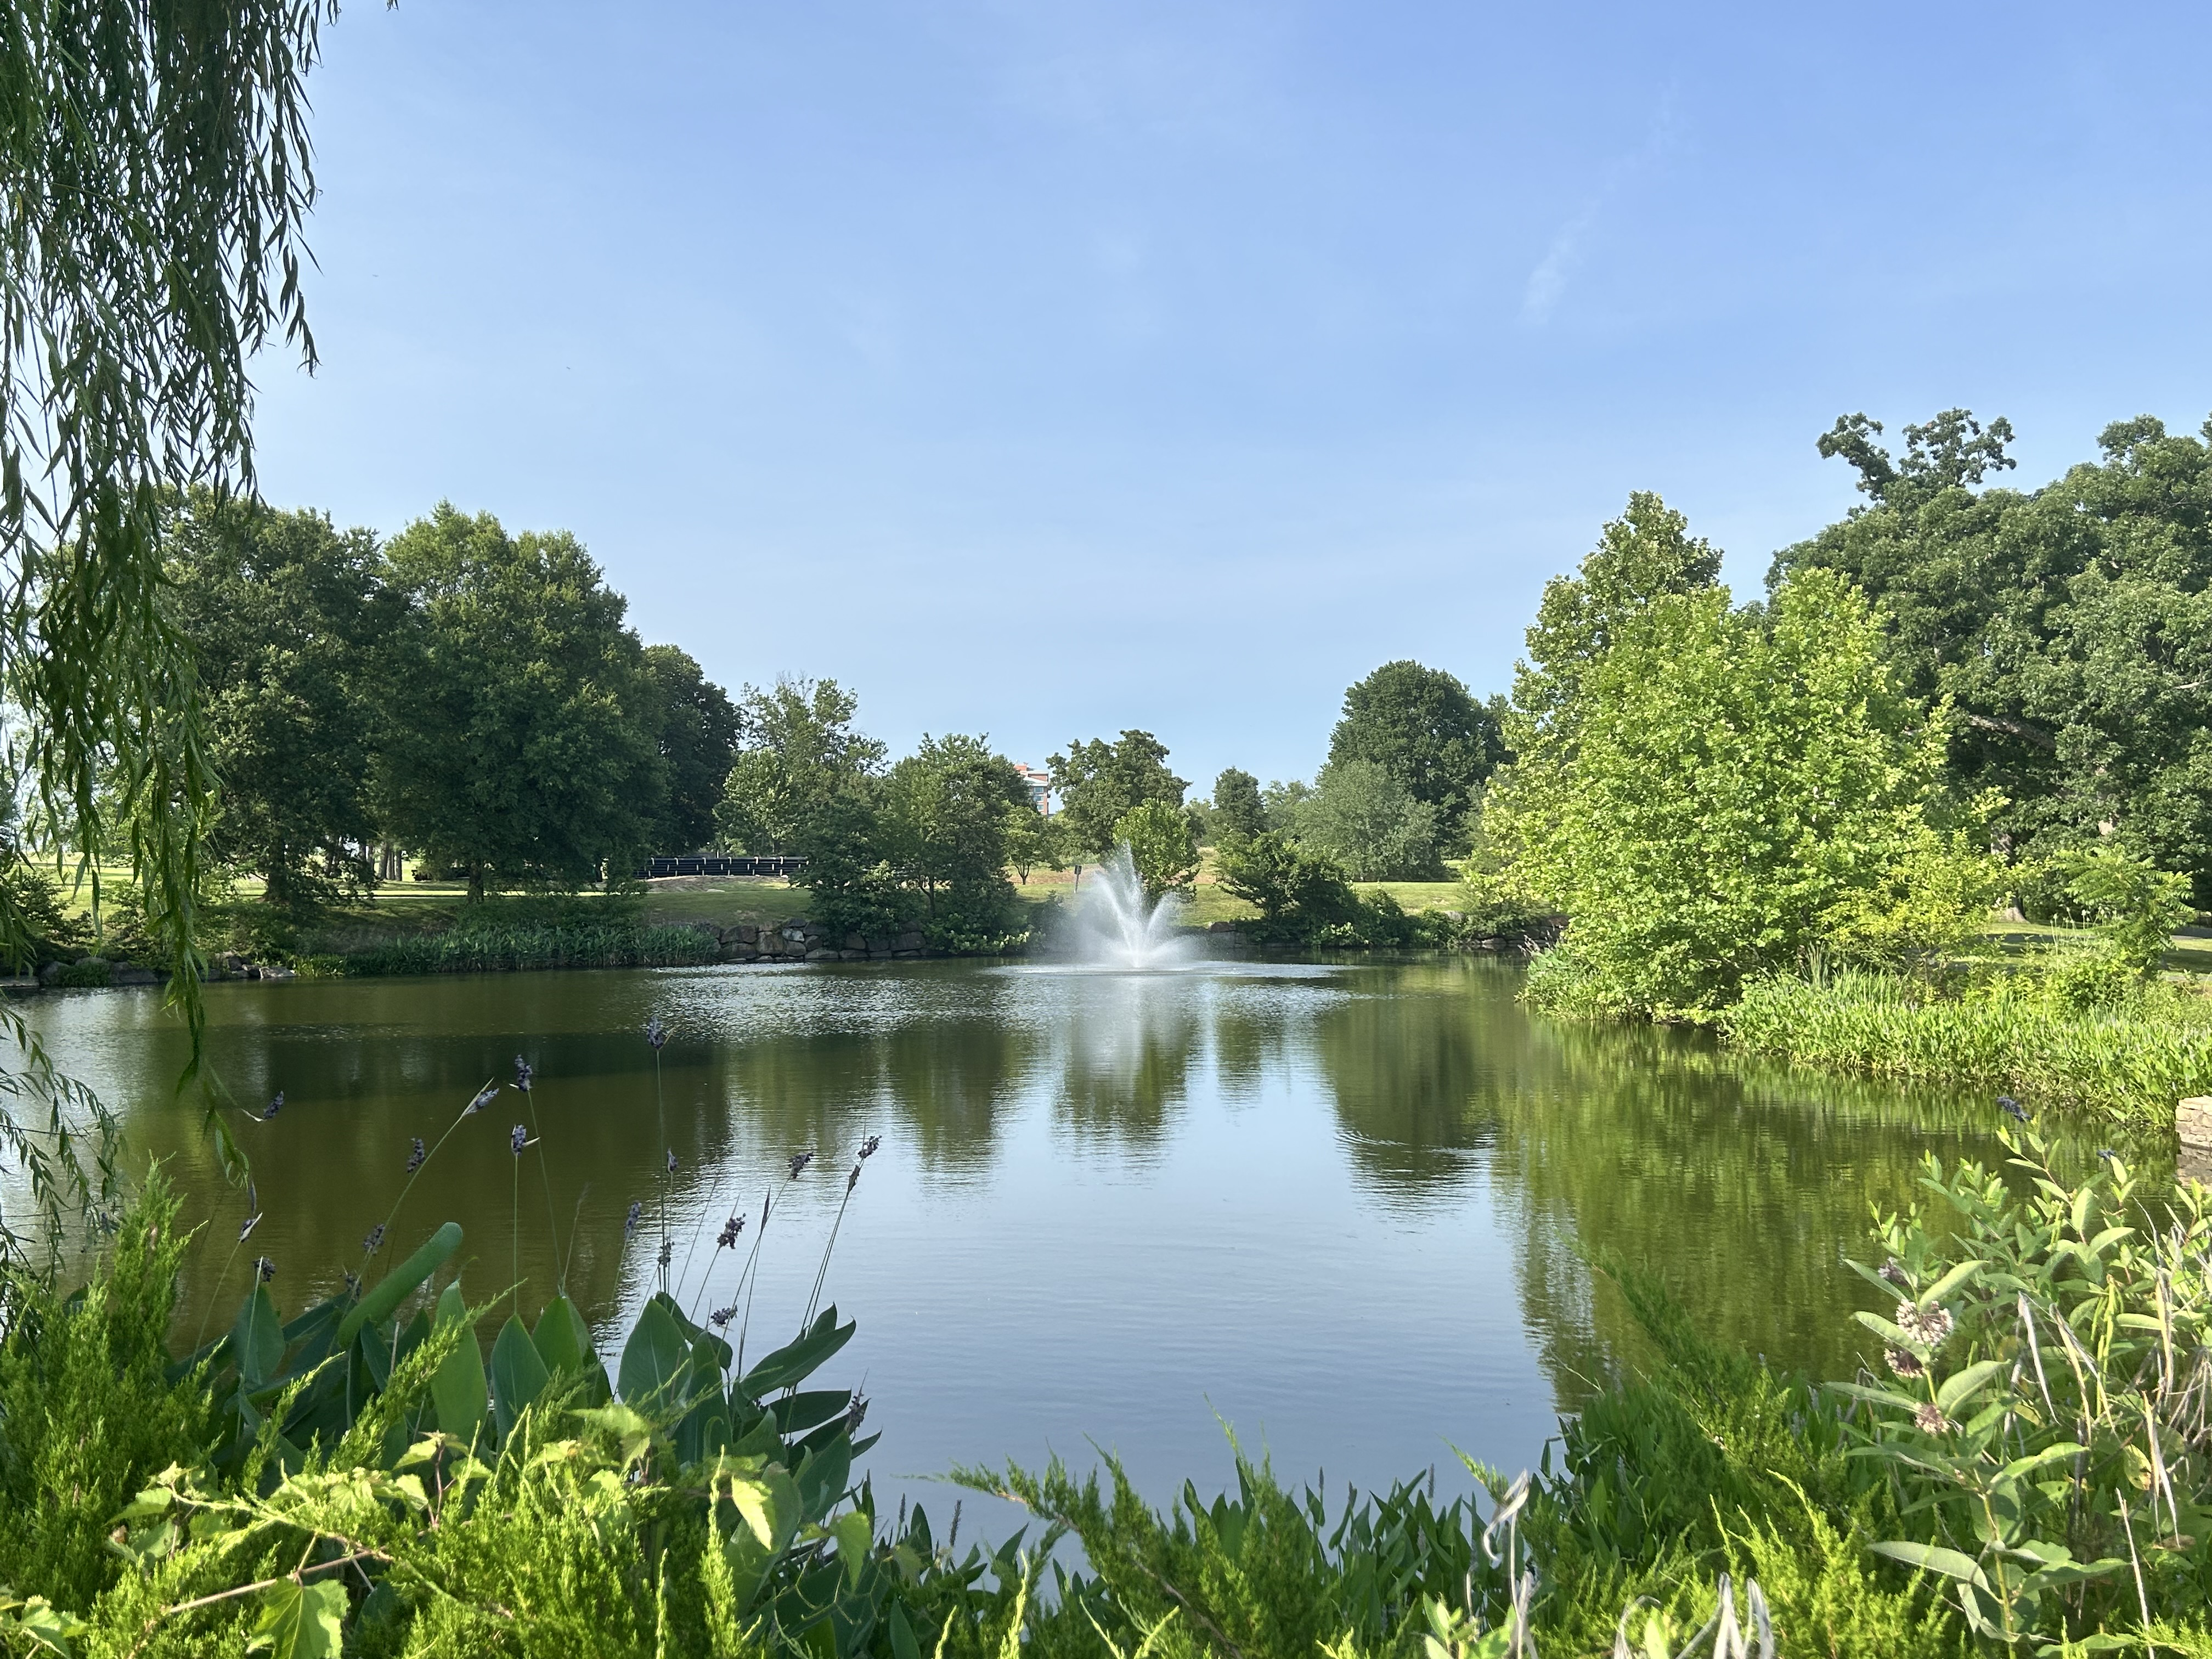

Nature Works Professional Land Management will treat the invasive species and restore the pond buffer to improve water quality, prevent erosion, and encourage desired wildlife. Nature Works estimates that the initial treatment of invasive plants will begin in late July. Follow-up treatments are expected in September, with planting of natives in October. The site will be monitored for invasives for a three-year period.

The IPSMP was launched with support from the Loudoun Invasive Removal Alliance (LIRA). Lansdowne Conservancy has been a proud member since 2025. The alliance now includes 88 communities, representing more than 230,000 Loudoun residents. The program’s broader goal is to raise awareness of the economic, environmental, and health impacts of invasive plants -ultimately encouraging residents and retailers alike to stop buying, selling, and planting these harmful species.

Watch for project updates and volunteer opportunities within the Conservancy. An invasive removal event is being planned for Earth Day 2027. No experience necessary. It would be wonderful to see you there.

For additional information:
https://blueridgeprism.org
https://www.loudoun.gov/InvasivePlants (Invasive Plant Species Management Program)
https://www.loudouninvasives.com (Loudoun Invasive Removal Alliance / LIRA)

Proposed Native Plant Species

