STONES TAKEOVER
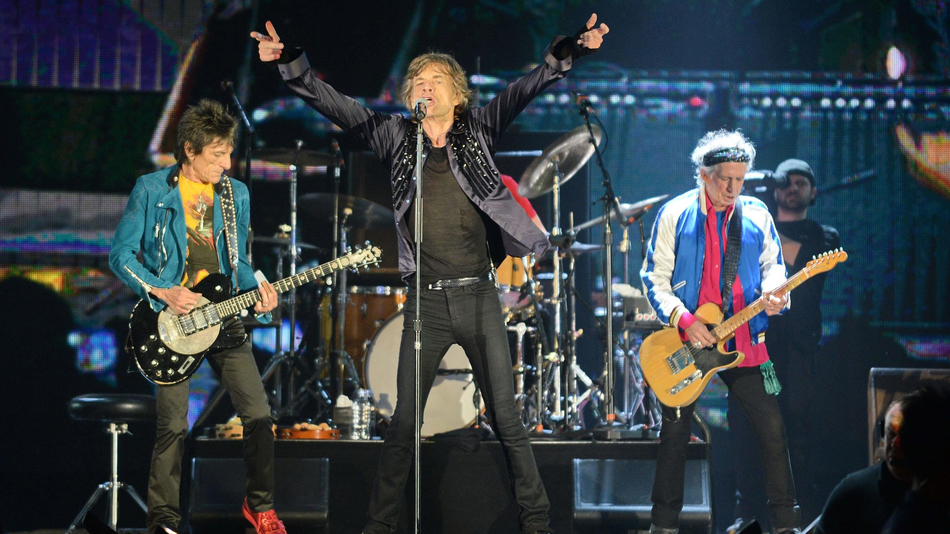
The Rolling Stones Total Immersion Event
5000+ images, 250+ music videos & all Stones music
Pro sound & event lighting ♦ Multiple large screen projection

NIGHTCLUBS
The band then and now –

DISTILLERIES

glitter, satin, private jets, BREWERIES
studios, concerts, backstage & more… PRIVATE PARTIES
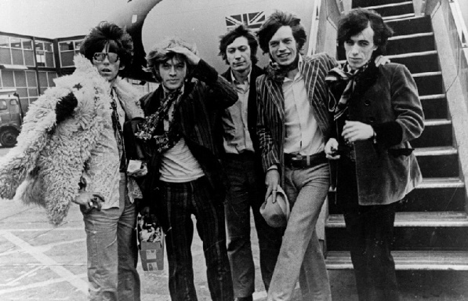
YOU WANT THEM
AT YOUR EVENT !

Presented by ROUNTREE PRODUCTIONS
Over 20 Years in Multimedia Entertainment

ROUNTREEPRODUCTIONS@GMAIL.COM

412.656.4792
WWW.ROUNTREEPRODUCTIONS.COm

