Mug Club Application
Cost = $100
Mug Club # _________
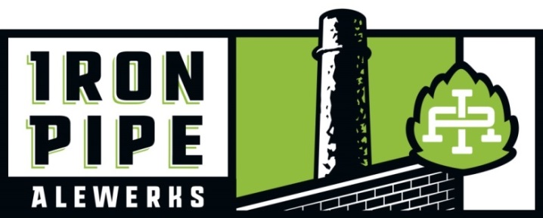
ENJOY BEING PART OF A UNIQUE CLUB OF LIKE-MINDED CRAFT BEER LOVERS BY JOINING THE IRON PIPE ALEWERKS MUG CLUB. A SOCIAL CLUB DESIGNED FOR THE ABOVE AVERAGE BEER ENTHUSIAST WHO WANTS TO BE PART OF THE IRON PIPE FAMILY FOR LIFE.
Club Benefits All We Need to Sign you up

First Name _____________________________________

Last name ______________________________________

E-Mail _________________________________________

Phone _________________________________________

Birthday ____________________
- Lifetime Membership – No Renewals required.
- 20oz pour every time for the price of 16oz pour.
- Your first pour is FREE on US!
- A Free 20oz pour in your mug on your Birthday (with ID)
- 10% off All Merchandise
- Invitations to Exclusive Mug Club Member Parties in the Spring and Fall, featuring first tastings of New Releases
- Early E-mail announcements on Discounts and Special events throughout the year

Mug Club Rules -
Just a Couple Rules
- You must be 21 years old or older.
- With a mug comes increased accountability, act like you belong, don’t break the rules and don’t be “THAT” family member who gets kicked out or gets banned.
- Mugs are for the sole use of the member who made the original purchase, so NO sharing or giving your mug to someone else to use, ID maybe required.
- Higher ABV style beers reaching 9% and above will not be served in 20oz pours.
- Cannot be combined with other discounts or specials.
- Of Course we are human. If we accidently break your mug, we will replace it, but if you break it, you’ll need to pay $20 for a new one and wait to be made.
**Management reserves the right to remove and/or revoke privileges of the Mug Club at discretion.
PLEASE, DON’T MAKE US!

XXX-XXX-XXXX
MM/DD/YYYY

